System and OS Virtualization

Santa Clara University Department of Computer Science and Engineering

Cloud Computing CSEN – 241

Homework – 1

Student Name – Avani Sanjay Vaidya

Student Id - 007700005517

INDEX

|  |  |  |
| --- | --- | --- |
| Sr. No | Topic | Page Number |
| 1. | Environment Setup | 3 |
| 2. | System Virtualization Setup | 4 |
|  | Disk Format – qcow2 | 5 |
|  | Disk Format – raw | 7 |
|  | LUKS Encryption | 8 |
| 3. | Operating System Virtualization Setup | 11 |
| 4. | Sysbench Setup | 14 |
| 5. | Sysbench Experiment | 16 |
| 6. | Experiment Results and Analysis | 69 |
| 7. | Sysbench Findings and Conclusion | 74 |
| 8. | Shell Script | 75 |

1. **ENVIRONMENT SETUP**

**Host System Configuration**

The configuration of the host system used to perform the experiment is as follows –

|  |  |
| --- | --- |
| Chip | Apple M2 |
| Total Number of Cores | 8 (4 performance and 4 efficiency) |
| Memory | 16 GB |
| Disk Space | 245.11 GB |
| Available Disk Space | 54.33 GB |
| Operating System | macOS Ventura Version 13.5 |

1. **SYSTEM VIRTUALIZATION SETUP**

To perform System Virtualization, we have used the QEMU hypervisor. Further, an Ubuntu Virtual Machine is created with Qemu. Following are the detailed steps to install Qemu and create an Ubuntu Virtual Machine with specific Disk space, CPU and RAM.

1. **Install Qemu** –

To install Qemu on macOS, we use the package manager Homebrew. We need to install Homebrew first. Open terminal on your host machine and run the following is the command to install Homebrew.



Further, we would need to add Homebrew to the PATH variable as follows.



Now we will install Qemu using Homebrew and following is the command used with the output.

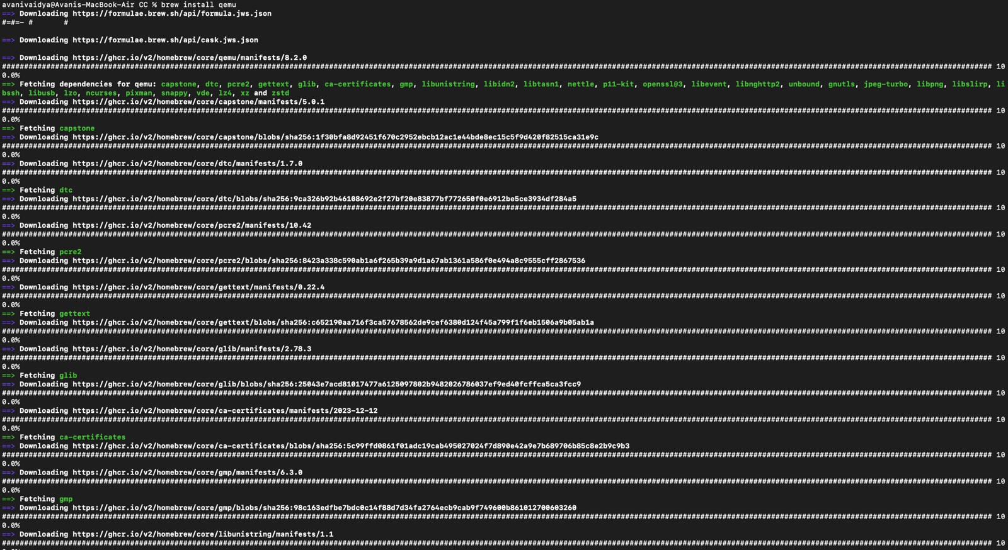

1. **Install Ubuntu server ISO image –**

In order to install the Ubuntu Guest Virtual Machine, we will need to install the Ubuntu 20.04 server ISO image from the following link

<https://releases.ubuntu.com/focal/>

1. **Create Qemu Image and Install Ubuntu VM –**

**Disk Image Format – qcow2**

Now we will create a Qemu image of Ubuntu in qcow2 disk format with 10G of disk space with the following command

sudo qemu-img create ubuntu.img 10G -f qcow2

where,

-“ubuntu.img” is the disk image filename

-“10g” of disk space

-“-f” option is used to mention the disk format, here it is qcow2.

Further we will run following command to install the Ubuntu VM using the Ubuntu iso server image from step (b) in the disk image created by above command.

sudo qemu-system-x86_64 -hda ubuntu.img -boot d -cdrom ./[UBUNTU_SERVER_ISO_FILE_NAME] -m 2046 -boot strict=on

In the above command the flags/option used have following meanings –

-hda: use file as a hard disk

-boot: this option specifies the boot order, for x86 architecture these drive letters are - a, b (for floppy drives), c (first hard-disk), d (first CD-ROM), n-p (Etherboot from network adapter 1-4). Hard-disk boot is the default option.

-cdrom: this option specifies the .iso file to be used as a base for image we are creating

-m: this option sets guest OS’s startup RAM to specified value i.e 2048 MB

Following the screenshot of the above commands



After the above command, a QEMU command prompt will open. There will be multiple steps follow and choose the appropriate configurations for our VM like Language, Packages to install etc. to install the VM successfully.

Following screen appears once installation is successful.

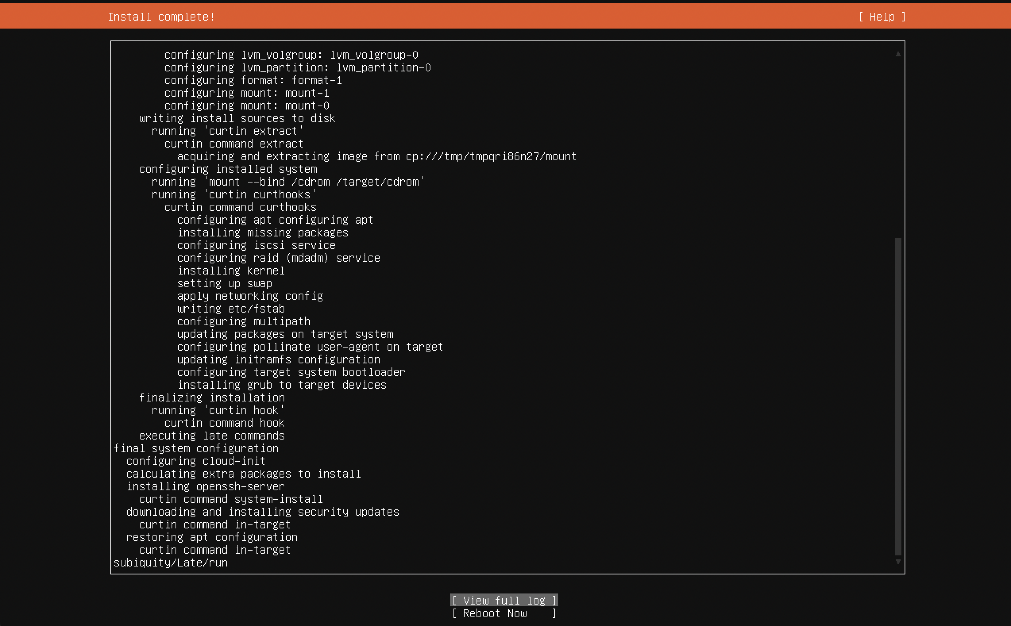

Thus, we have successfully installed the Ubuntu Guest VM on the Qemu image. We need to reboot the system now.

Once the system is rebooted, we can start the server using the following command.



where,

-smp is the flag used to set the number of CPU’s

-m is the flag used to set the amount of RAM

-had is used to specify file to be used as hard disk, in this case it is the Ubuntu image.

We can check the details of the image created above using following command.

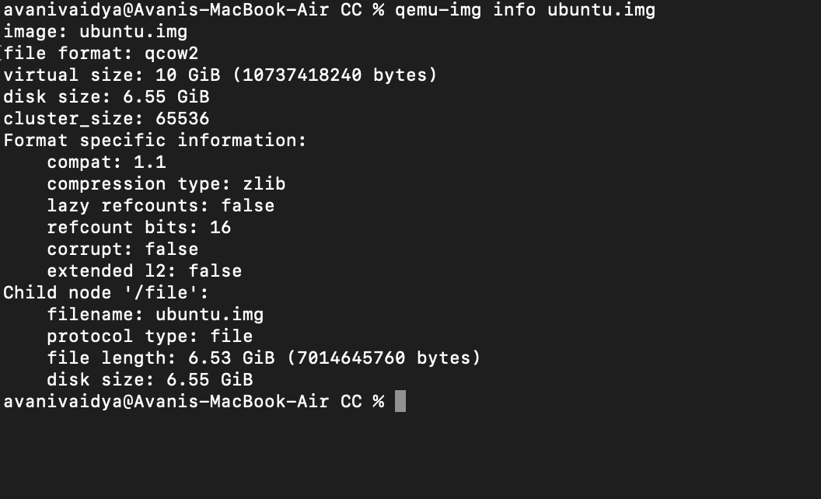

**Disk Image format – raw**

To create a Qemu image of Ubuntu in raw disk format with 10G of disk space we will follow the same steps as seen in 2.c except the file format will be changed to “raw”. Following is the command to create Qemu image of Ubuntu with raw disk format and output of the command.



Here,

-rubuntu.img” is the disk image file name

-option “-f” is used to specify the disk image format, in this case it is “raw”

-with “10G” of disk space.

The flag/options for the second command seen in the screenshot is similar to mentioned in section 2.c

Thus, after running the above commands a Qemu command prompt will open, where we will need to choose the appropriate configurations for our VM to install it successfully. Once, installed we will need to reboot the system as mentioned in 2.c.

Once the system is rebooted, we can start the server using the same command as qcow2 disk format, as follows –



We can check the details of the image created with the following command.

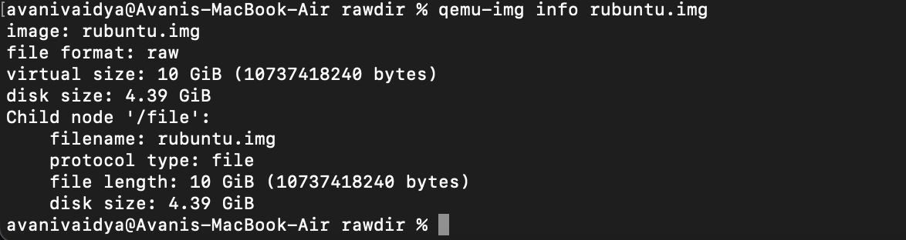

**LUKS Encryption**

To generate an encrypted QEMU image of Ubuntu in the qcow2 file format we use the following command with LUKS encryption format.



Description of the flags used in the above command.

--object secret,id=sec0,data=123456: This part creates a QEMU secret object named sec0 with a data value of 123456. Secrets in QEMU can be used for various purposes, including encryption keys.

-o encrypt.format=luks,encrypt.key-secret=sec0: It indicates that the encryption format is LUKS (Linux Unified Key Setup), and it associates the secret object sec0 as the key for encryption.

Now further, we will create the Ubuntu Virtual Machine using the following command



Description of the flags used in the above command.

-had: Specifies the file to be used as a hard disk.

-boot: Defines the boot order for x86 architecture, where drive letters represent different boot options. For example, a, b (for floppy drives), c (first hard disk), d (first CD-ROM), n-p (Etherboot from network adapter 1-4). The default option is the hard disk boot.

-cdrom: Indicates the .iso file to be utilized as the base for the image being created.

-m: Sets the startup RAM for the guest OS to the specified value, in this case, 2048 MB.

--object secret,id=sec0,data=123456: This flag passes a QEMU secret object named sec0 with a data value of 123456. This secret can be used for various purposes, including encryption keys.

-drive driver=qcow2,file.filename=eubuntu.qcow2,encrypt.key-secret=sec0: This flag configures a virtual drive for the virtual machine. It specifies that the driver is qcow2, sets the filename to eubuntu.qcow2, and uses the secret object sec0 as the key for encryption. This indicates that the virtual machine will use an encrypted qcow2 image file.

The information of the created image can be seen using following command.

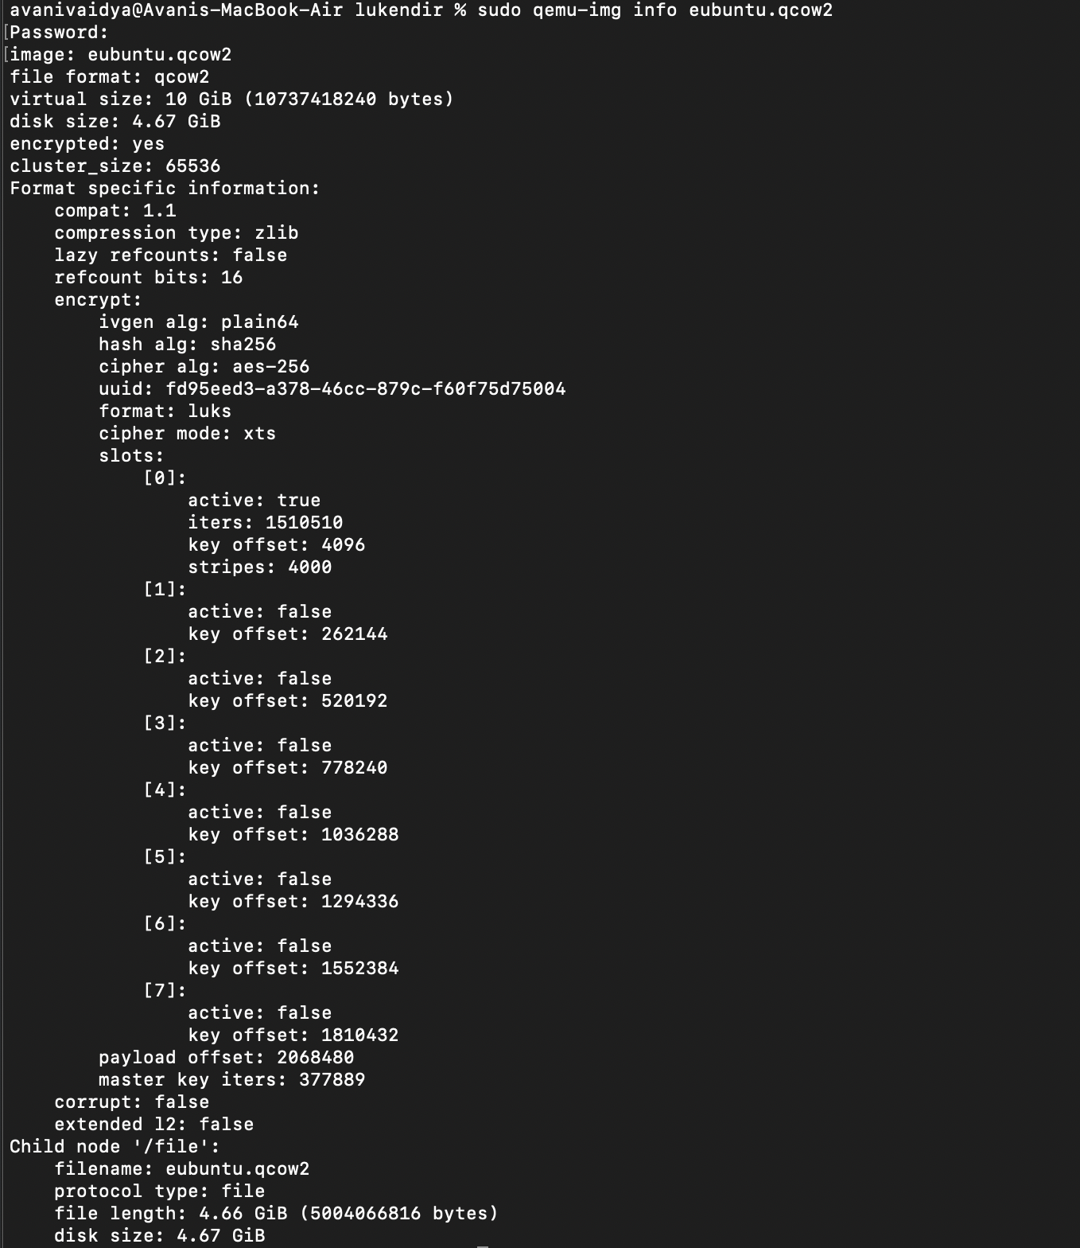

1. OPERATING SYSTEM VIRTUALIZATION SETUP

To perform OS Virtualization we will use Docker, which is a container management platform. We will install the Ubuntu Operating System on our Docker image.

1. **Install Docker Desktop -**

To install Docker Desktop on macOS use the following link.

<https://docs.docker.com/desktop/mac/install/>

Follow the installation steps to successfully install Docker Desktop on your machine.

Once Docker is installed you can open terminal and check if installation is successful with following command and the output is seen as -

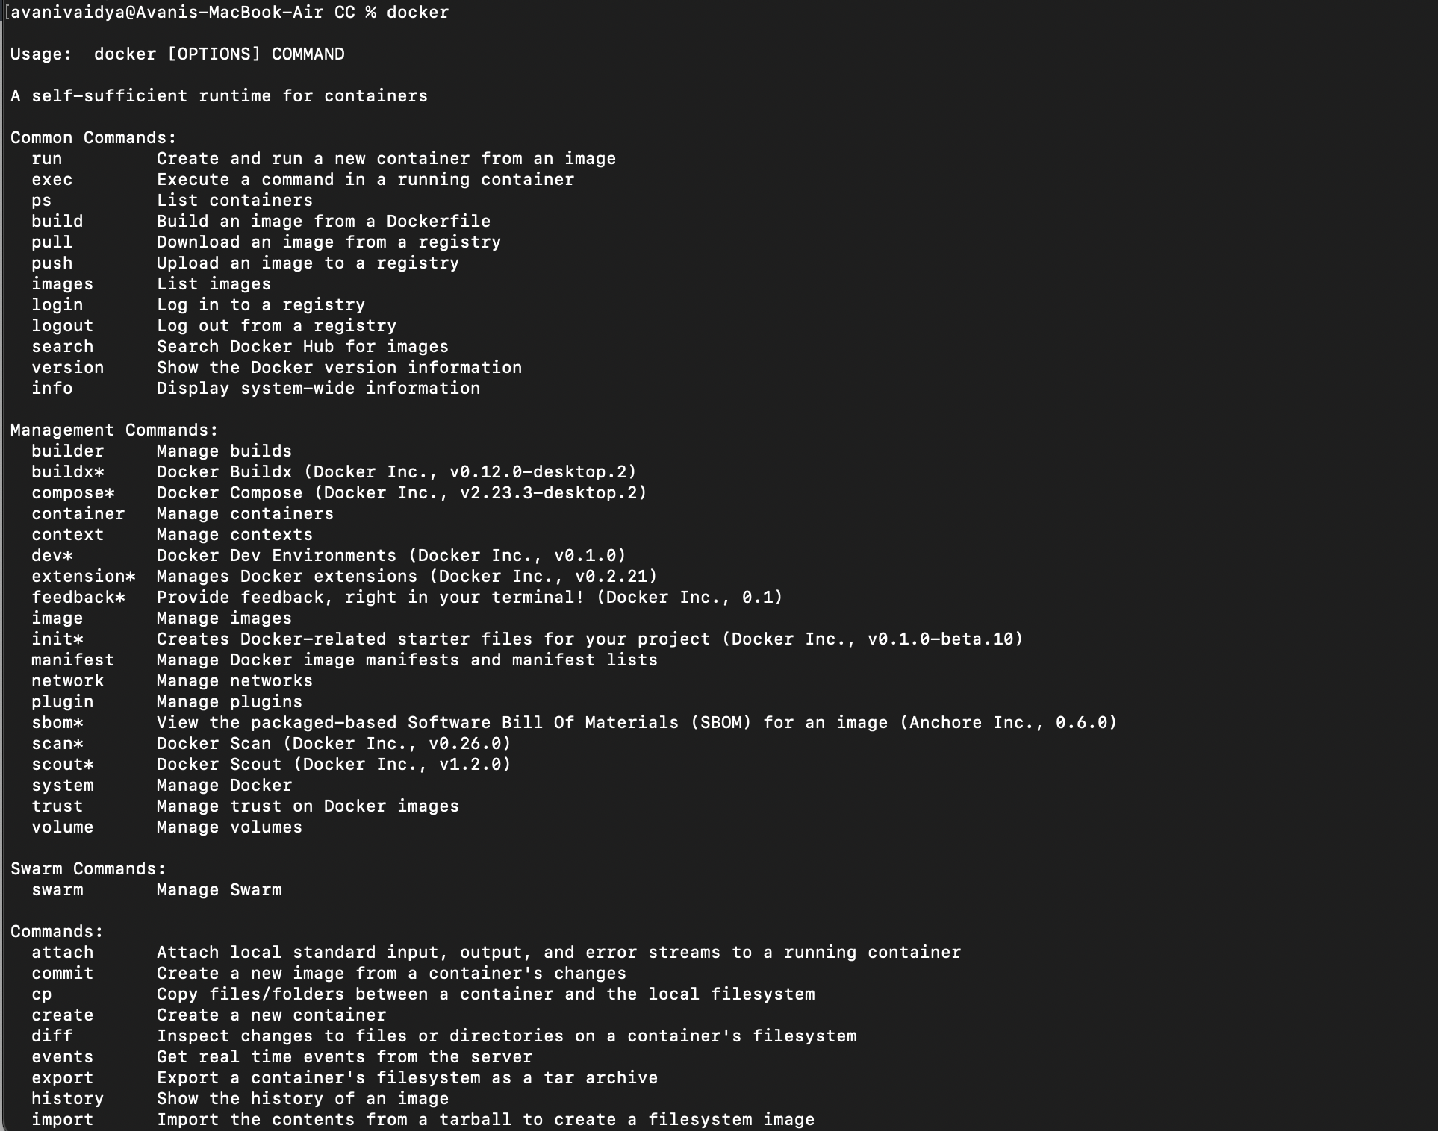

1. **Download latest Ubuntu image –**

To install latest Ubuntu image run the following command from terminal and the output is seen as follows.

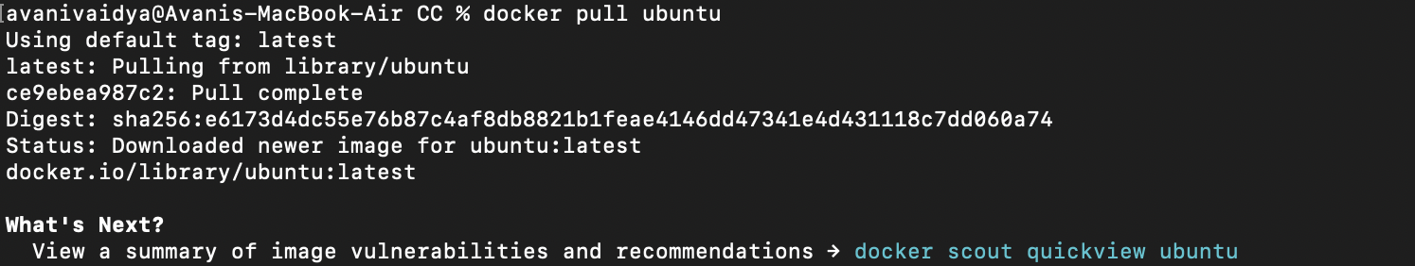

1. **Create Docker container –**

Now we will create a Docker container with the above Ubuntu image with the following command. The command will start the container and we will be redirected to the bash shell of the Ubuntu container as seen in following screenshot.



We can also run the docker container by mentioning the number of CPU cores and amount of RAM as follows, which we need in sysbench experiment testing.



where

--cpus is the flag used to mention the number of CPU cores

--memory is used to mention the amount of RAM

1. **Check image id and image history –**

Image id of the docker container created above can be checked with the following command.

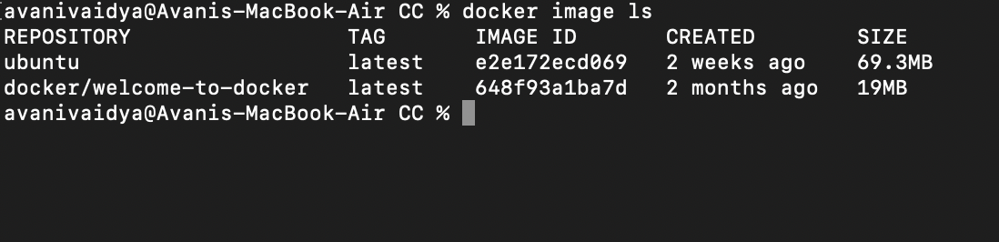

History of the image can be seen with the following command.

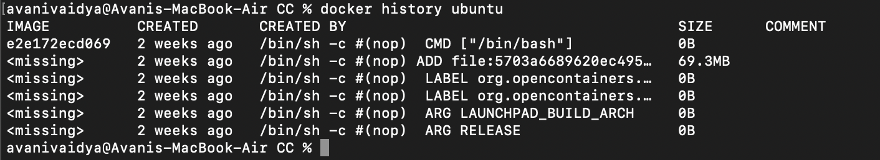

1. SYSBENCH SETUP

We will use sysbench to understand the performance characteristics of each of the virtualization technologies.

1. **Sysbench for Qemu Ubuntu Guest Virtual Machine -**

To install sysbench on Ubuntu run the following commands on the Qemu command prompt.

$ sudo apt update

$ sudo apt install sysbench

Following screenshot shows the output of the above command for Qemu.

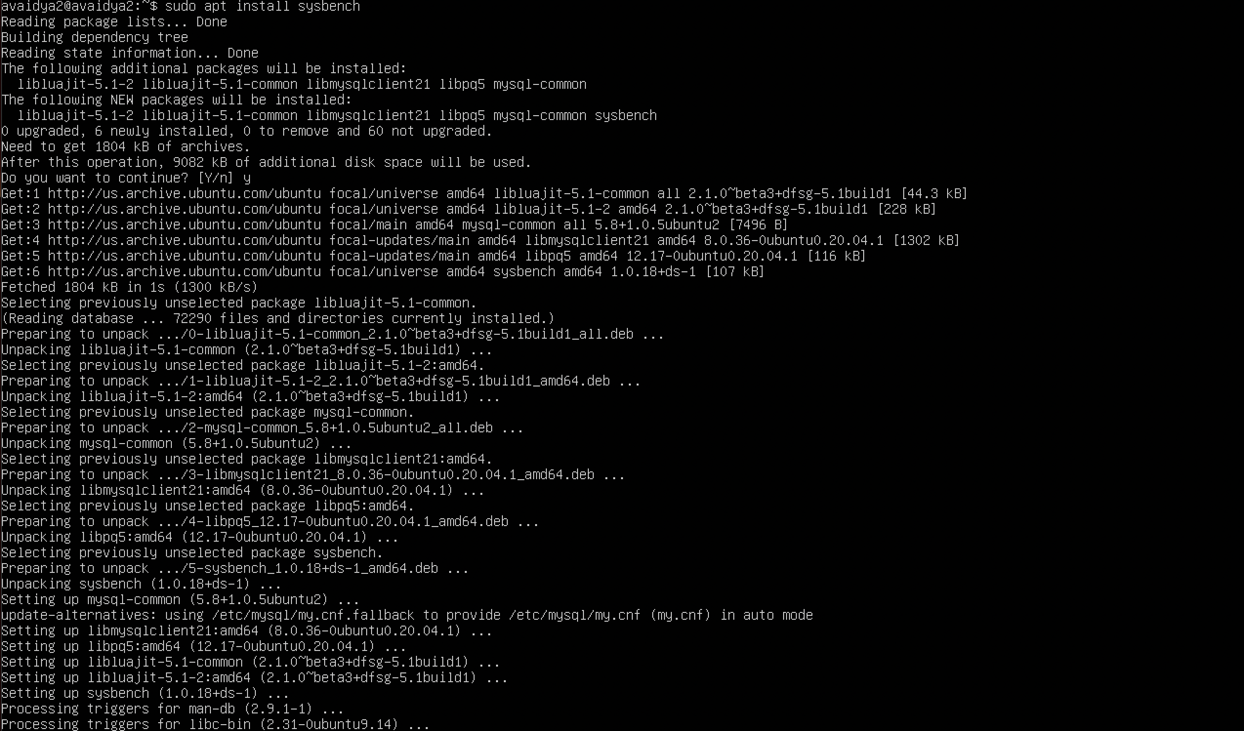

1. **Sysbench for Docker Ubuntu Container –**

To install sysbench on Docker, you will need to run the above commands. However, docker images are lightweight and thus, we need to explicitly install sudo package. Following screenshots shows the commands to install sudo package and add the current user to sudo group users.

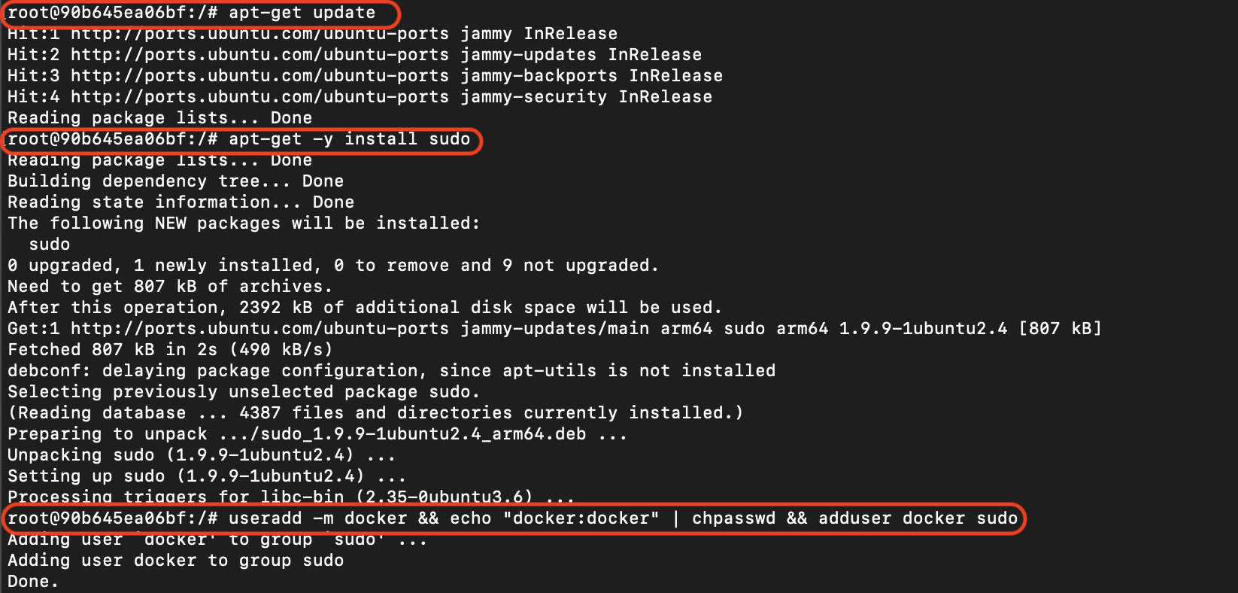

Now you can run the following commands (mentioned in section 4.a) to install sysbench. Following screenshot contains the output after running the commands.

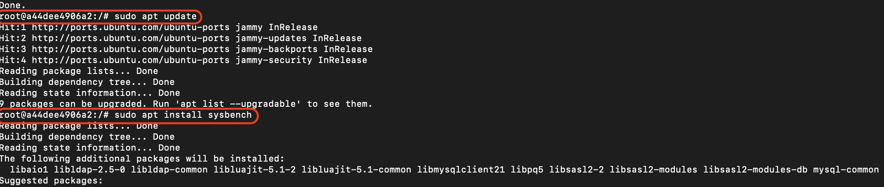

1. **SYSBENCH EXPERIMENT**

We have performed the Sysbench test cases for –

1. qcow Qemu image format
2. raw Qemu image format
3. Docker

In each case, we have built a Virtual Machine with two arguments for CPU and RAM each.

Further, we have run Sysbench test cases for cpu, fileio and memory test modes, where for each test mode we have chosen two arguments.

Thus, the total test cases performed are –

○ QEMU: 2 disk drives x 2 QEMU CPU x 2 QEMU Memory x 6 sysbench = 48

○ Docker: 2 Docker CPU setting x 2 Docker Memory setting x 6 sysbench = 24

This section includes the experimental results for qcow vs raw vs docker, with the different sysbench test cases mentioned as above.

**CPU TEST**

1. **CPU TEST WITH CPU – 2 CORES AND RAM – 4G**

**Test 1 – cpu-max-prime = 2000**

1. Qemu qcow2 format –

Following screenshot shows the sysbench command with cpu test mode and time set to 30 seconds.

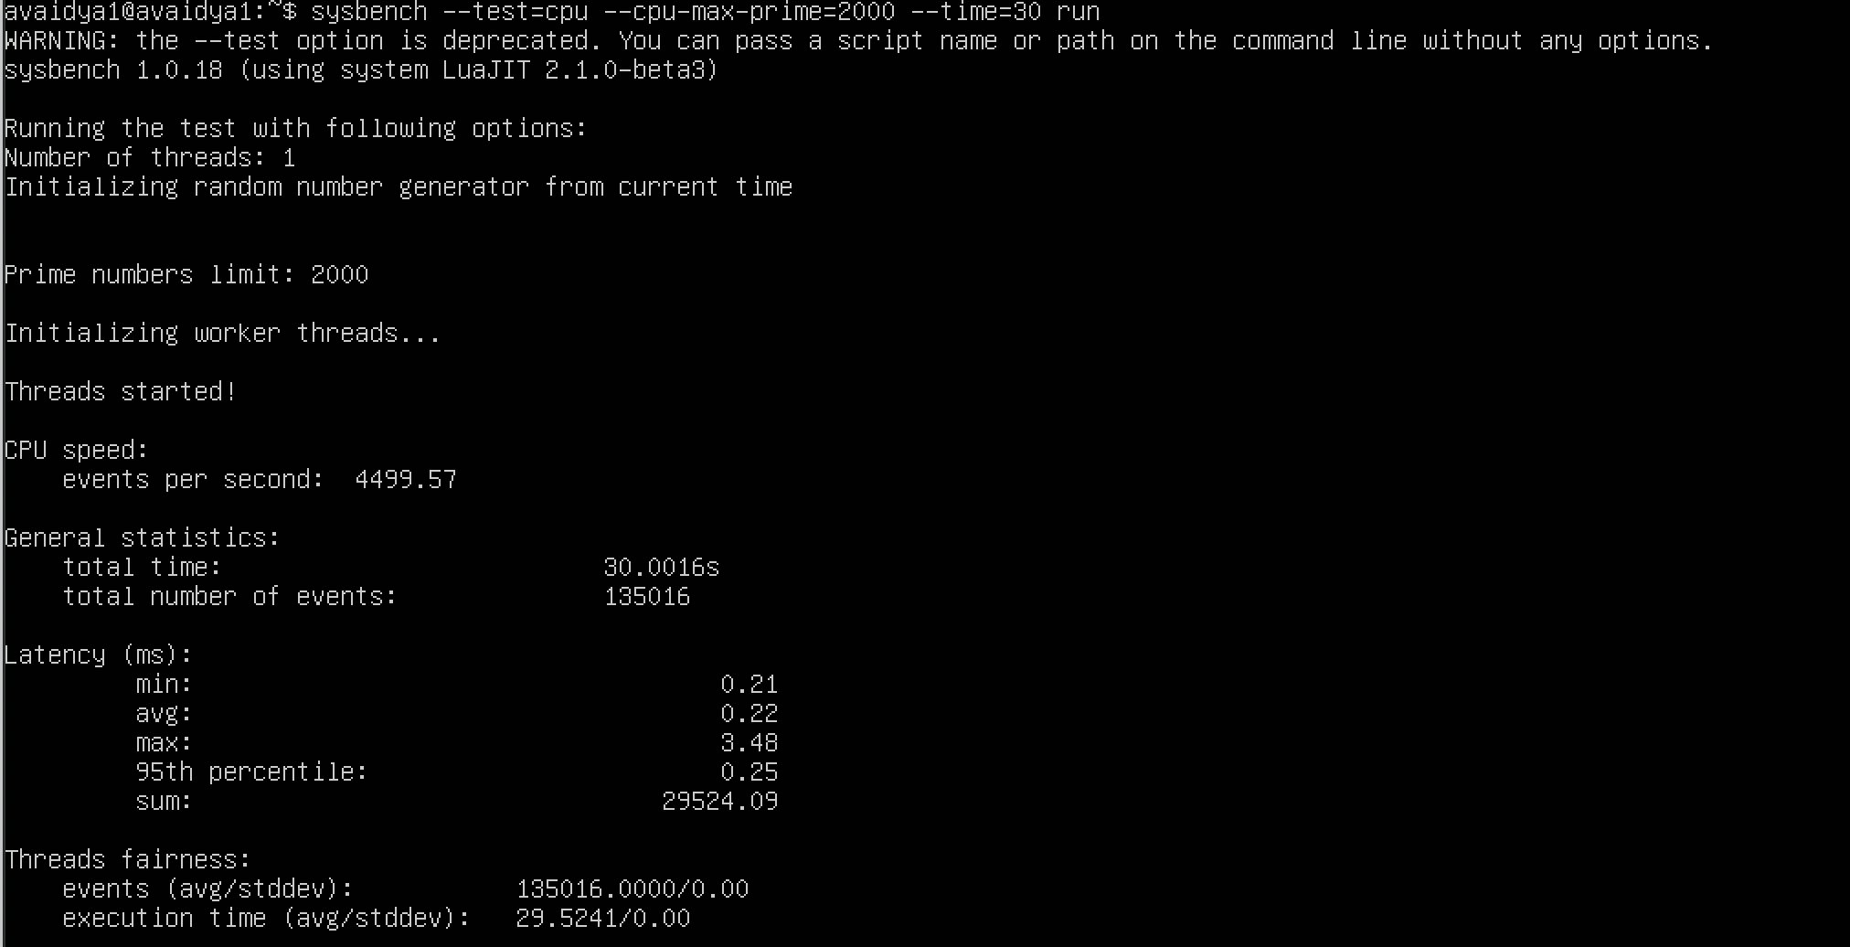

1. Qemu raw format –

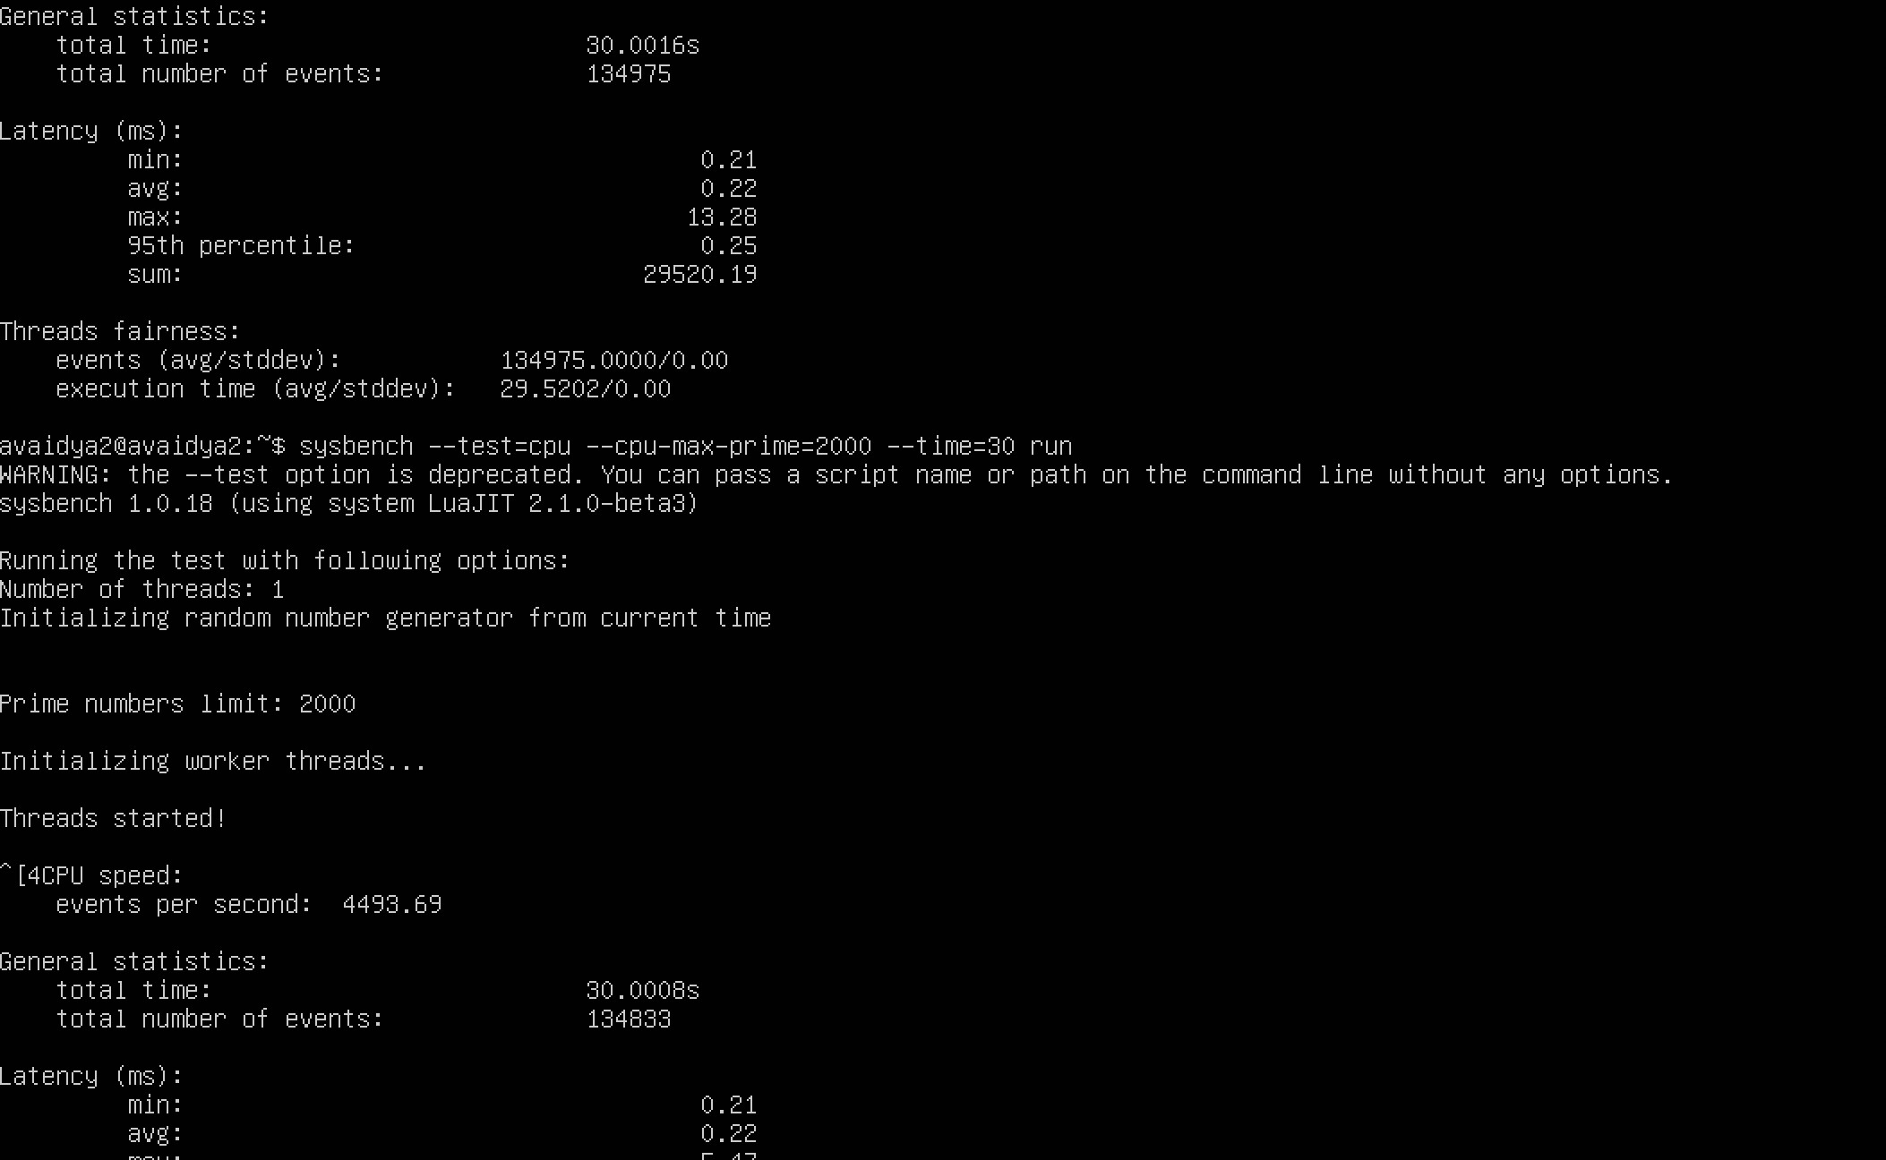

1. Docker –

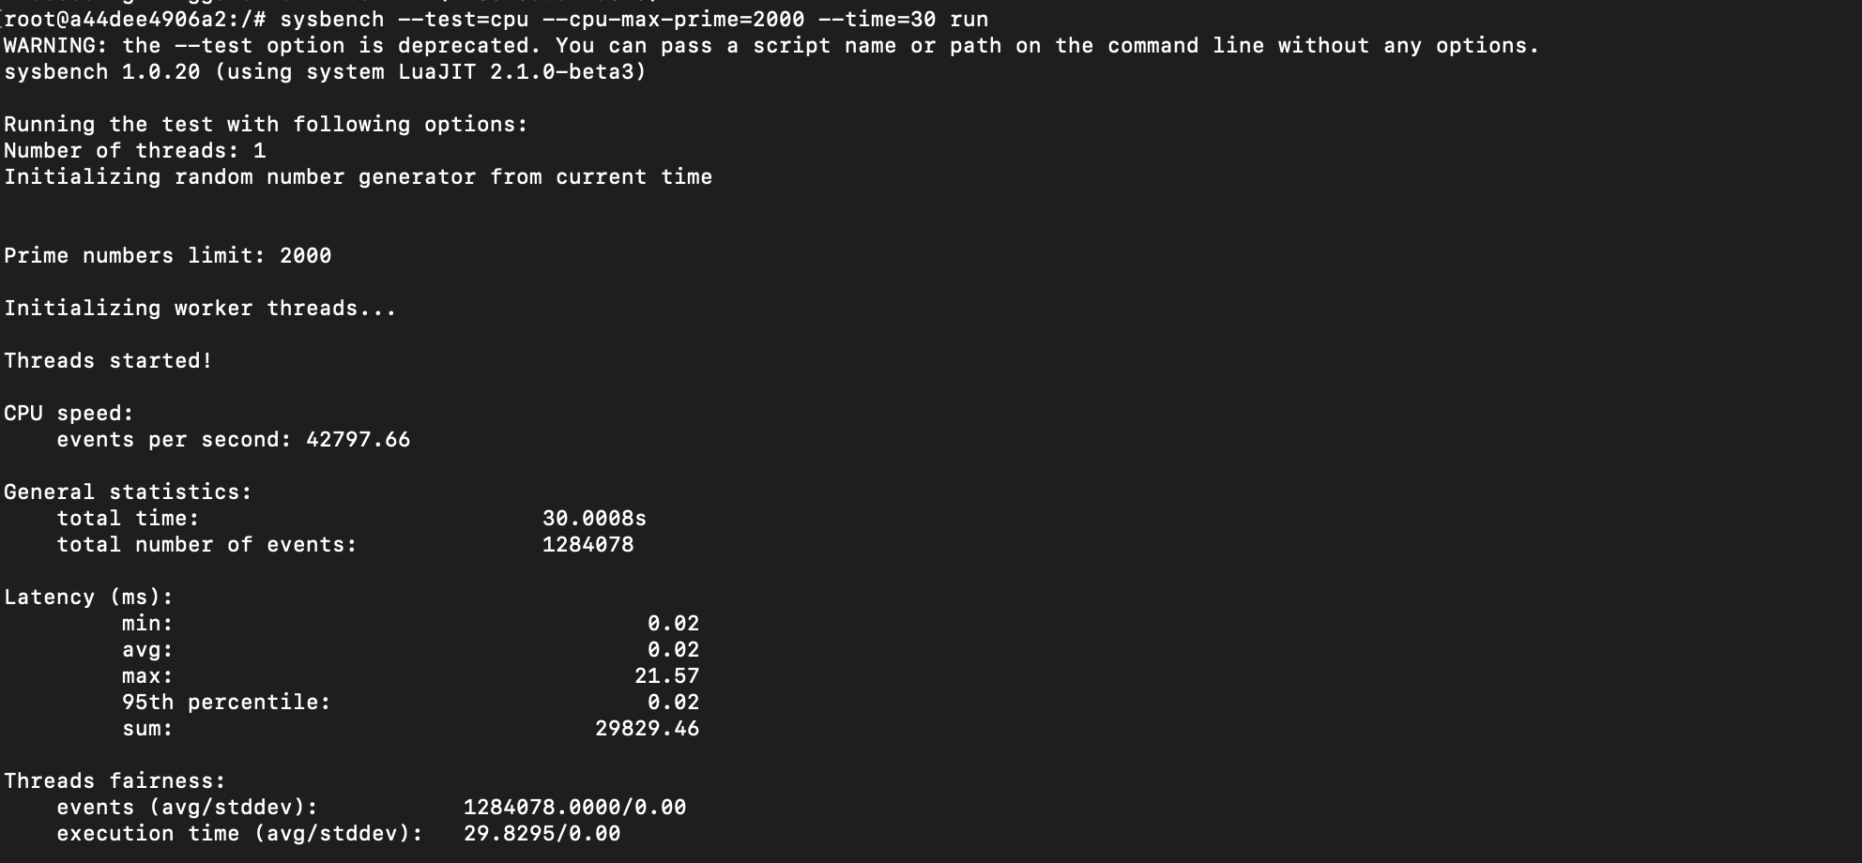

**Test 2 – cpu-max-prime=3000**

1. QEMU qcow2 format –

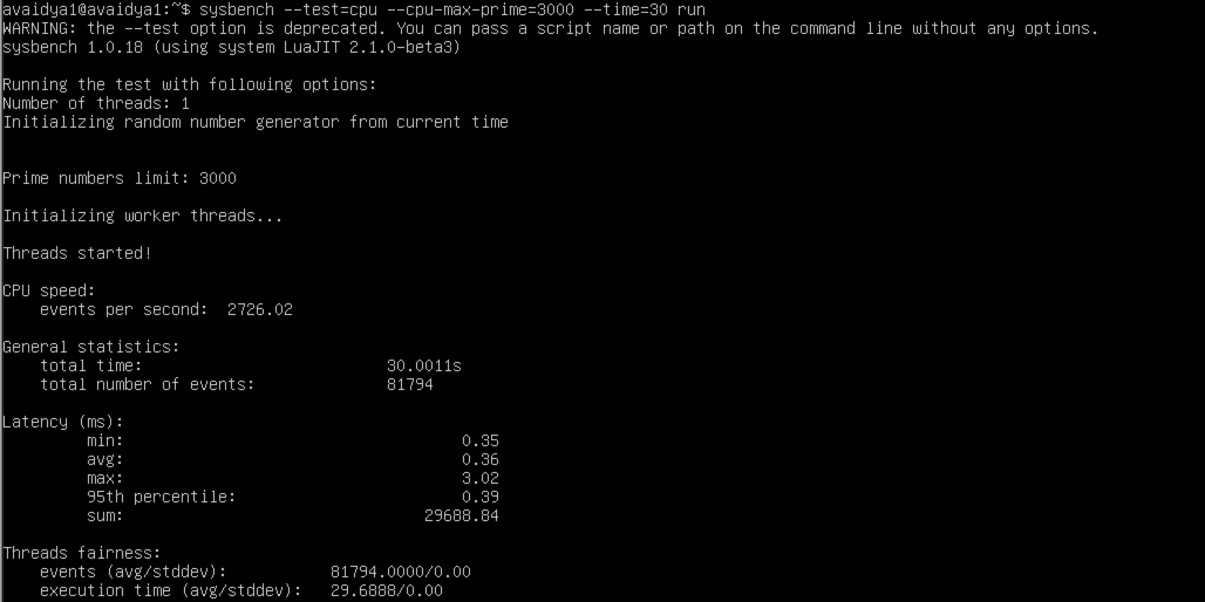

1. QEMU raw format –

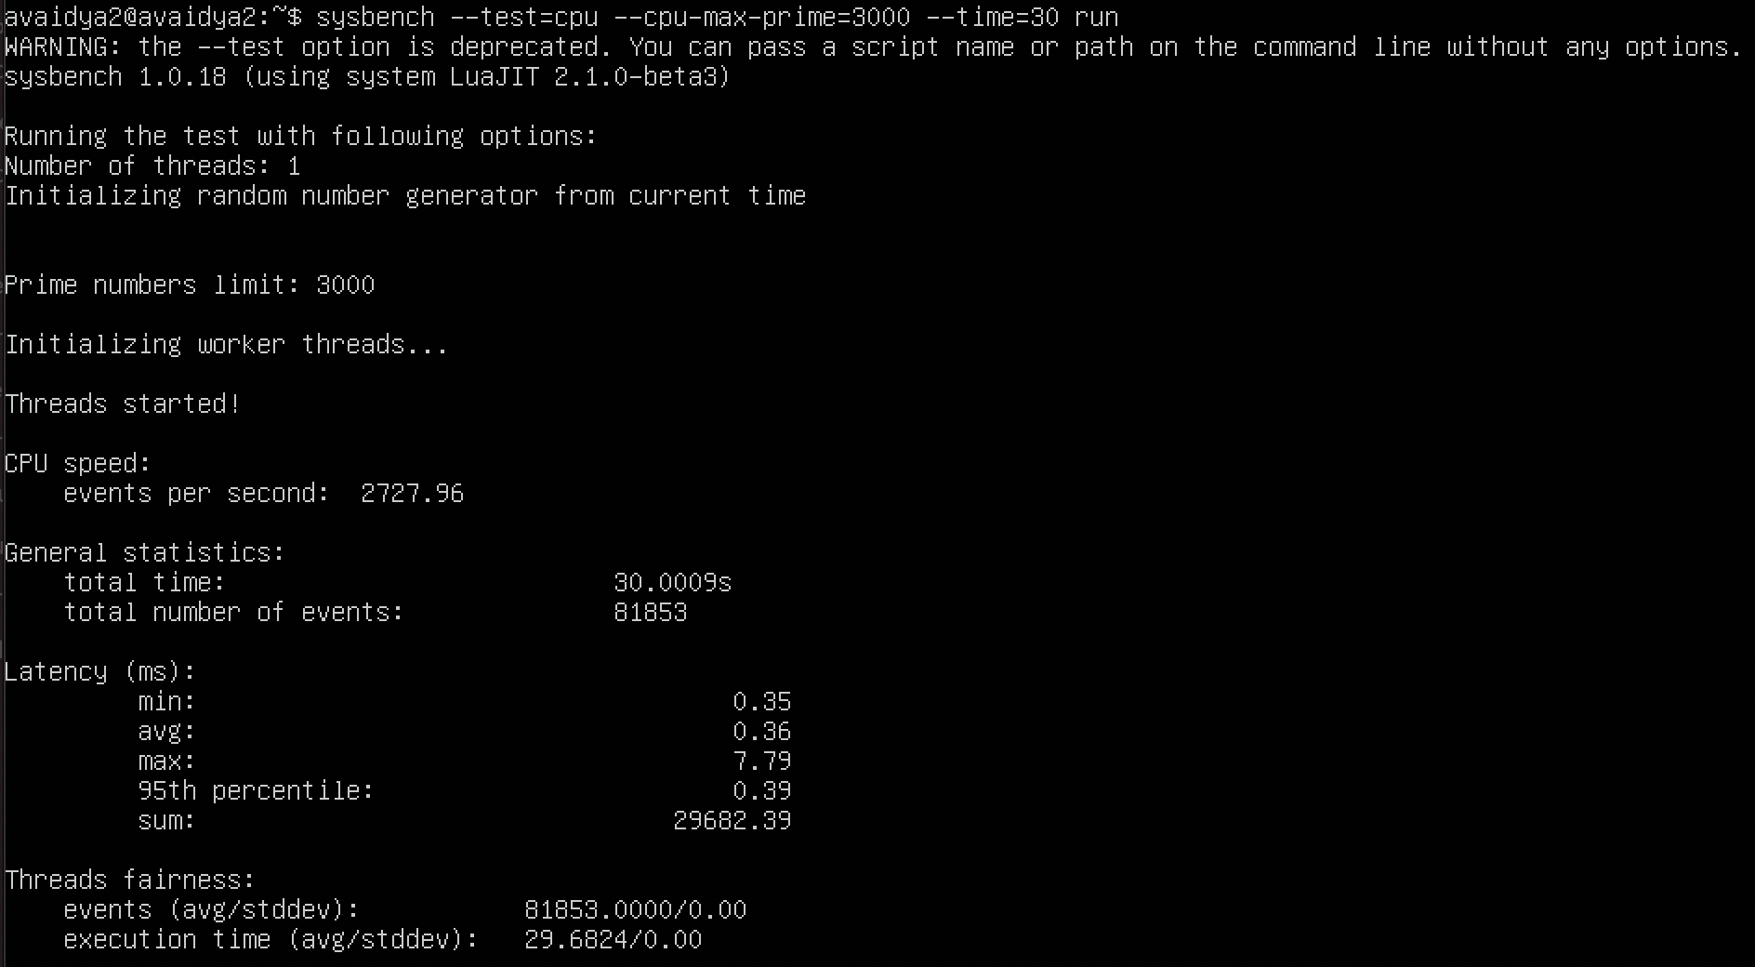

1. Docker –

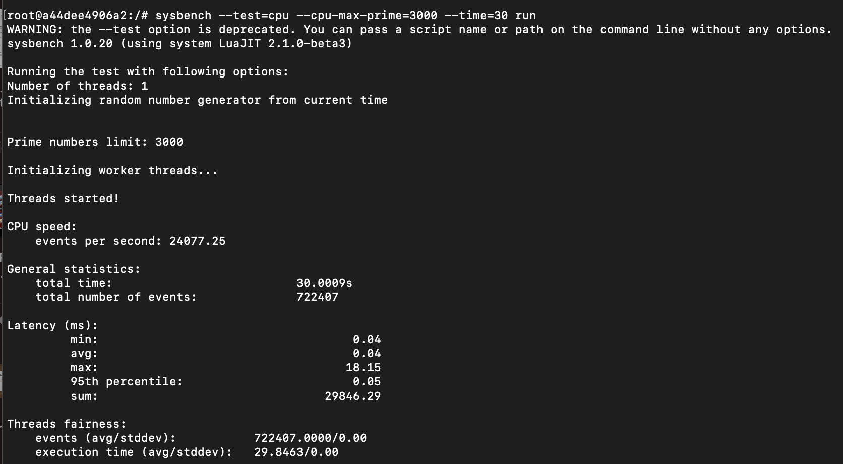

1. **CPU TEST WITH CPU – 3 CORES AND RAM – 2G**

**Test 1 – cpu-max-prime=2000**

1. QEMU qcow2 format –

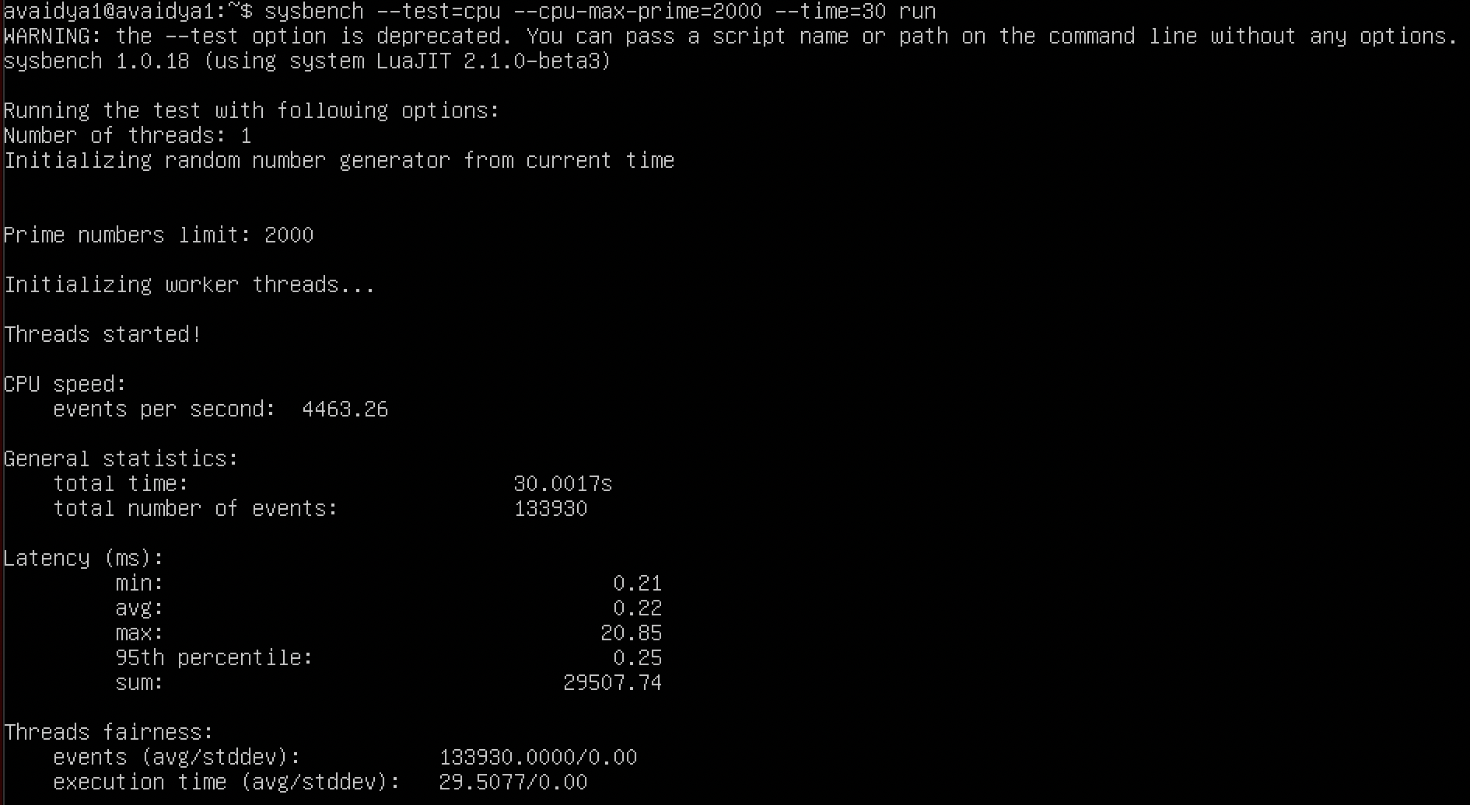

1. QEMU raw format –

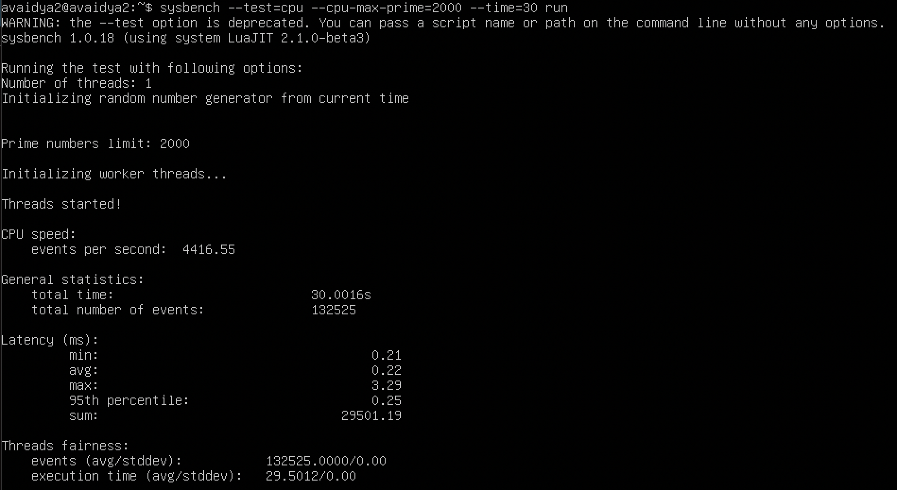

1. Docker –

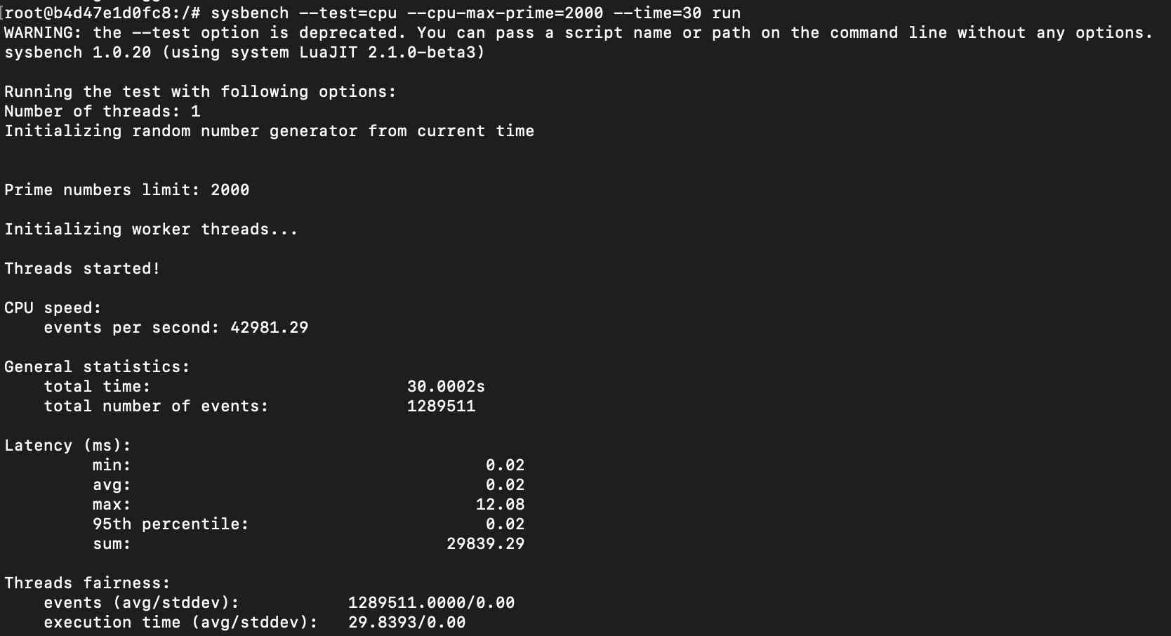

**Test 2 – cpu-max-prime=3000**

1. QEMU qcow2 format –

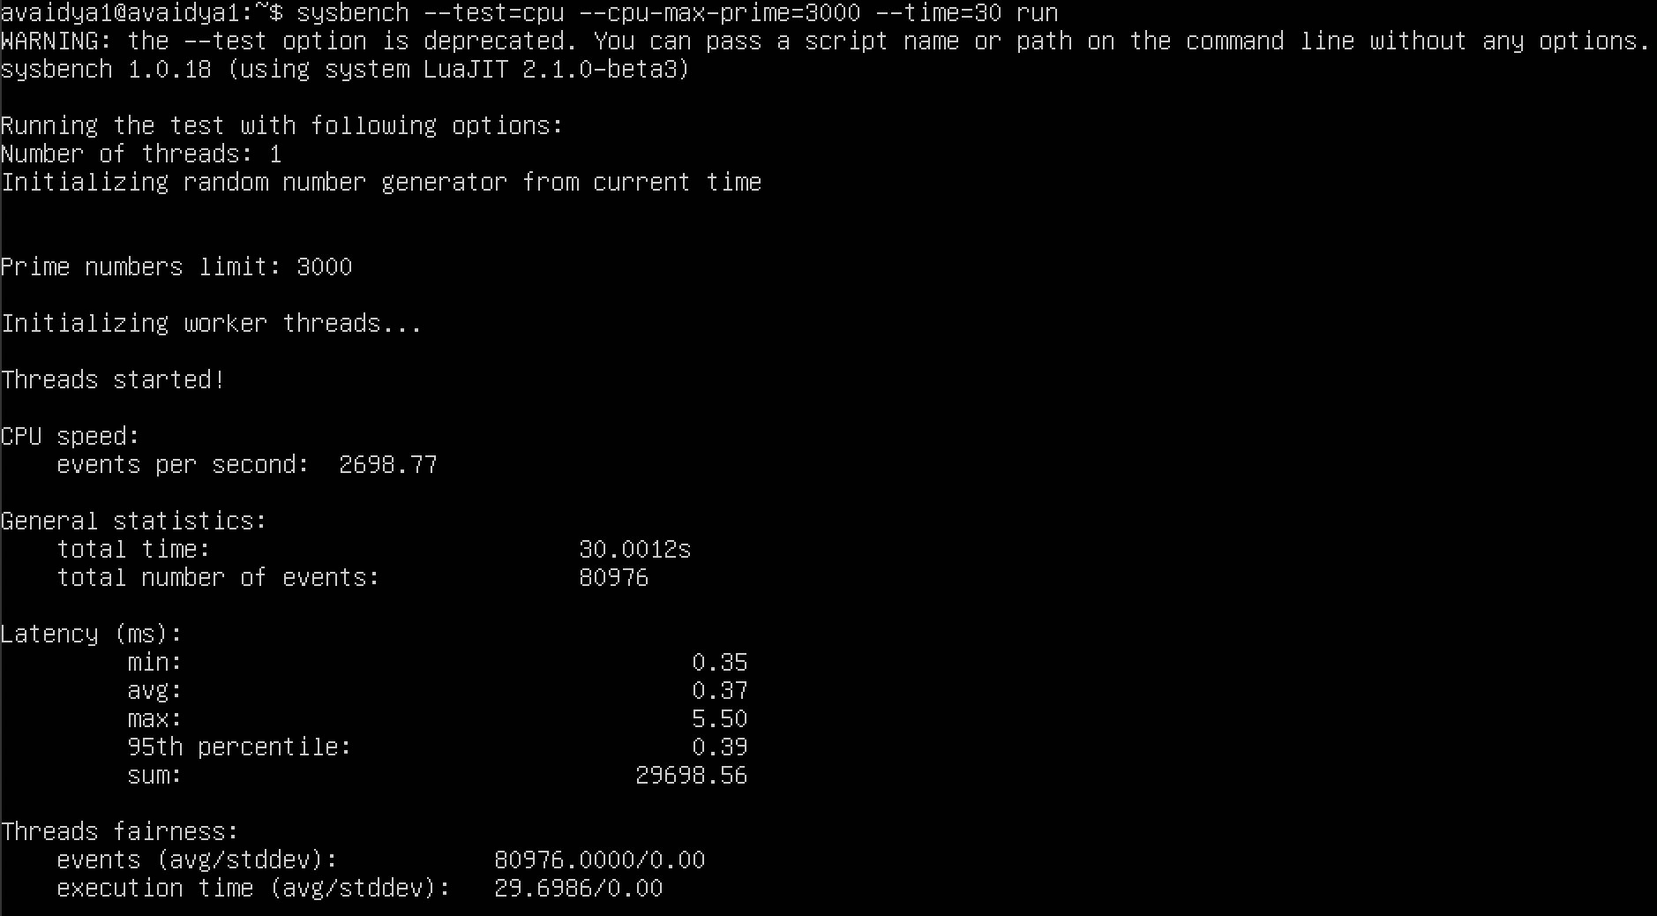

1. QEMU raw format –

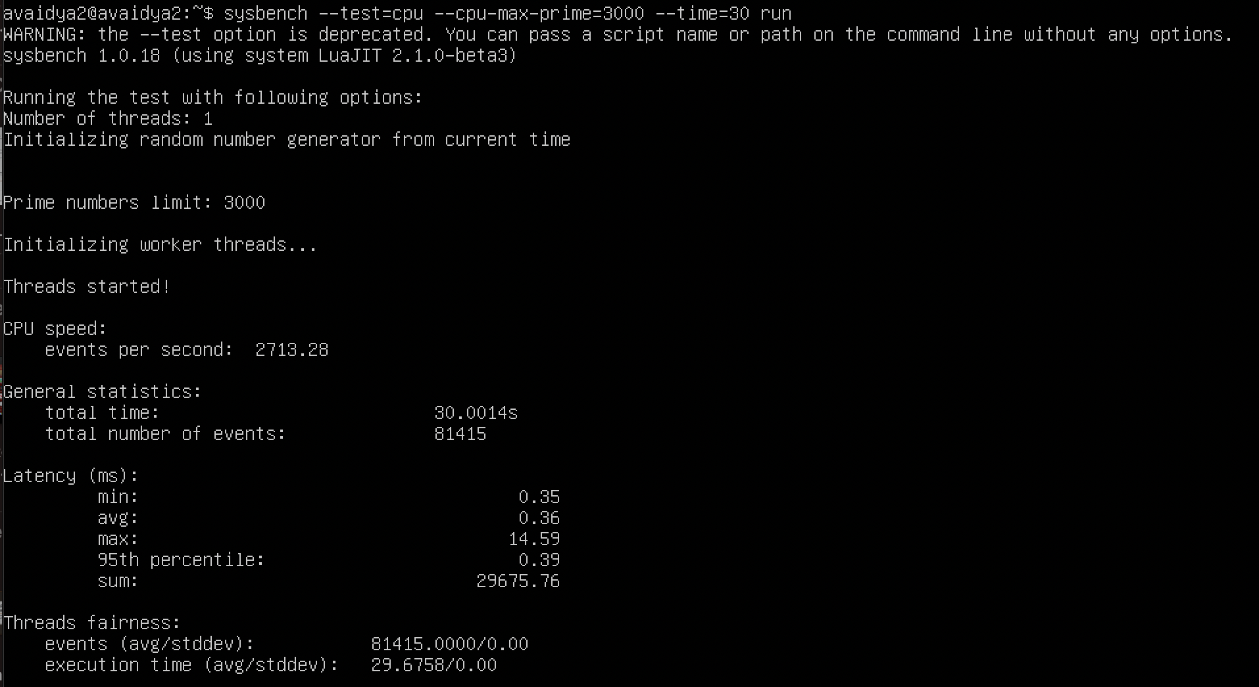

1. Docker –

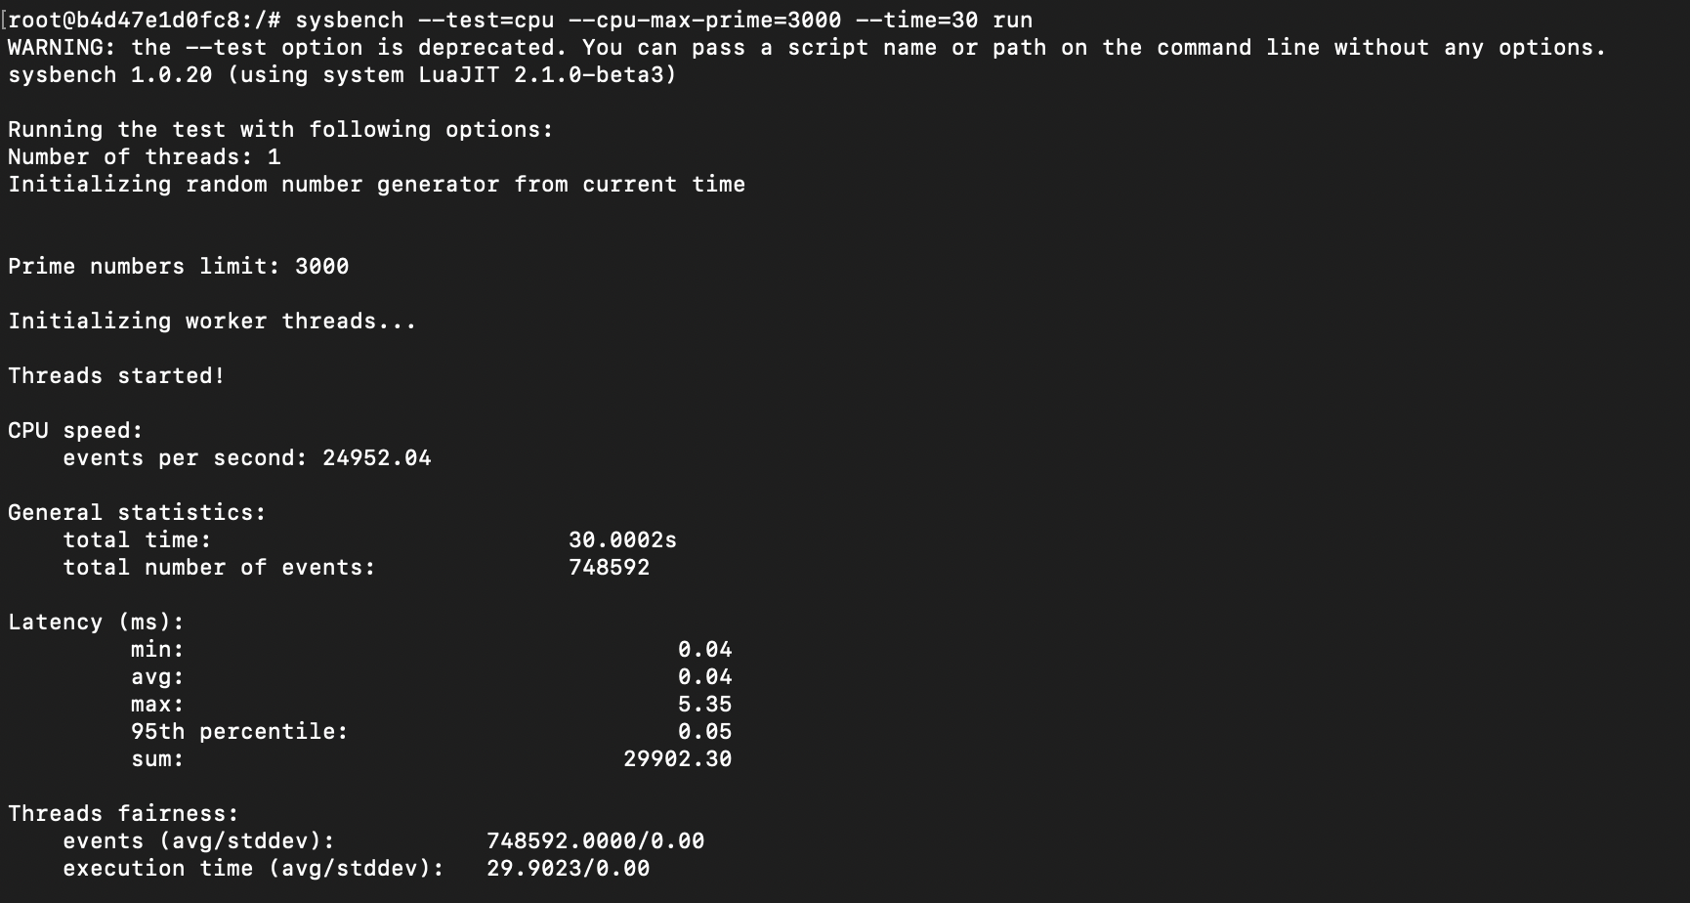

1. **CPU TEST WITH CPU – 2 CORES AND RAM – 2G**

**Test 1 – cpu-max-prime=2000**

1. QEMU qcow2 format –

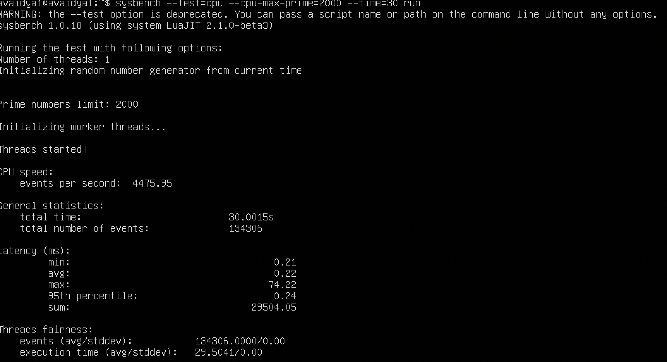

1. QEMU raw format –

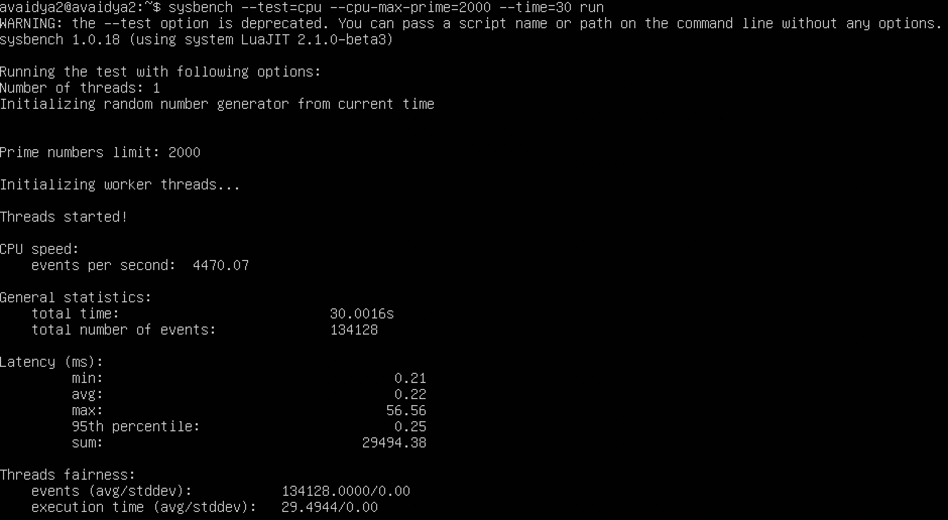

1. Docker –

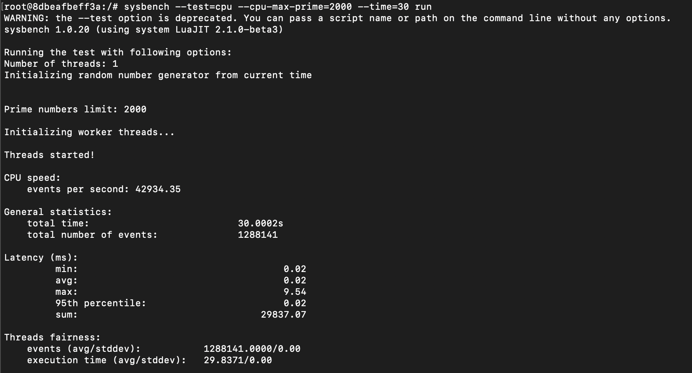

Test 2 – cpu-max-prime=3000

1. QEMU qcow2 format –

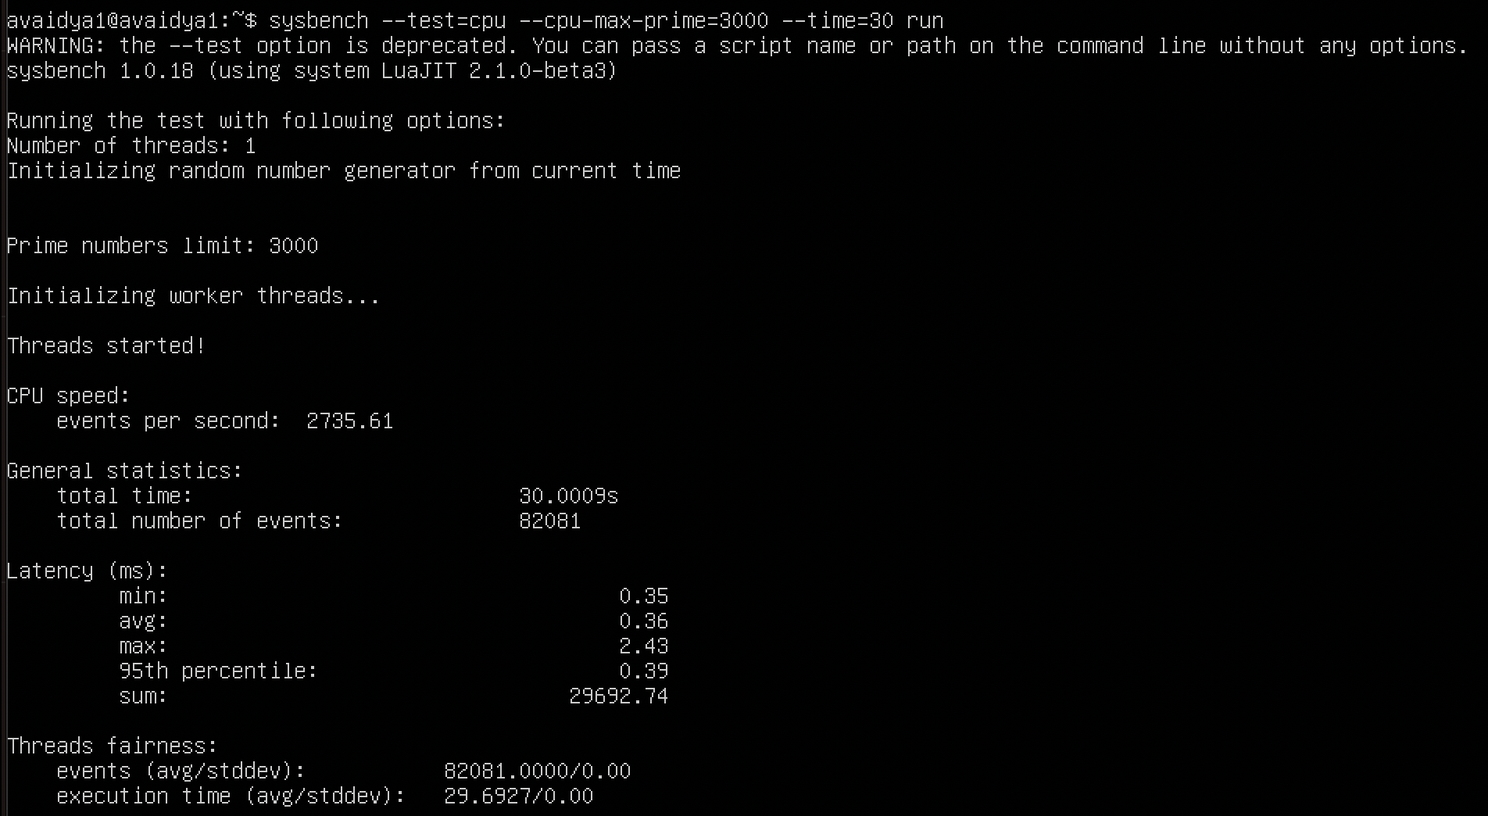

1. QEMU raw format –

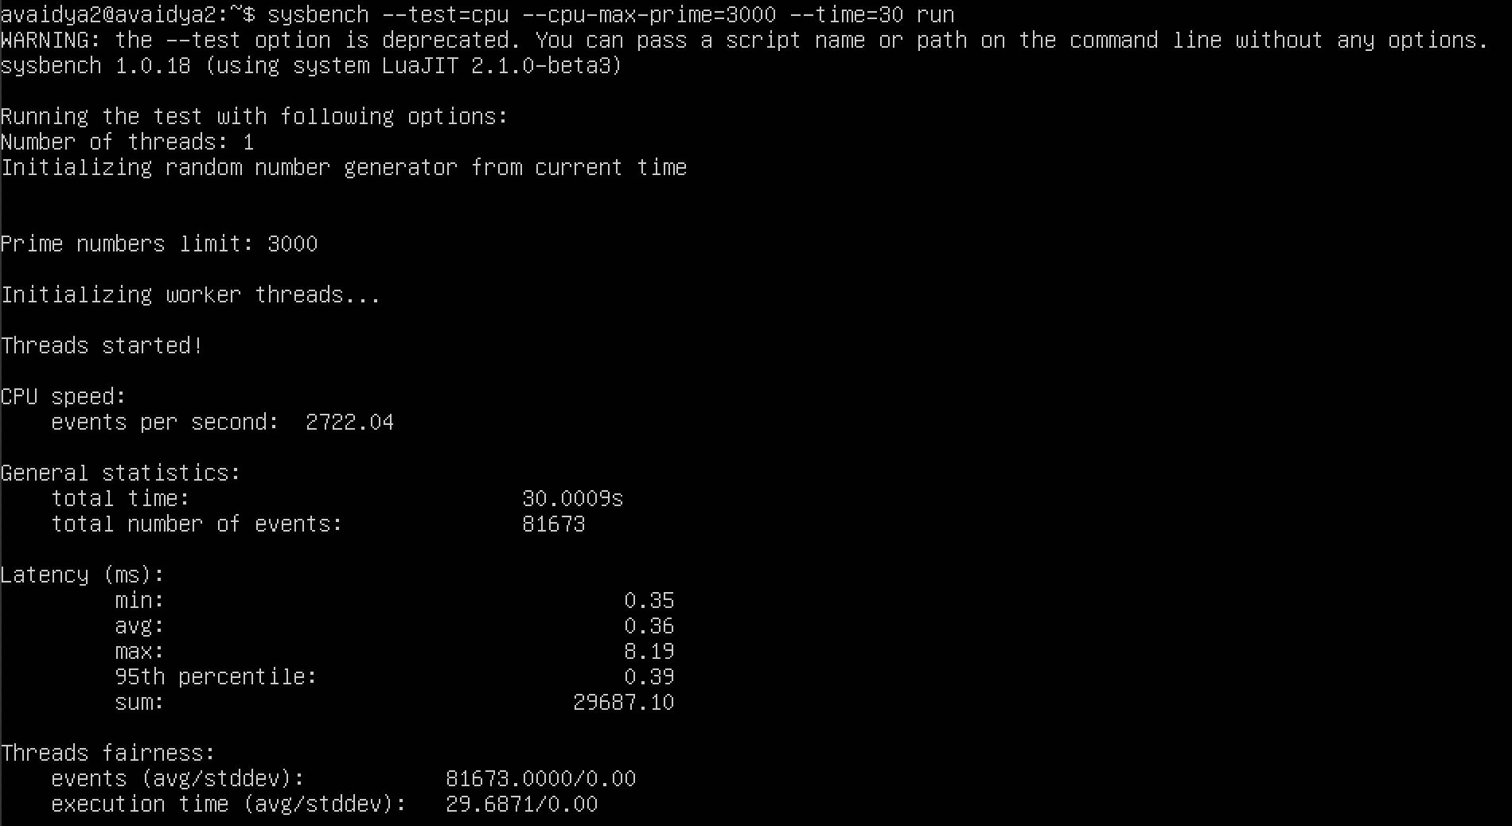

1. Docker –

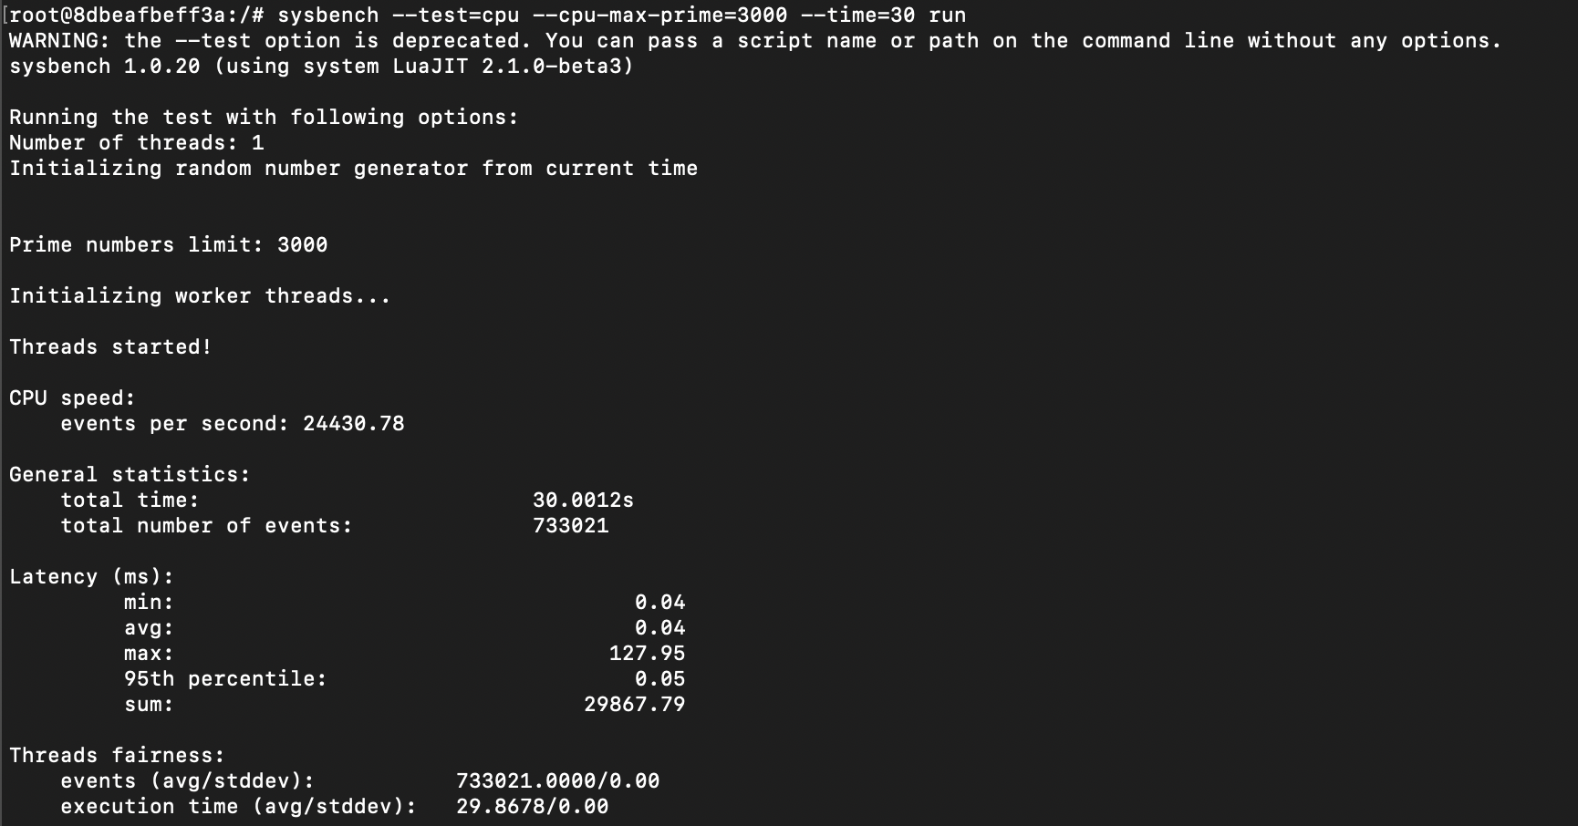

1. **CPU TEST WITH CPU – 3 CORES AND RAM – 4G**

**Test 1 – cpu-max-prime=2000**

1. **QEMU qcow2 format –**

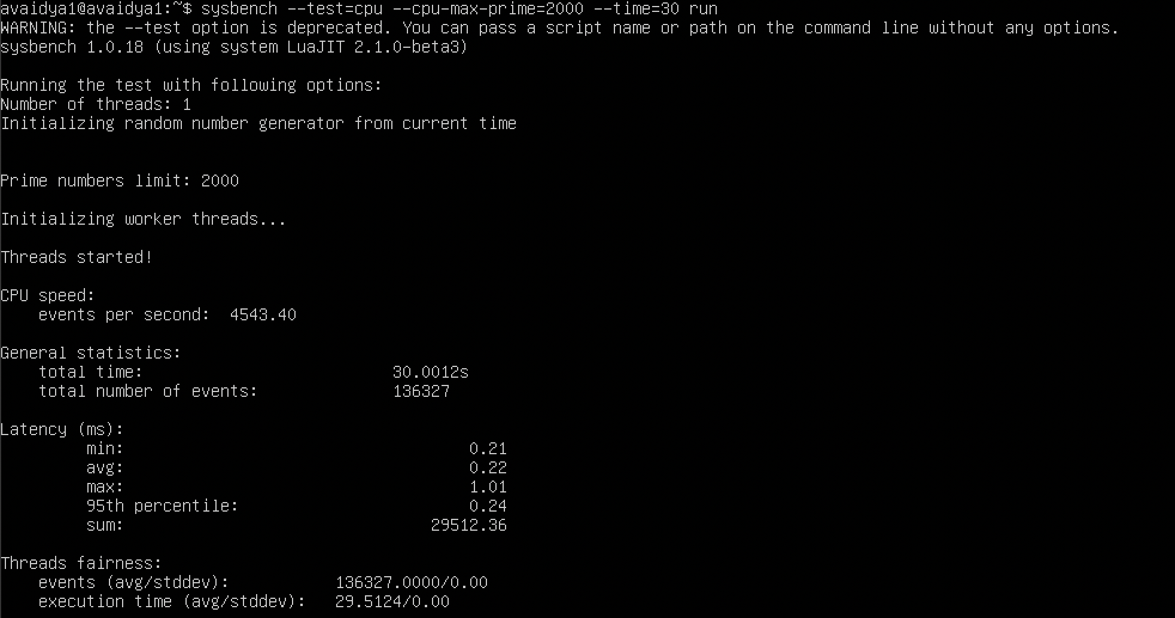

1. QEMU raw format –

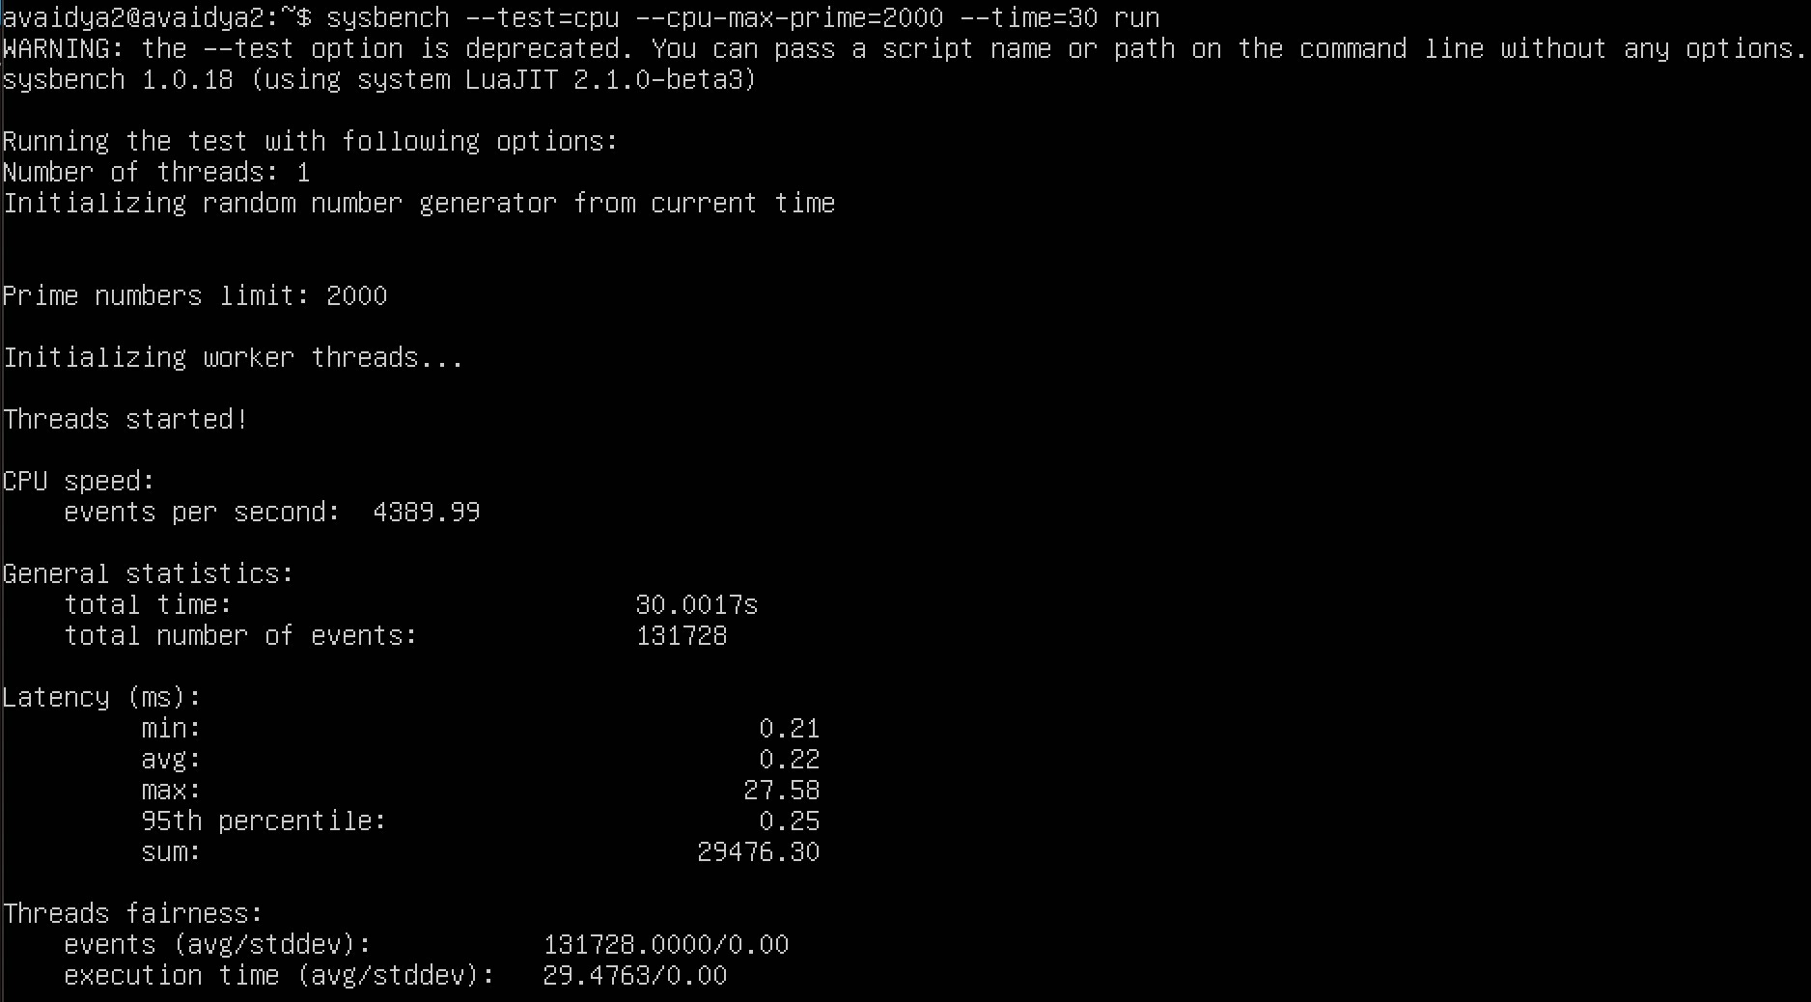

1. Docker –

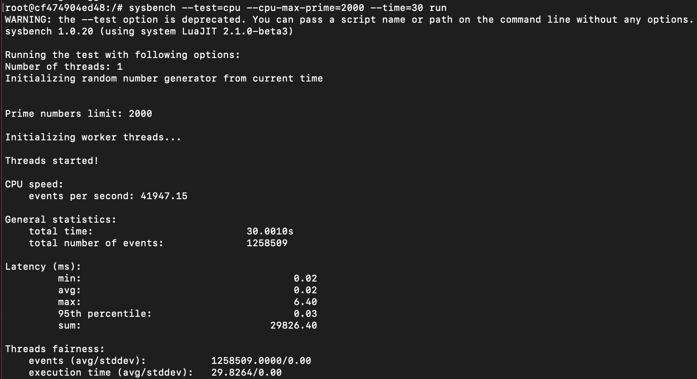

**Test 2 – cpu-max-prime=3000**

1. QEMU qcow2 format –

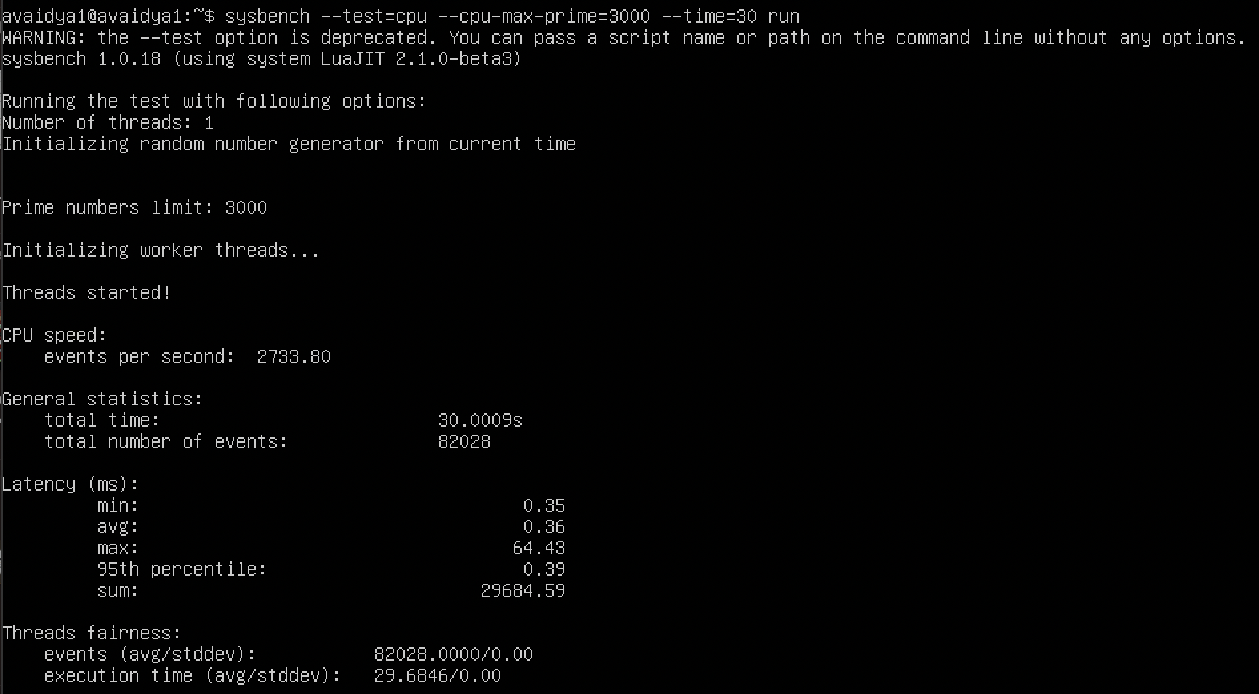

1. QEMU raw format –

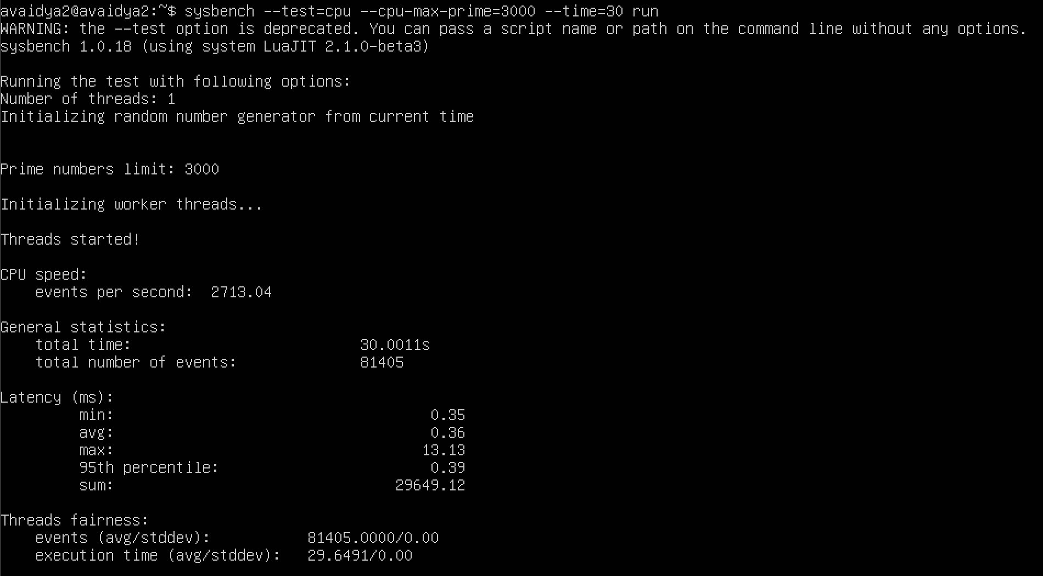

1. Docker –

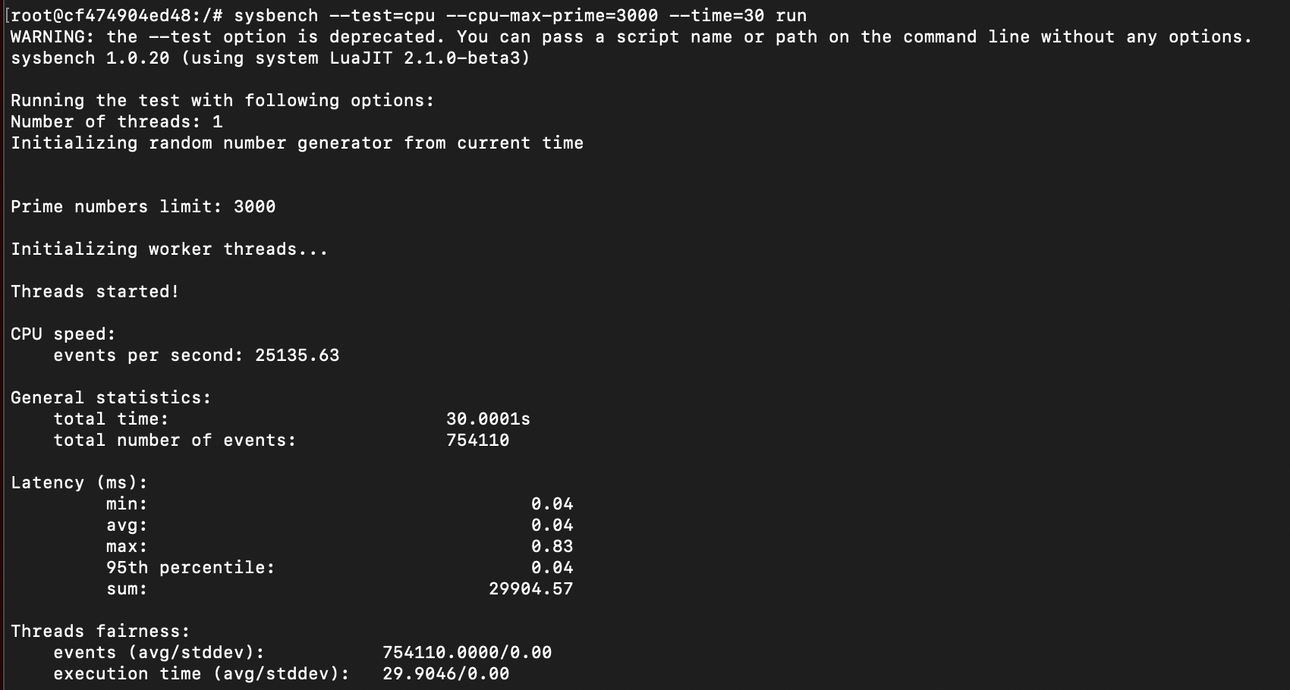

**MEMORY TEST**

1. **MEMORY TEST WITH CPU – 2 CORES AND RAM – 4 G**

**Test 1 – memory-block-size=1G**

1. QEMU qcow2 format –

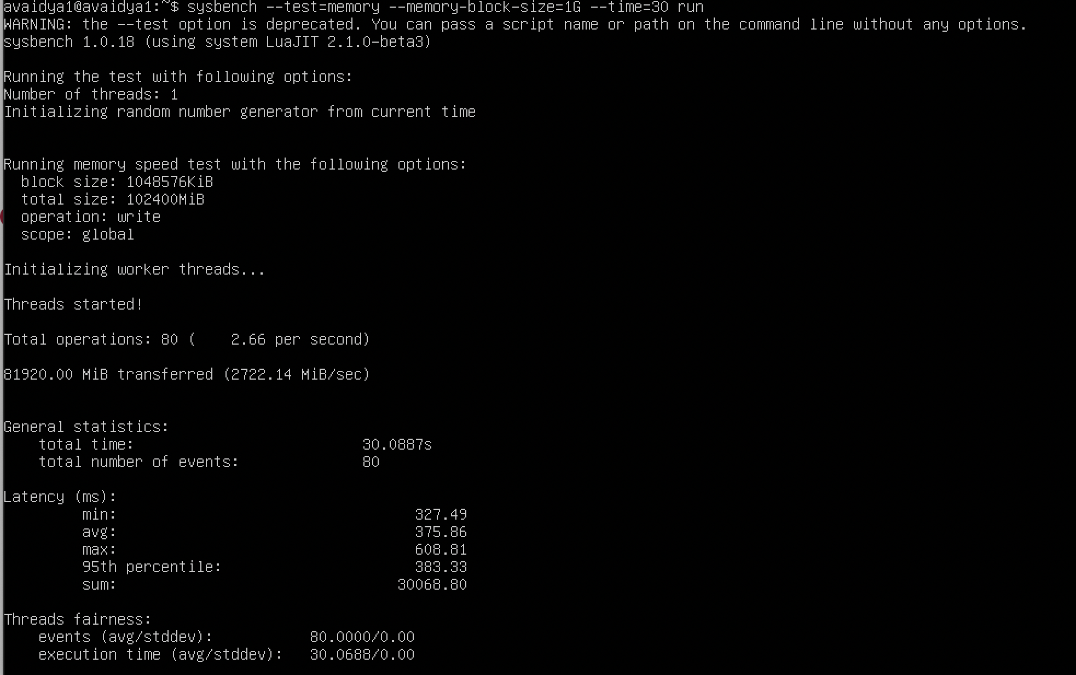

1. QEMU raw format –

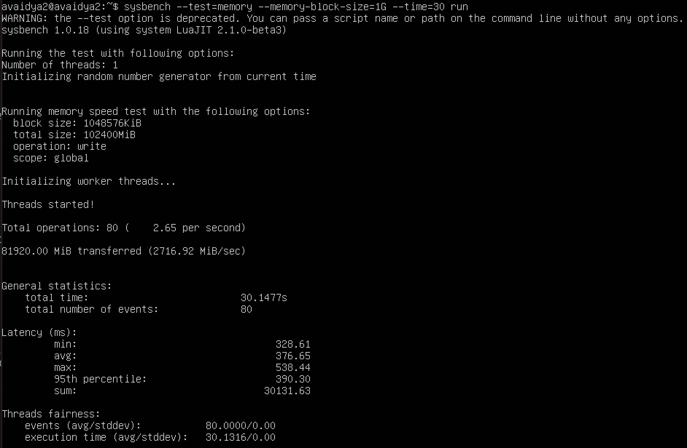

1. Docker –

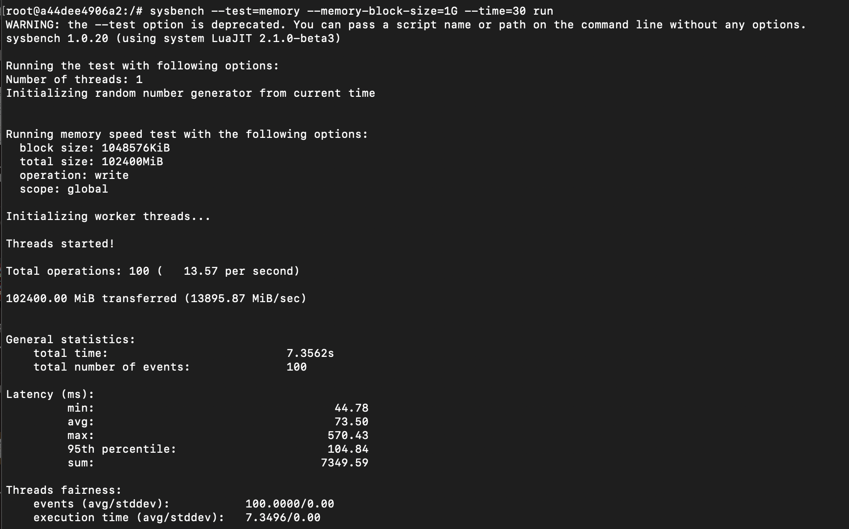

**Test 2 – memory-block-size=2G**

1. QEMU qcow2 format –

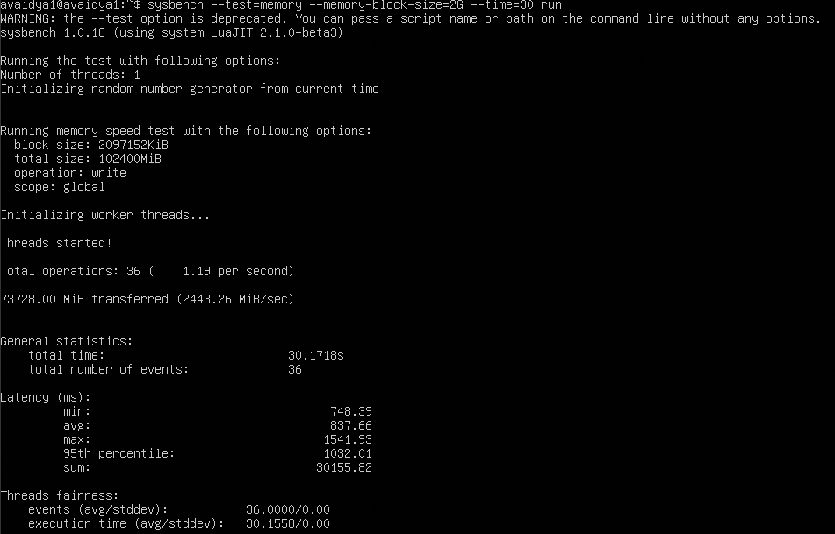

1. QEMU raw format –

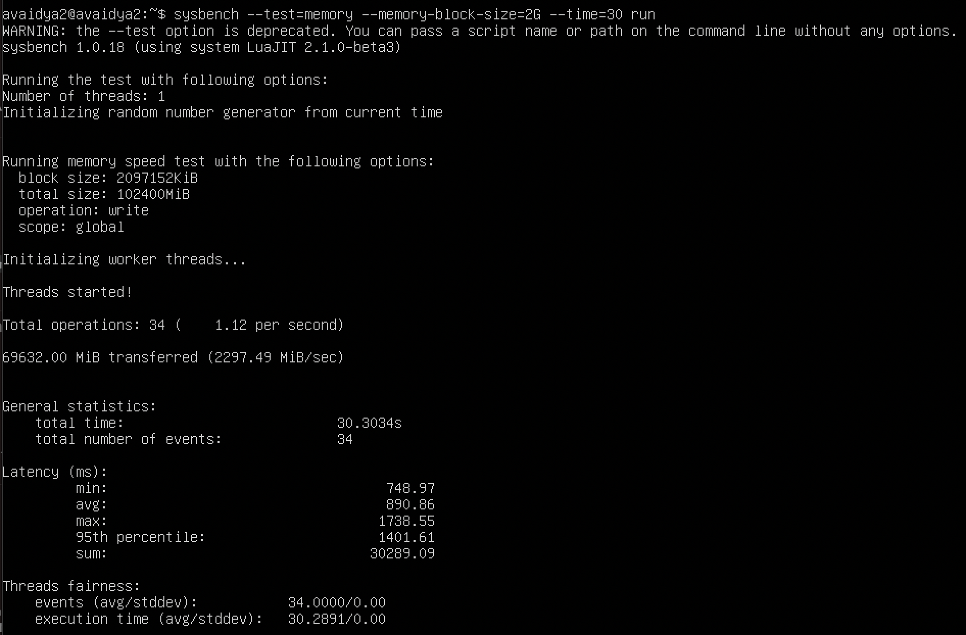

1. Docker –

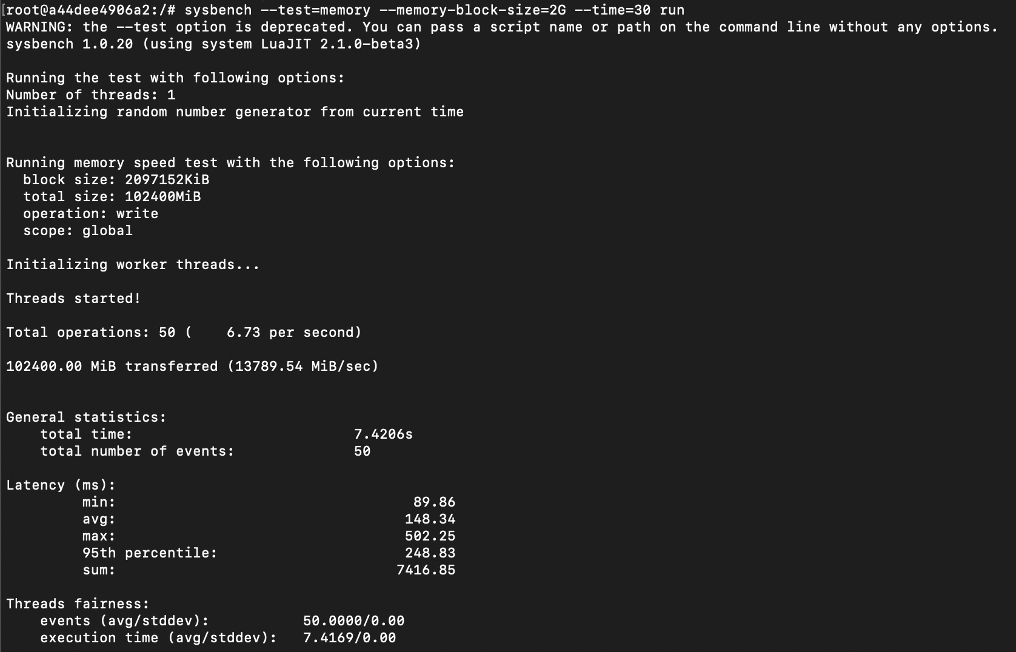

1. **MEMORY TEST WITH CPU – 3 CORES AND RAM – 2G**

**Test 1 – memory-block-size=1G**

1. QEMU qcow2 format –

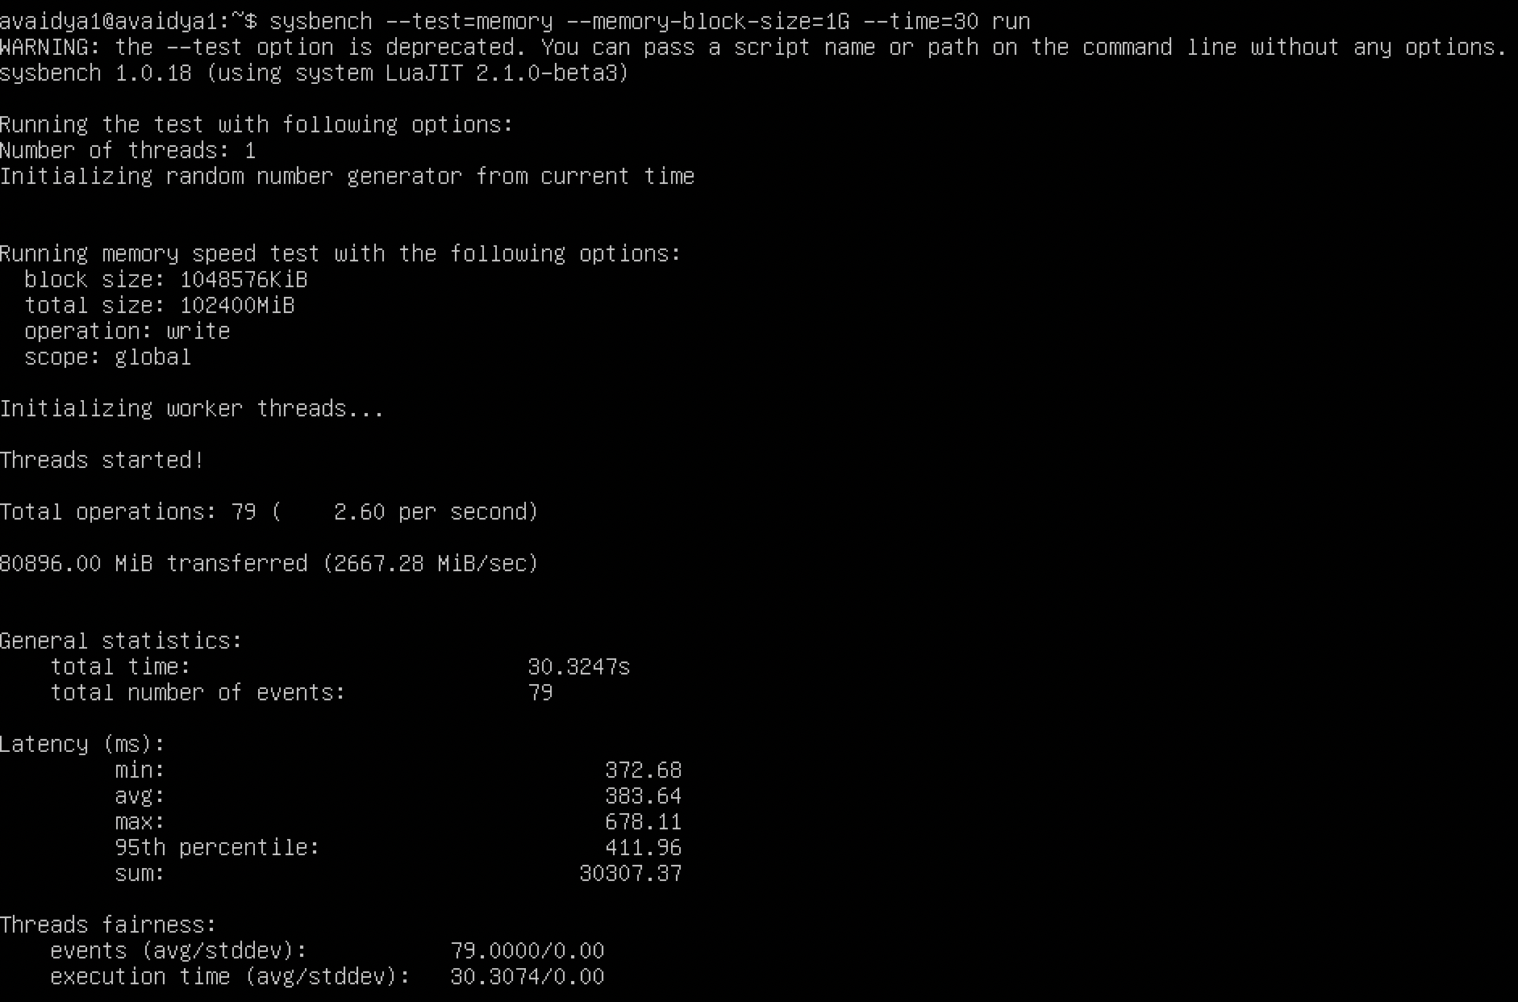

1. QEMU raw format –

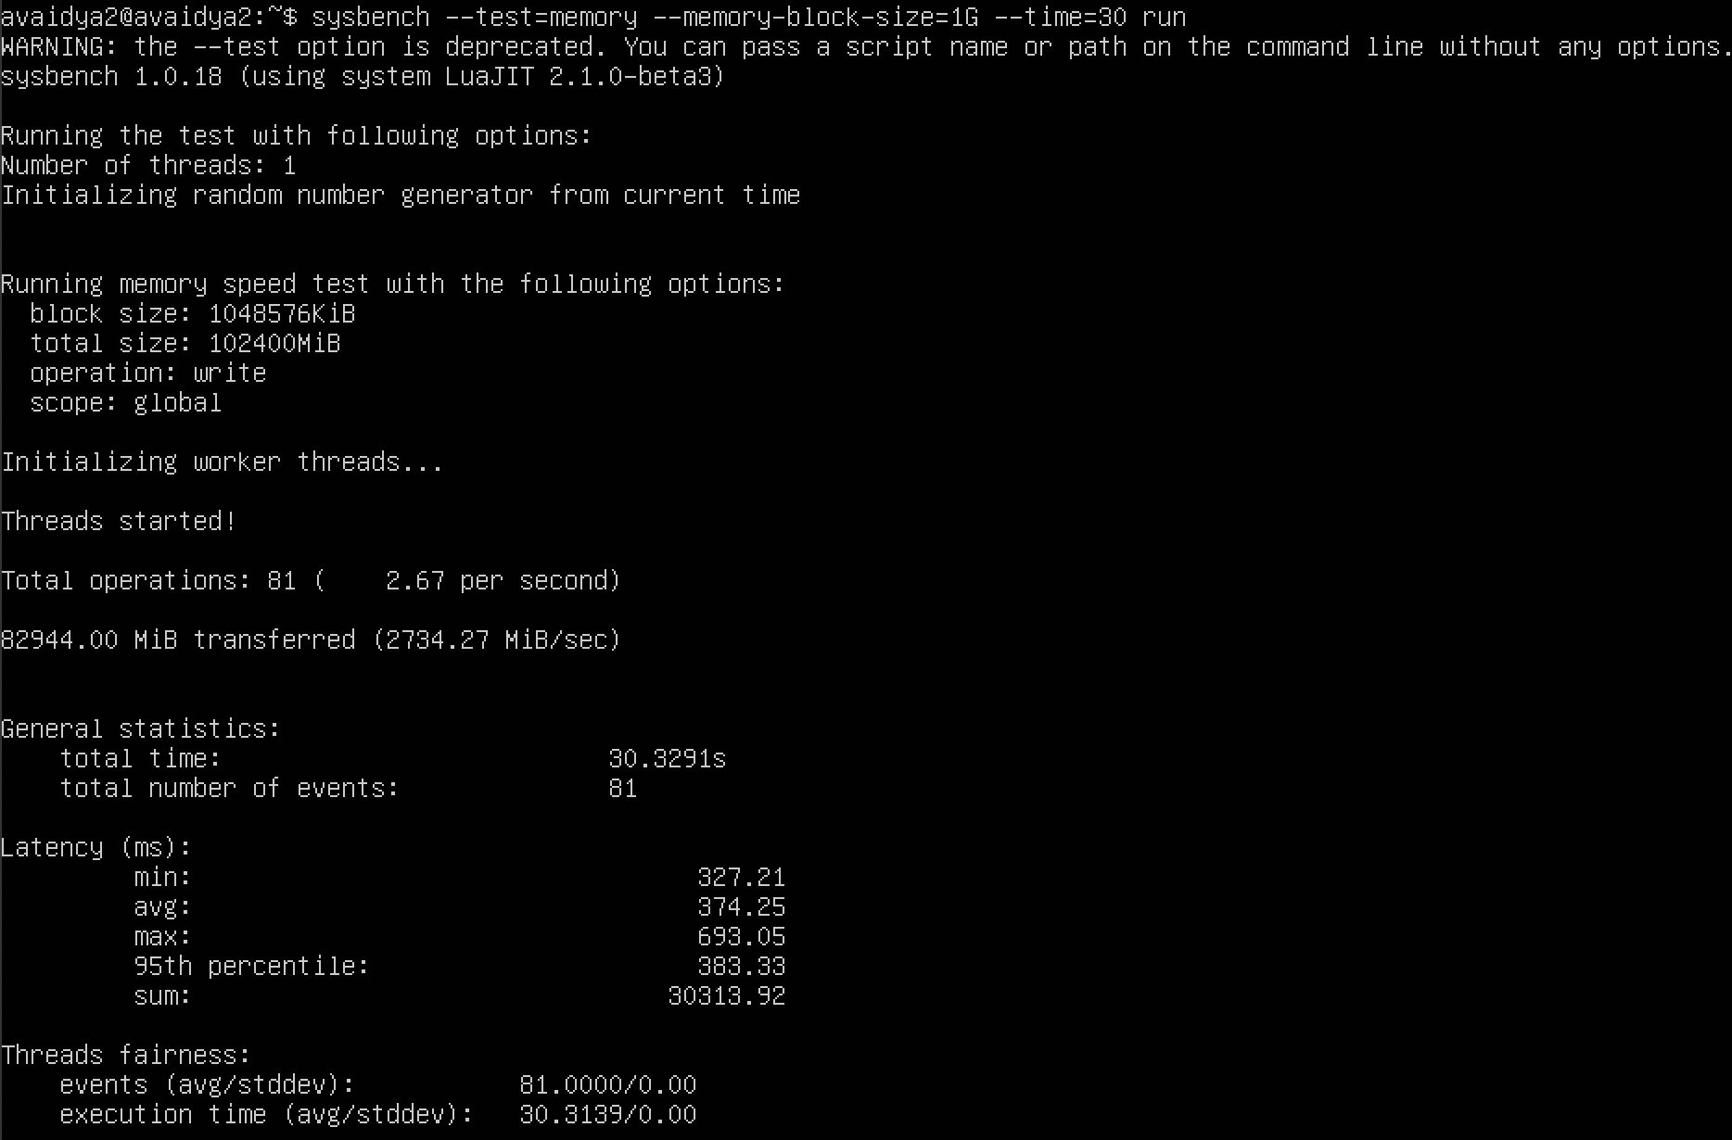

1. Docker –

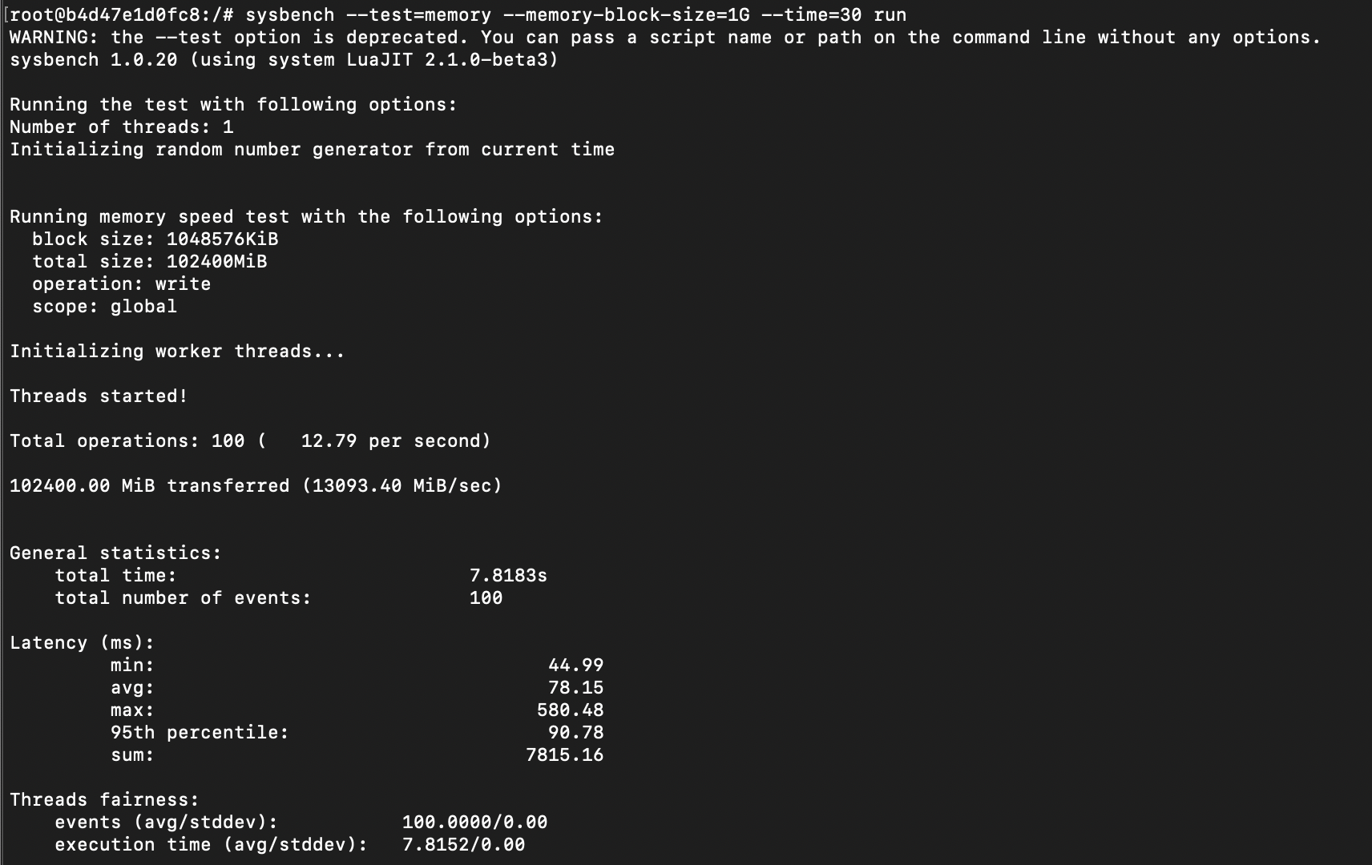

**Test 2 – memory-block-size=2G**

1. QEMU qcow2 format –

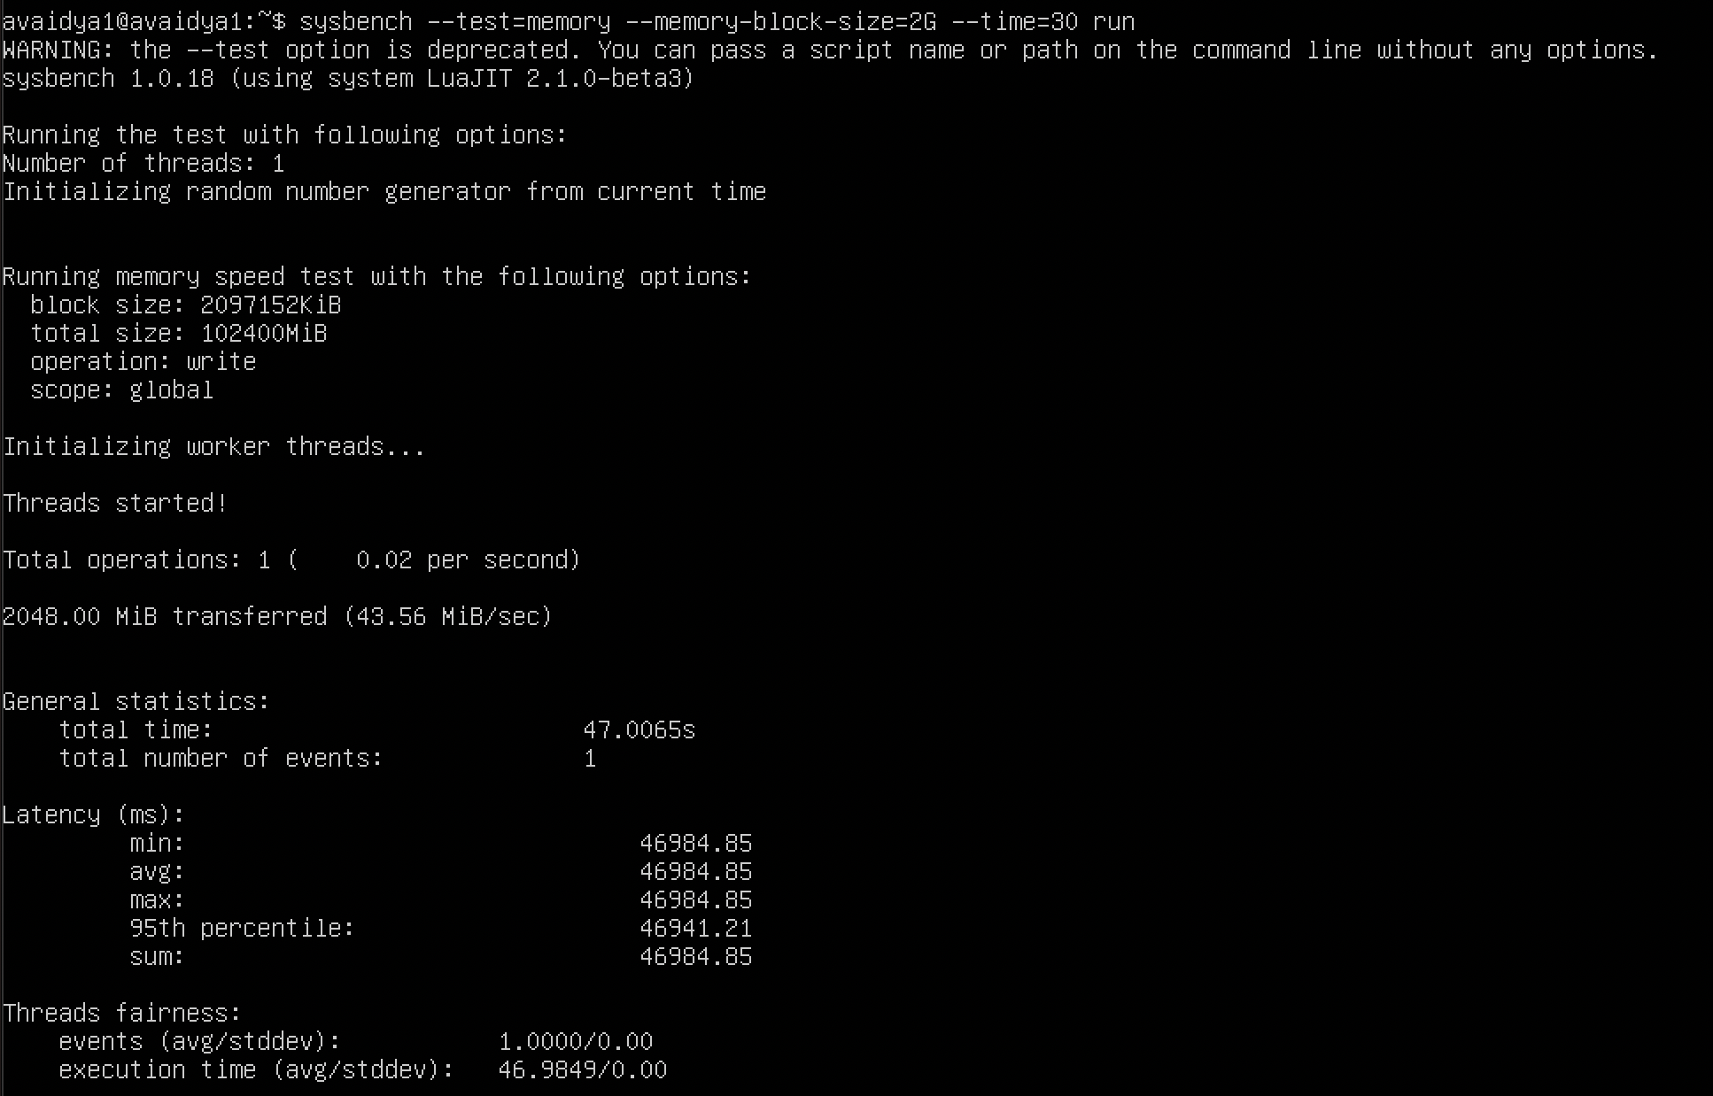

1. QEMU raw format –

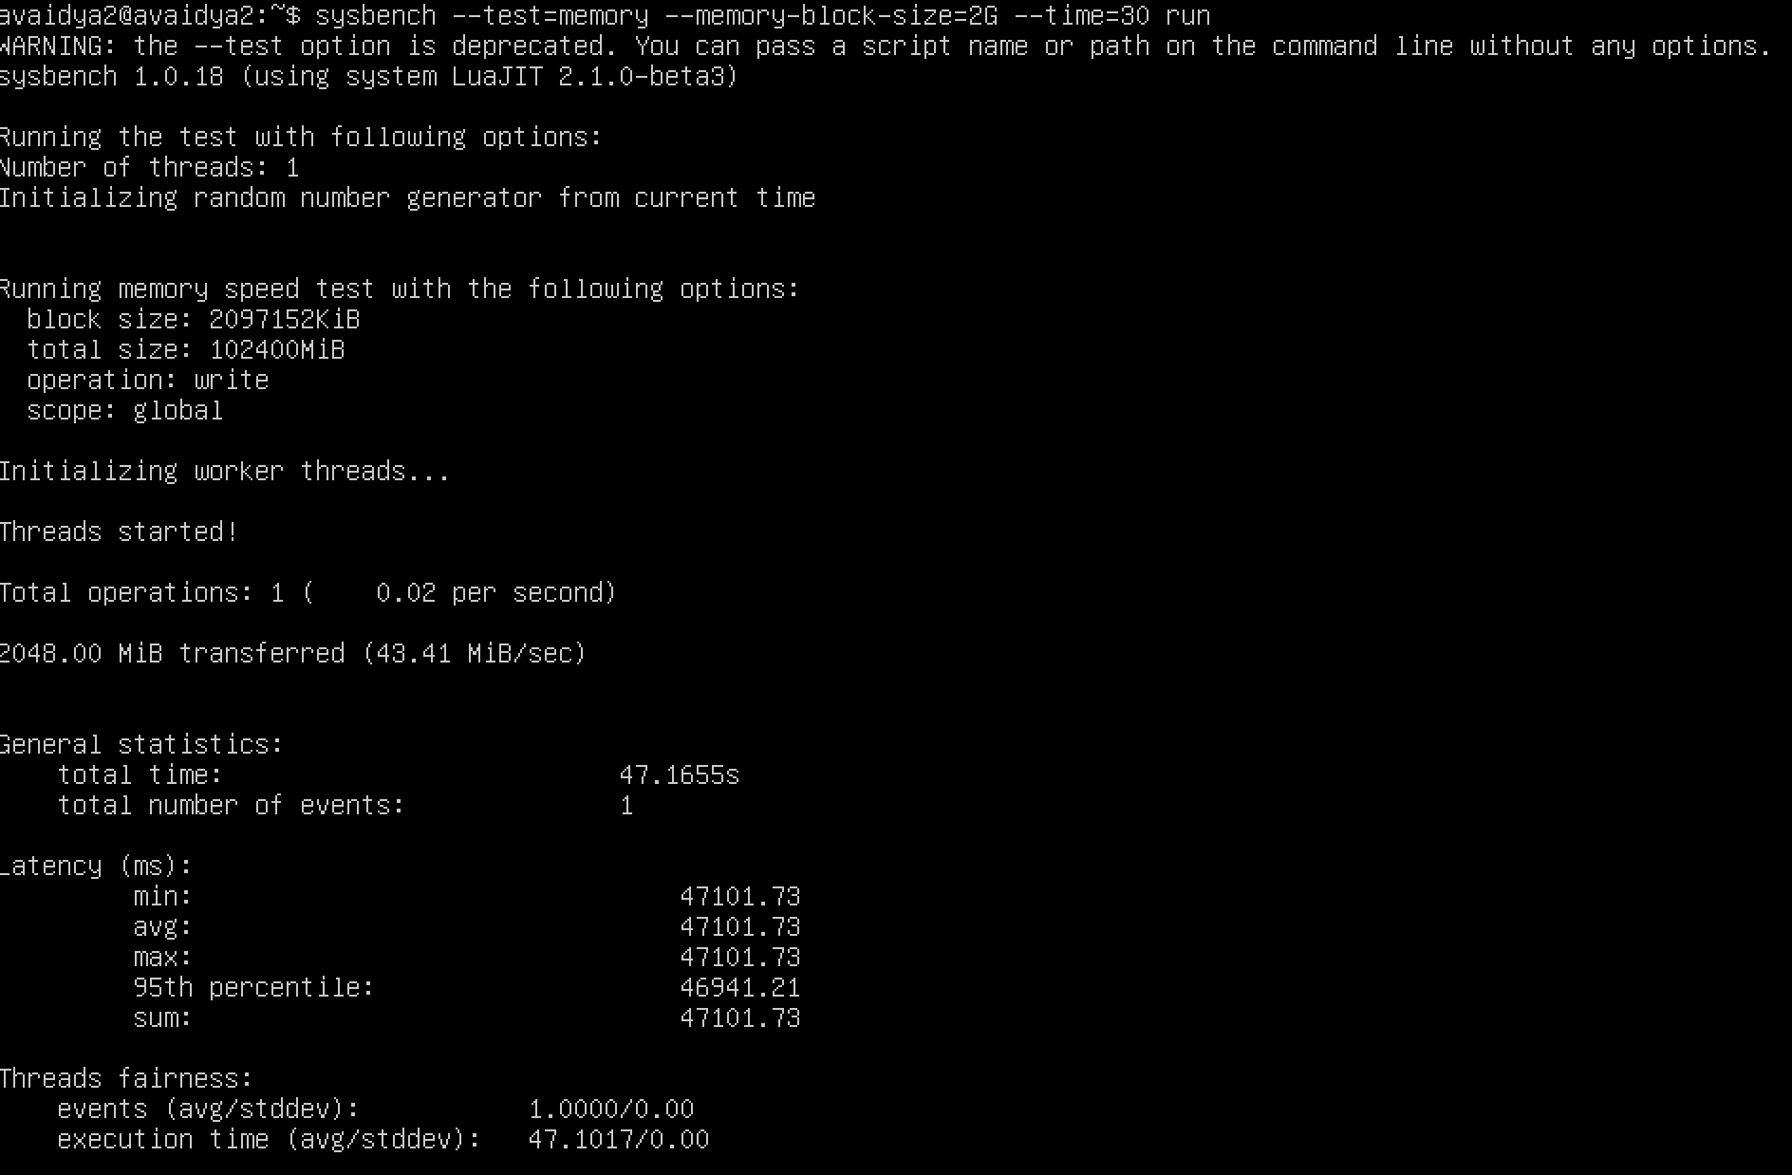

1. Docker –

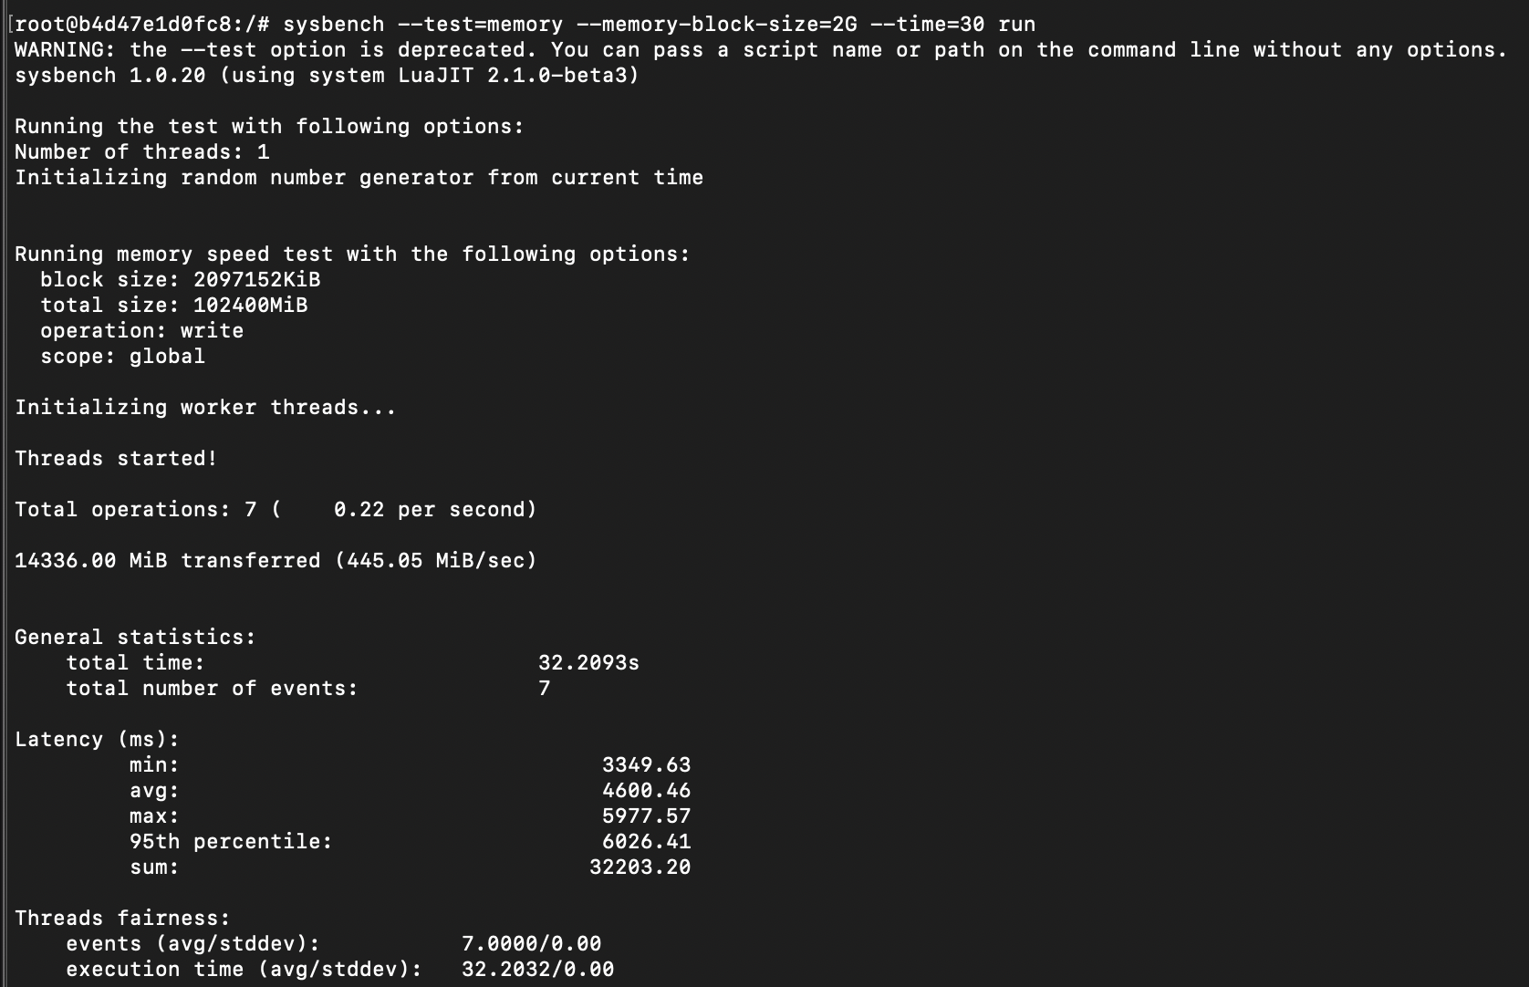

1. **MEMORY TEST WITH CPU – 2 CORES AND RAM – 2G**

**Test 1 – memory-block-size=1G**

1. QEMU qcow2 format –

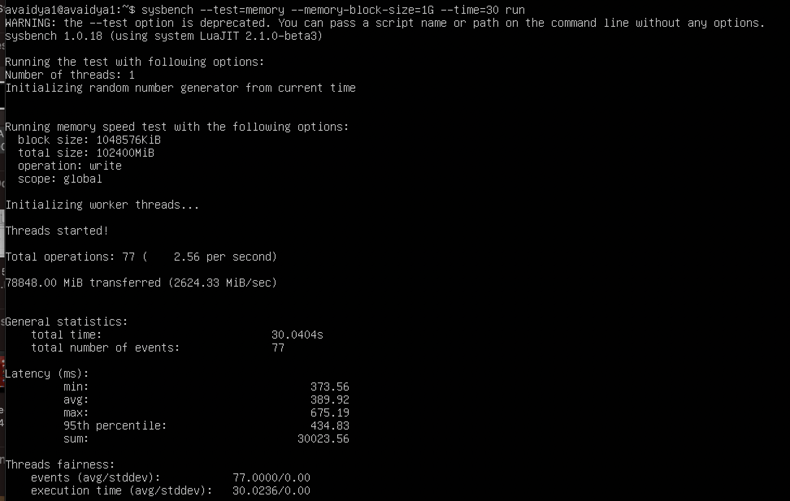

1. QEMU raw format –

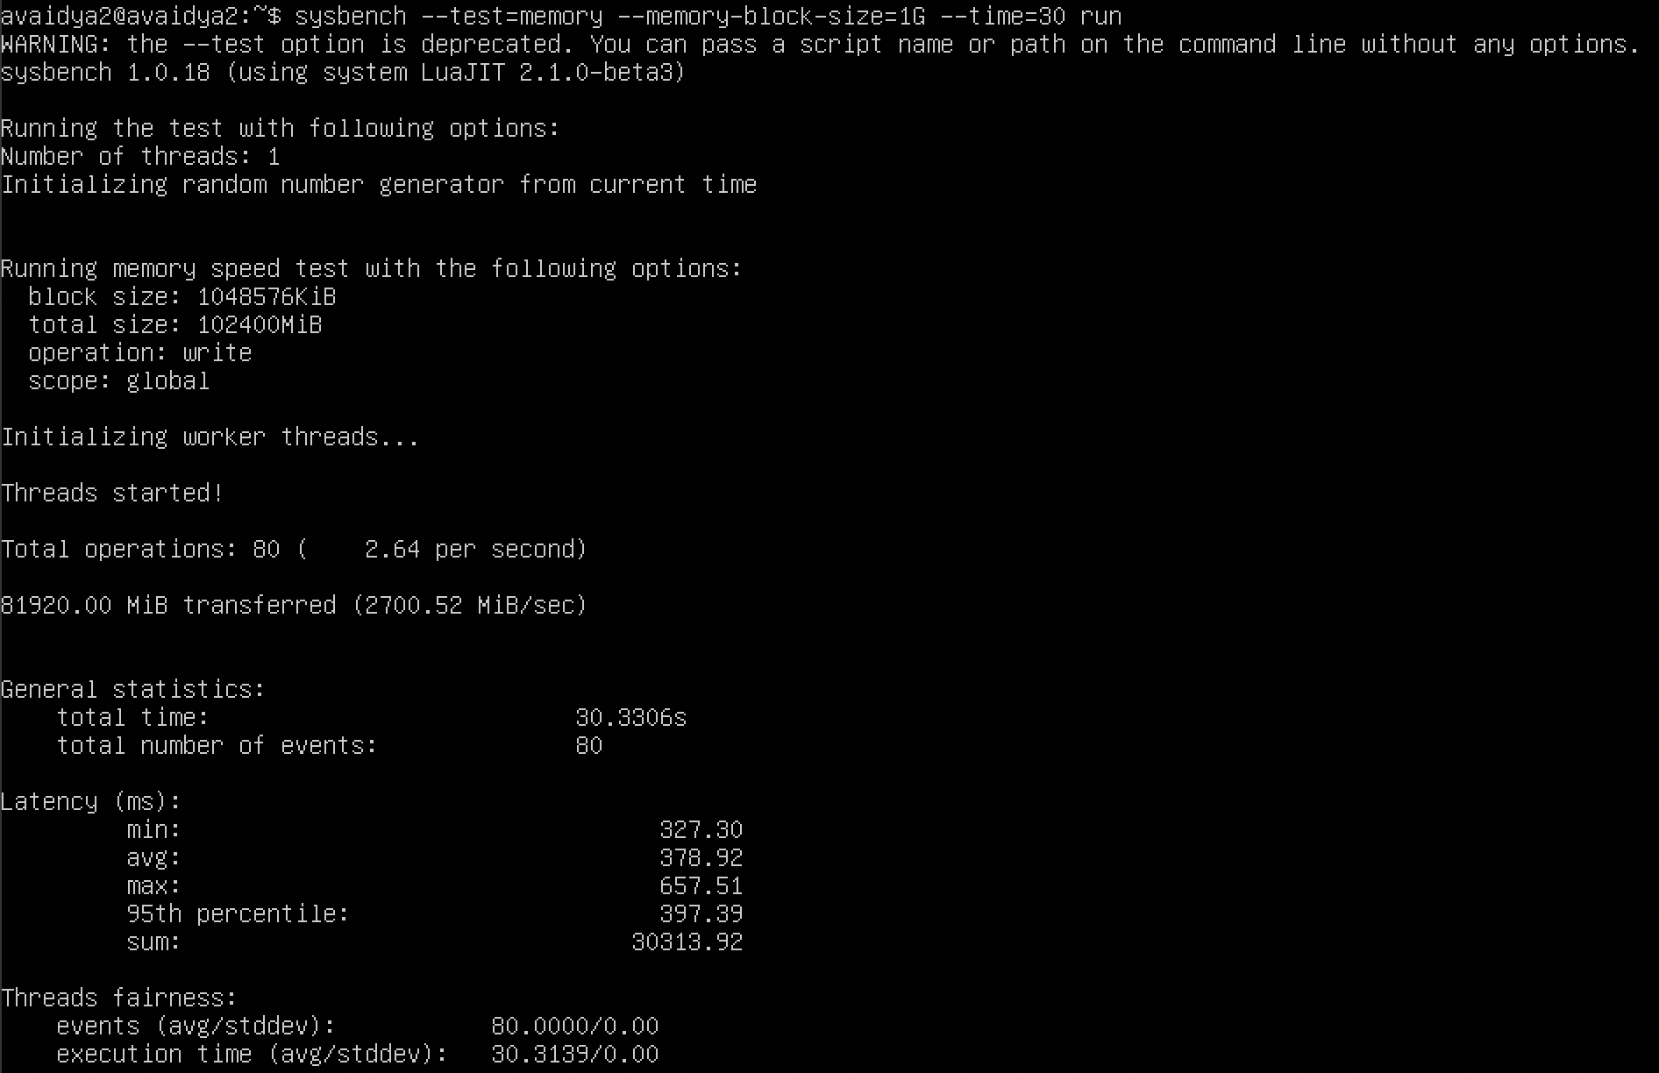

1. Docker –

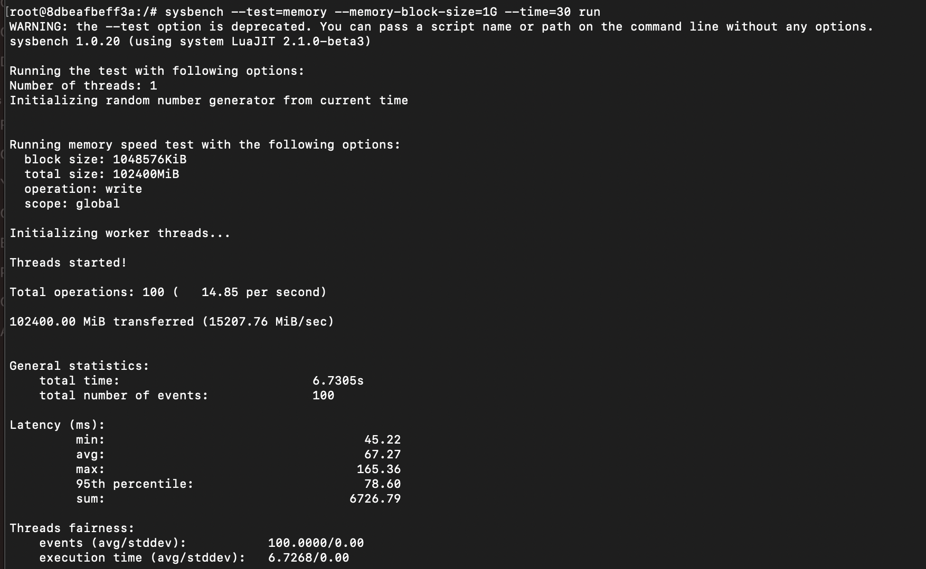

**Test 2 – memory-block-size=2G**

1. QEMU qcow2 format –

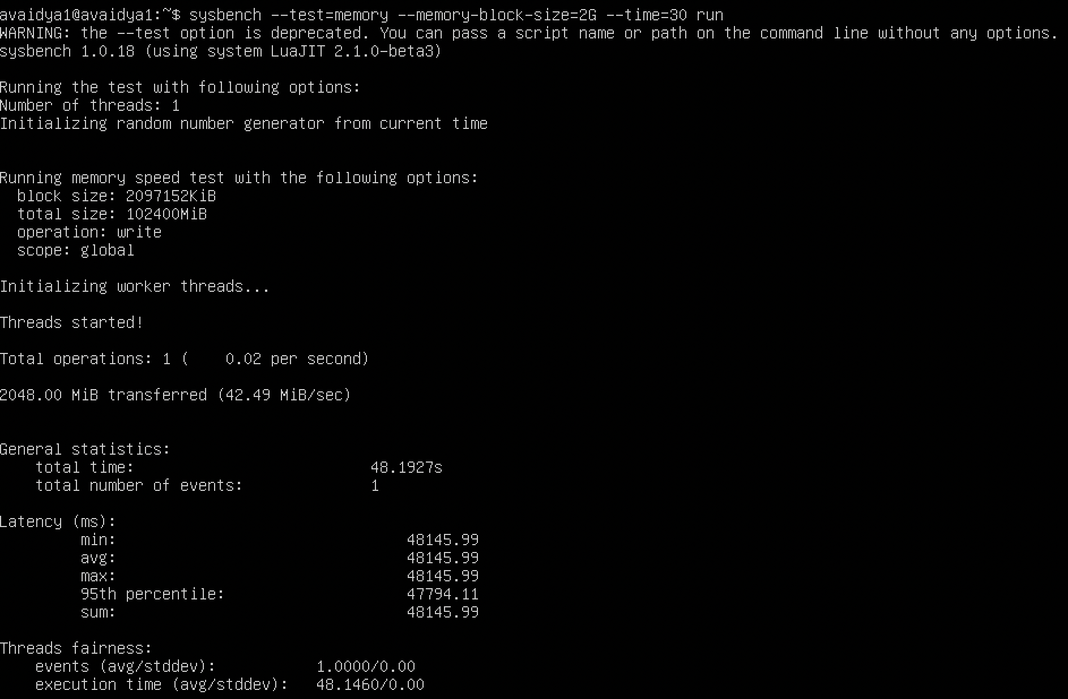

1. QEMU raw format –

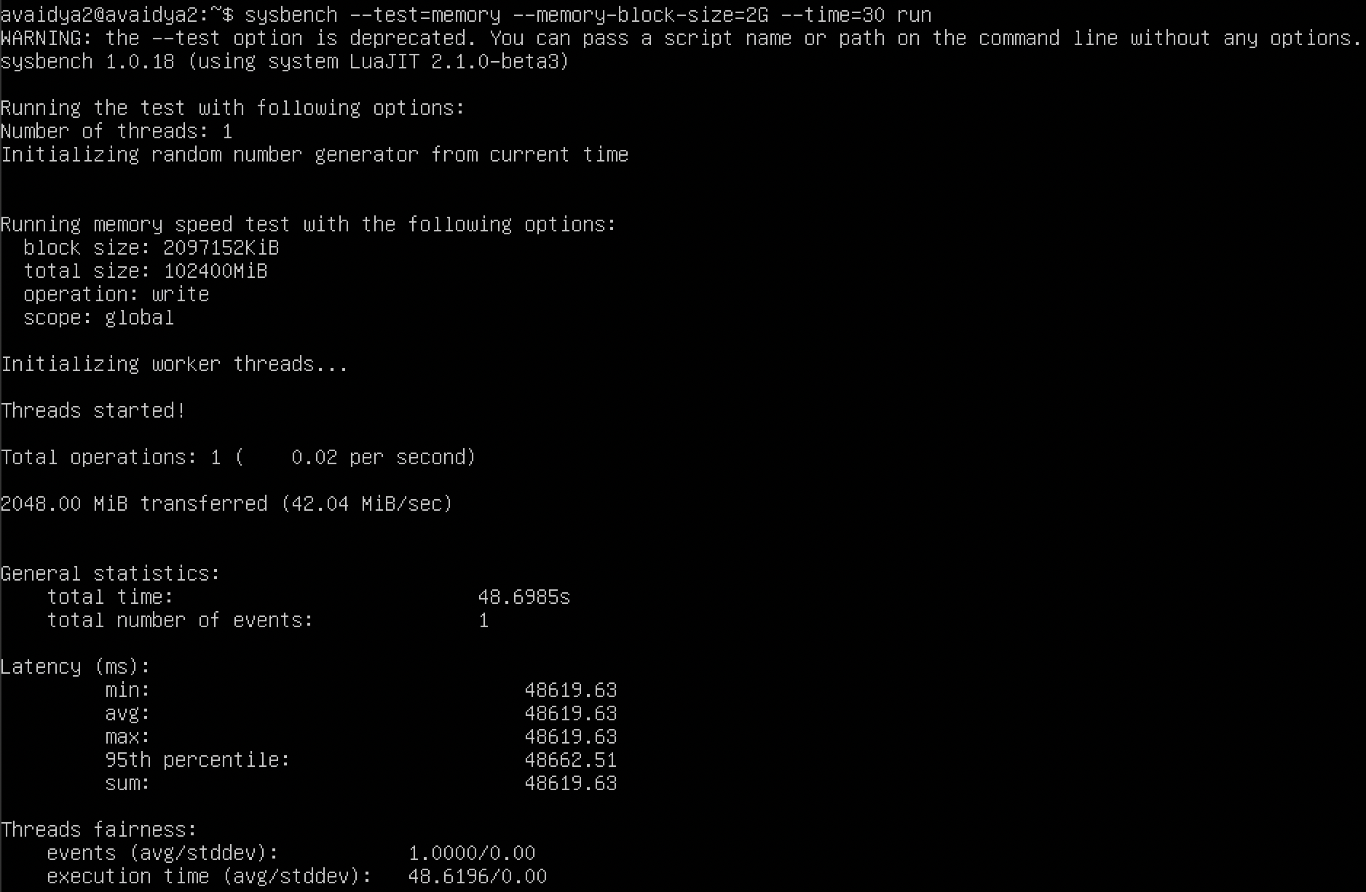

1. Docker –

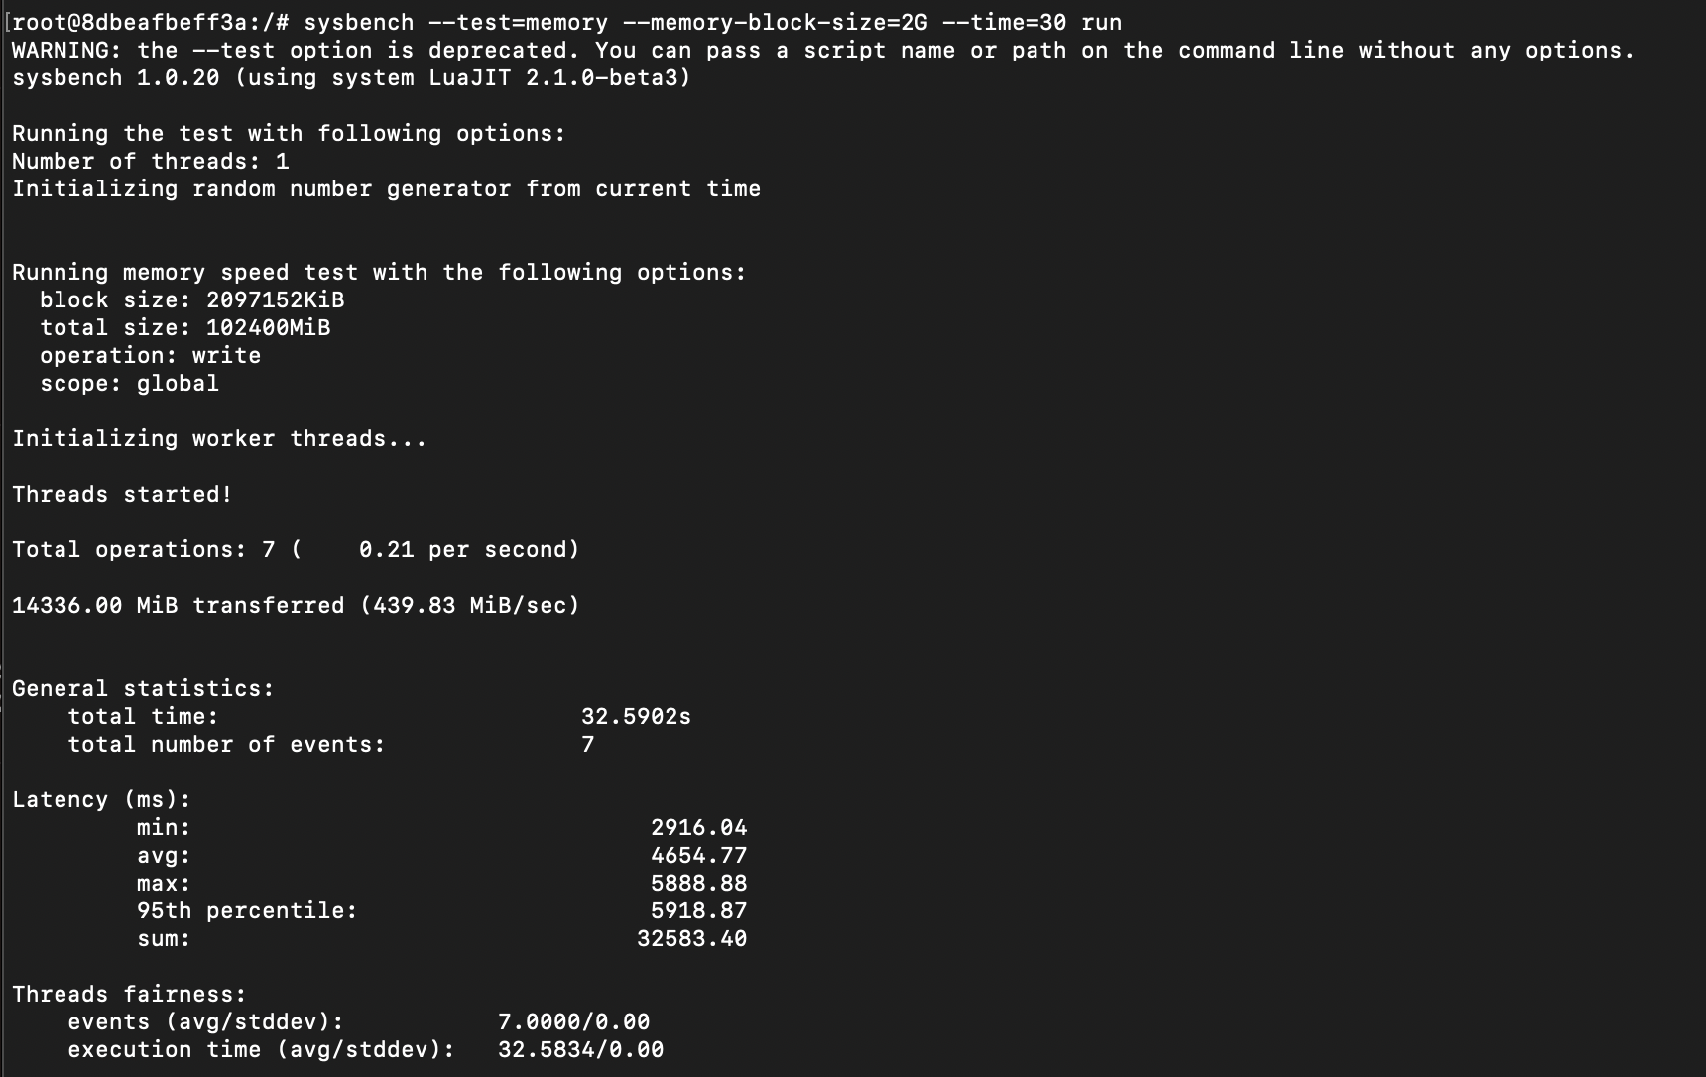

1. **MEMORY TEST WITH CPU – 3 CORES AND RAM – 4G**

**Test 1 – memory-block-size=1G**

1. QEMU qcow2 format –

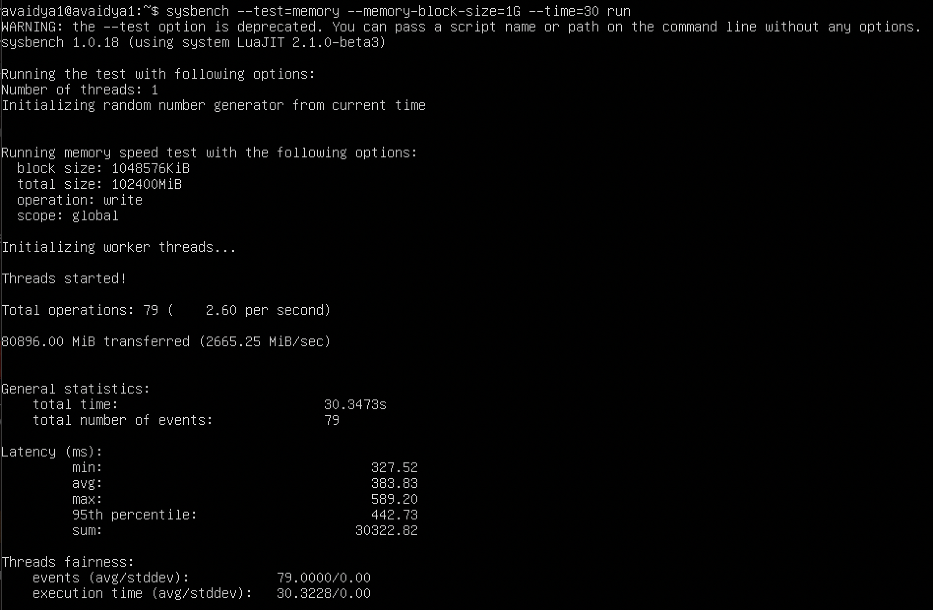

1. QEMU raw format –

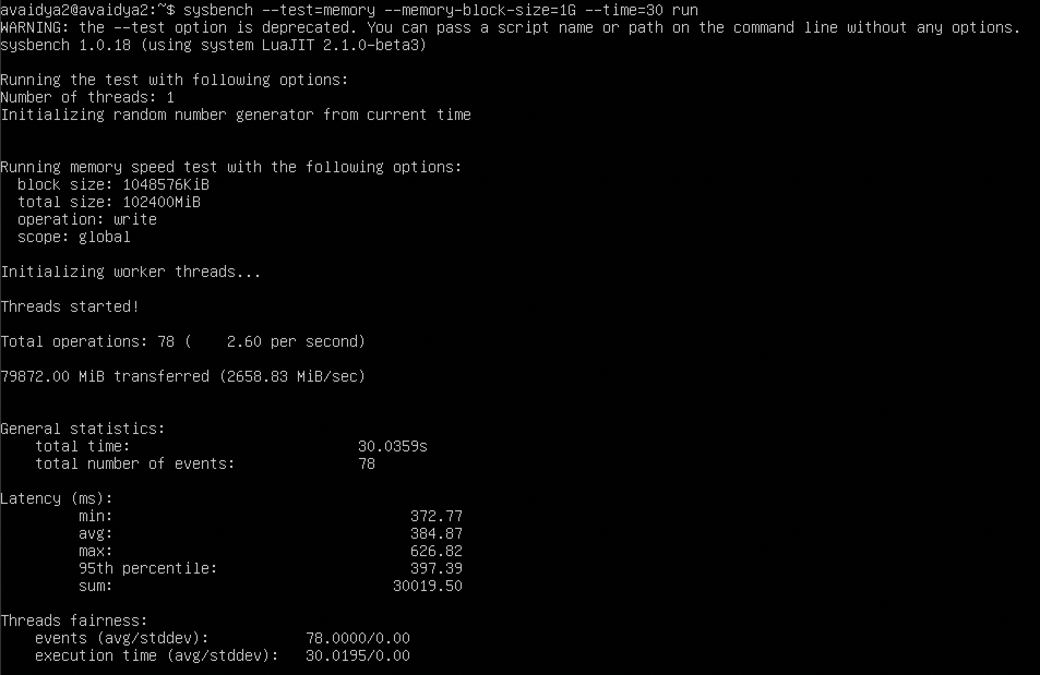

1. Docker –

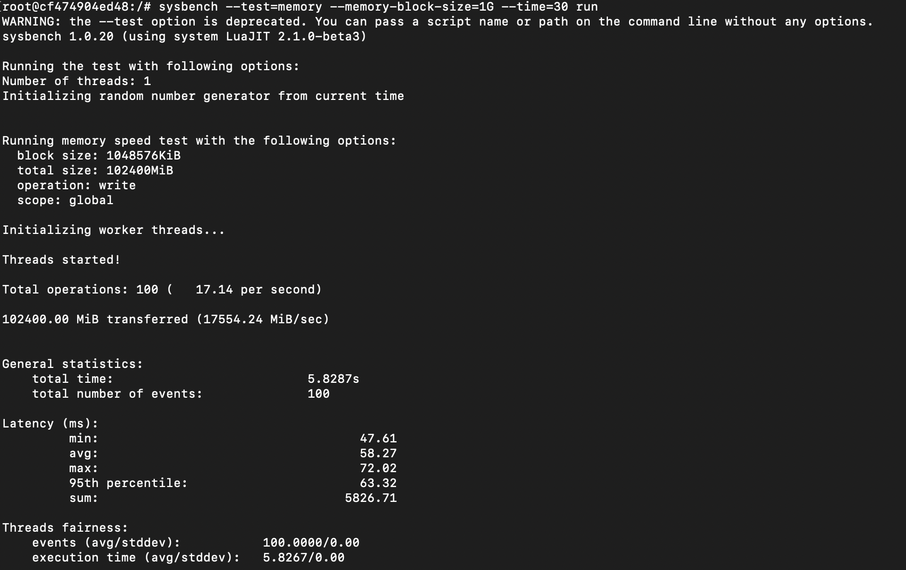

**Test 2 – memory-block-size=2G**

1. QEMU qcow2 format –

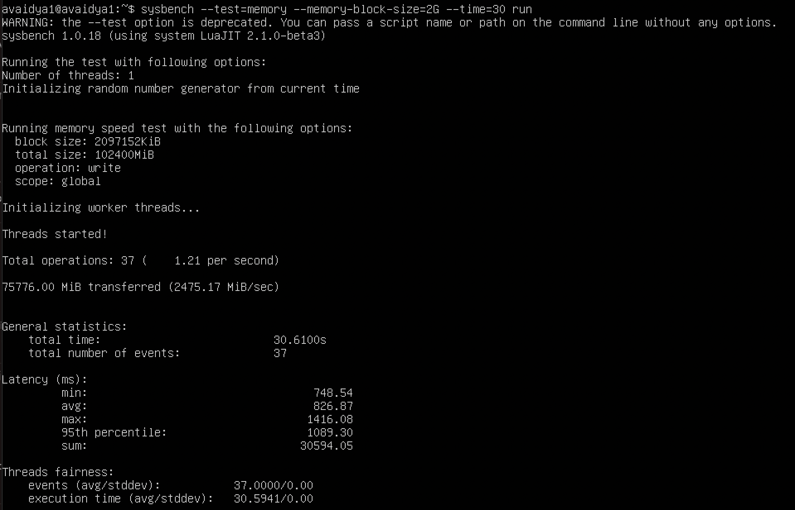

1. QEMU raw format –

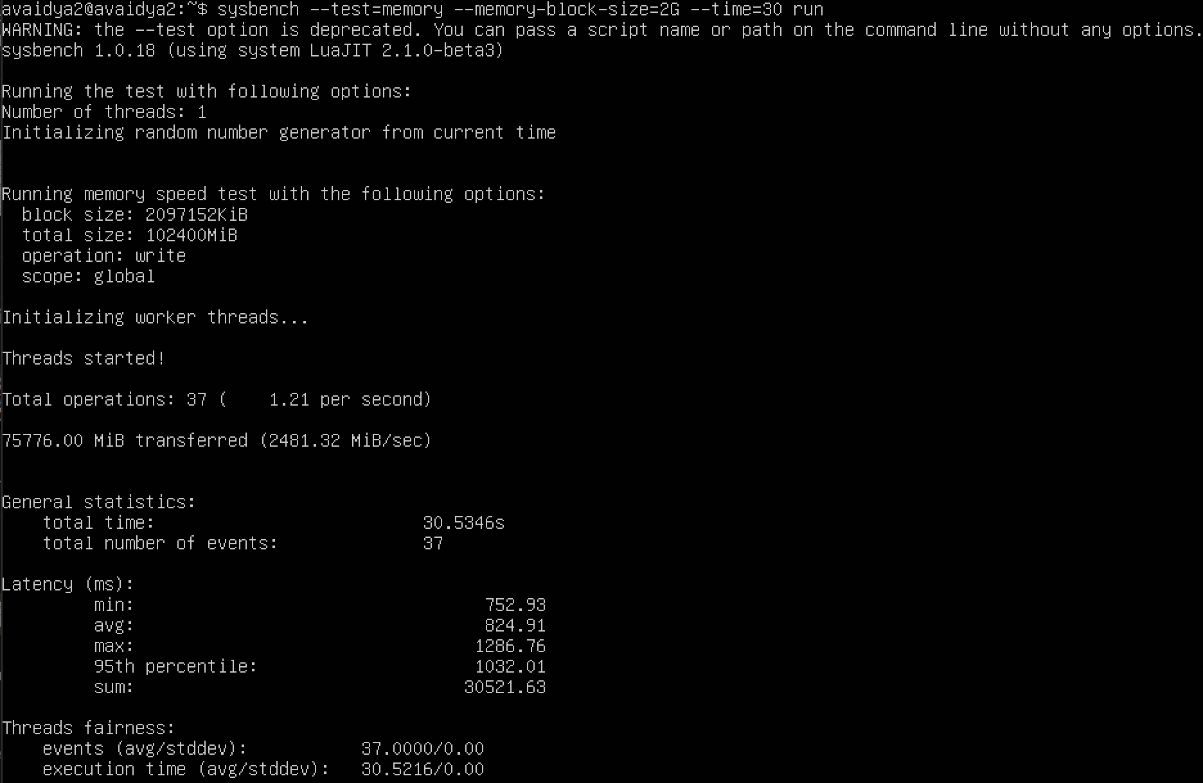

1. Docker –

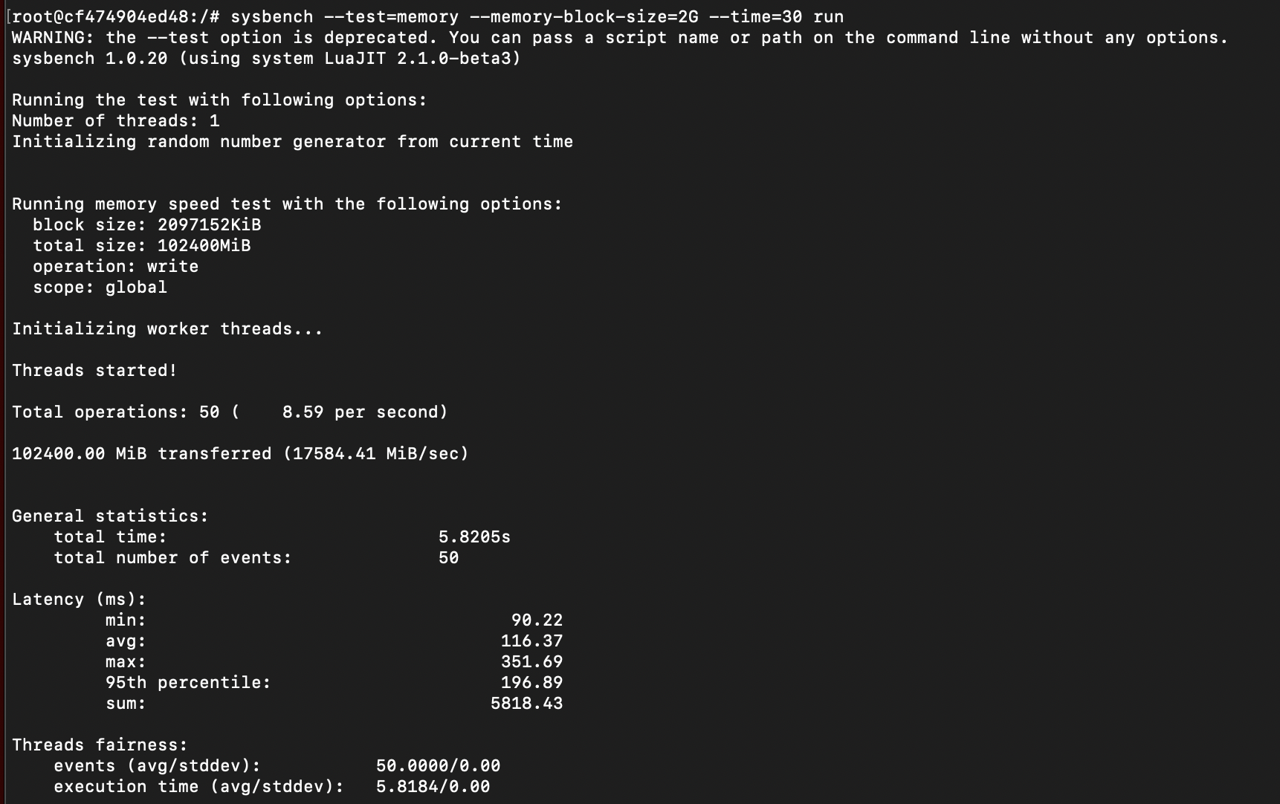

FILEIO TEST

1. FILEIO TEST WITH CPU – 2 CORES AND RAM – 4G

Test 1 – file-test-mode=seqwr

1. QEMU qcow2 format –

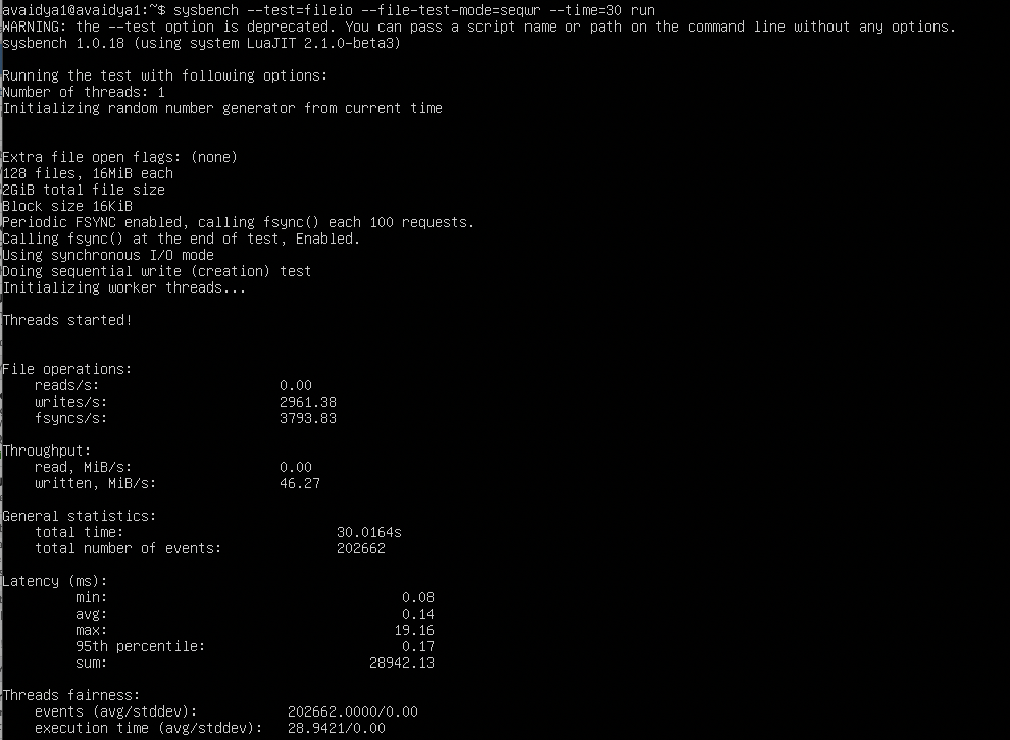

1. QEMU raw format –

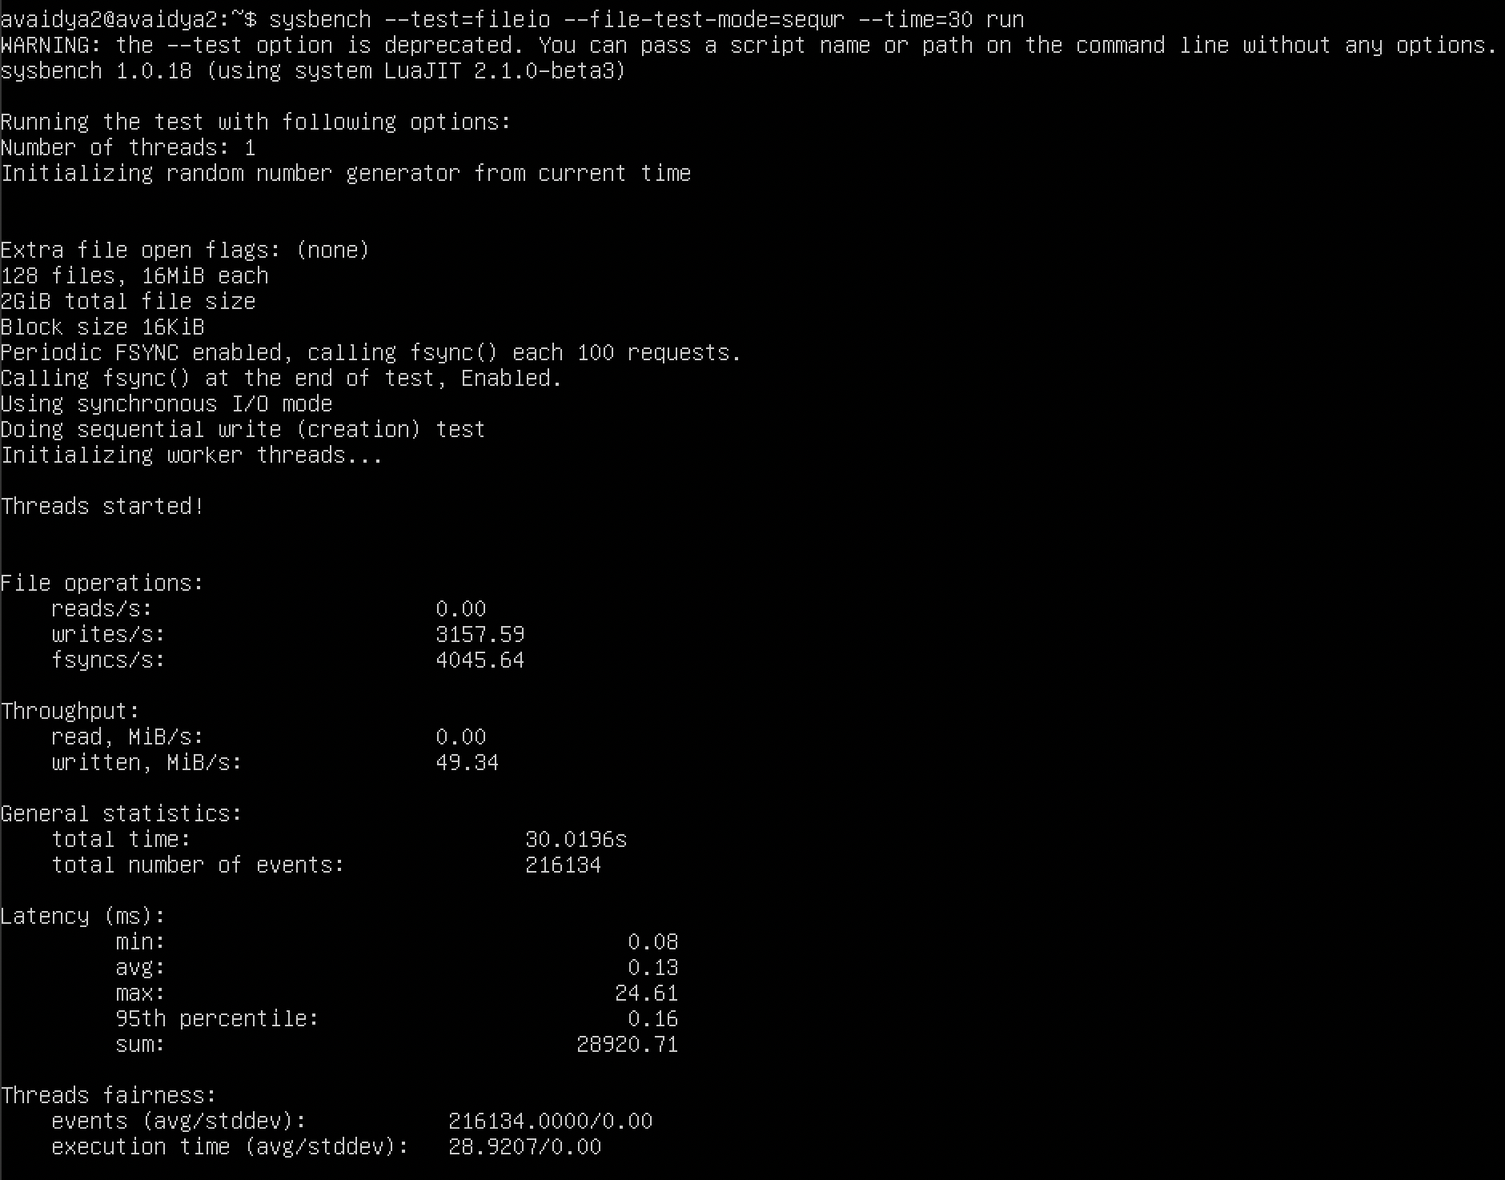

1. Docker –

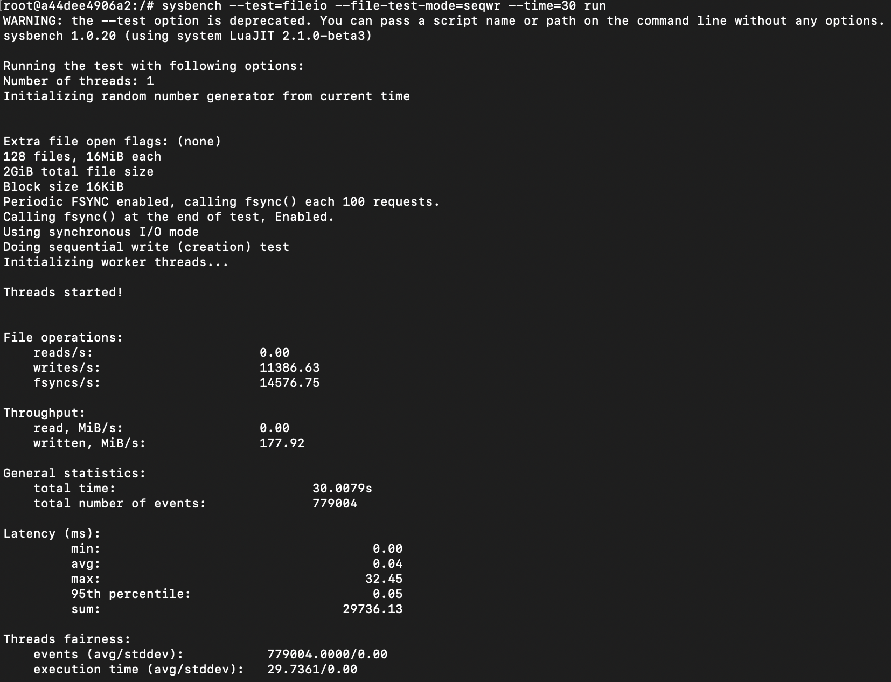

Test 2 – file-test-mode=rndwr

1. QEMU qcow2 format –

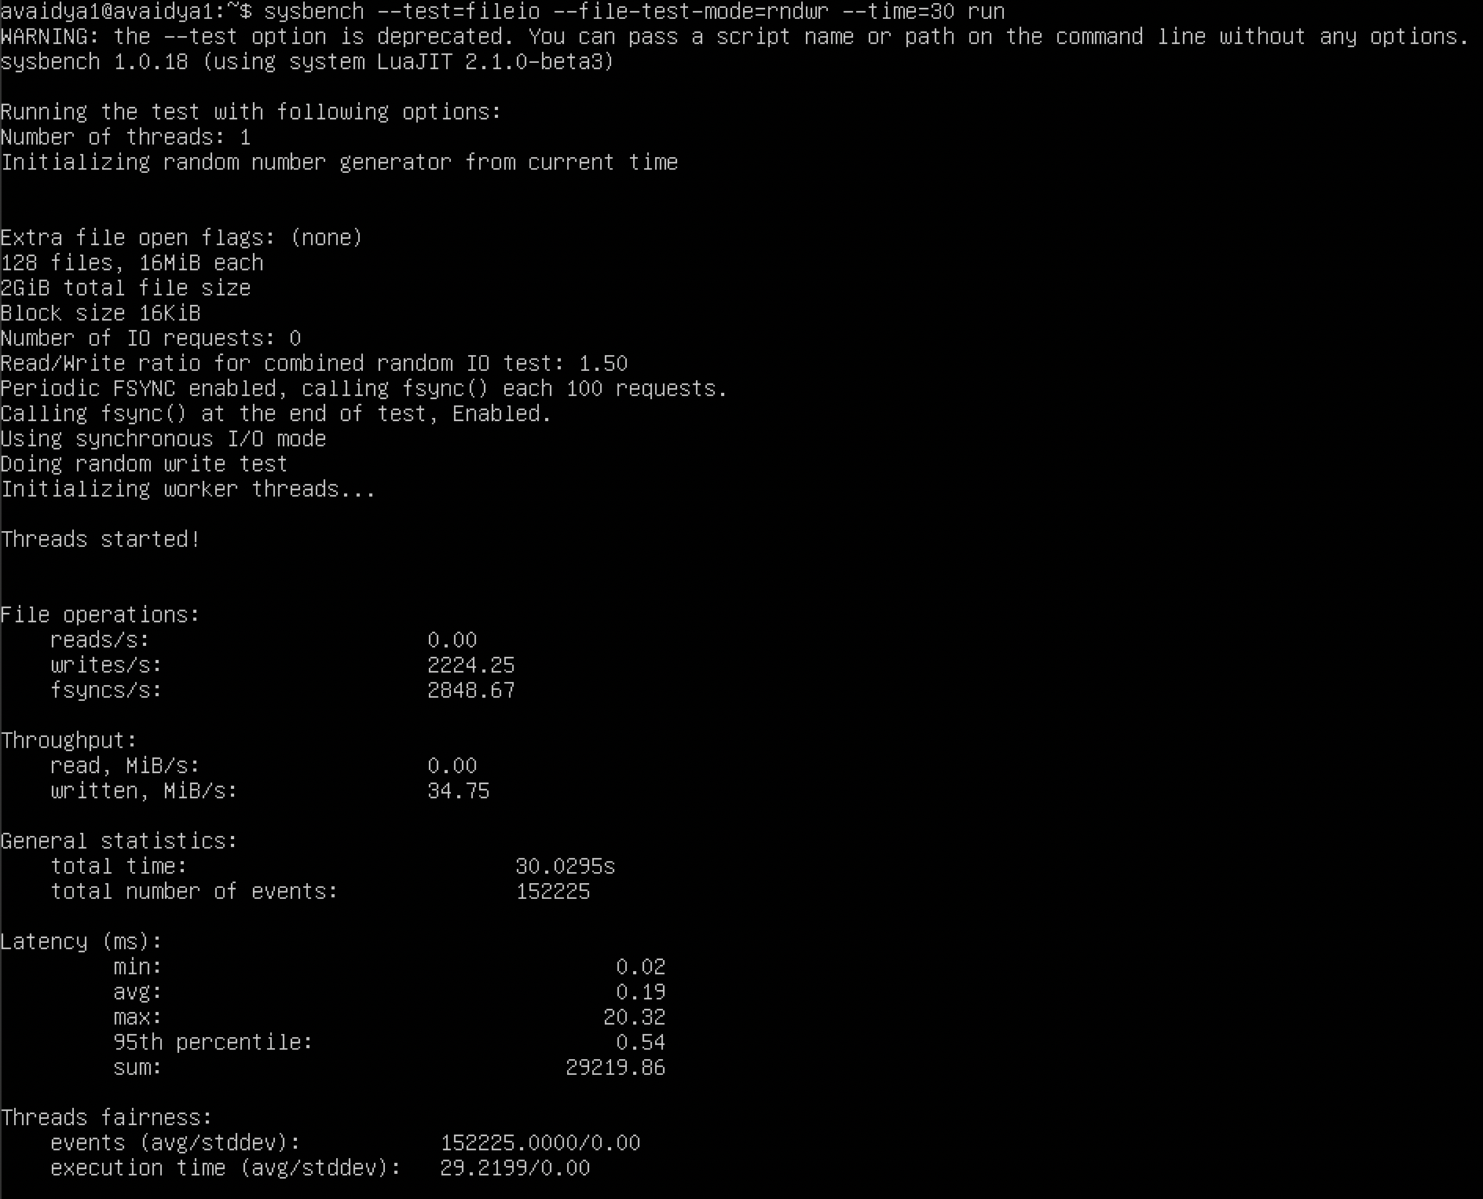

1. QEMU raw format –

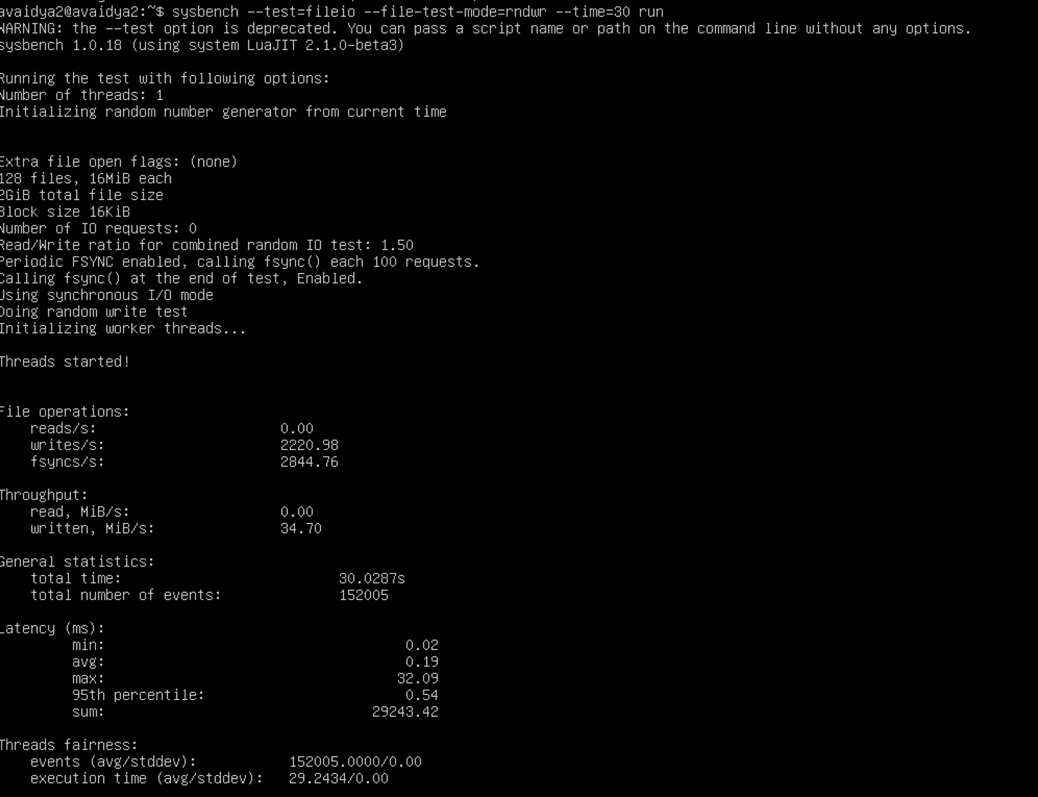

1. Docker –

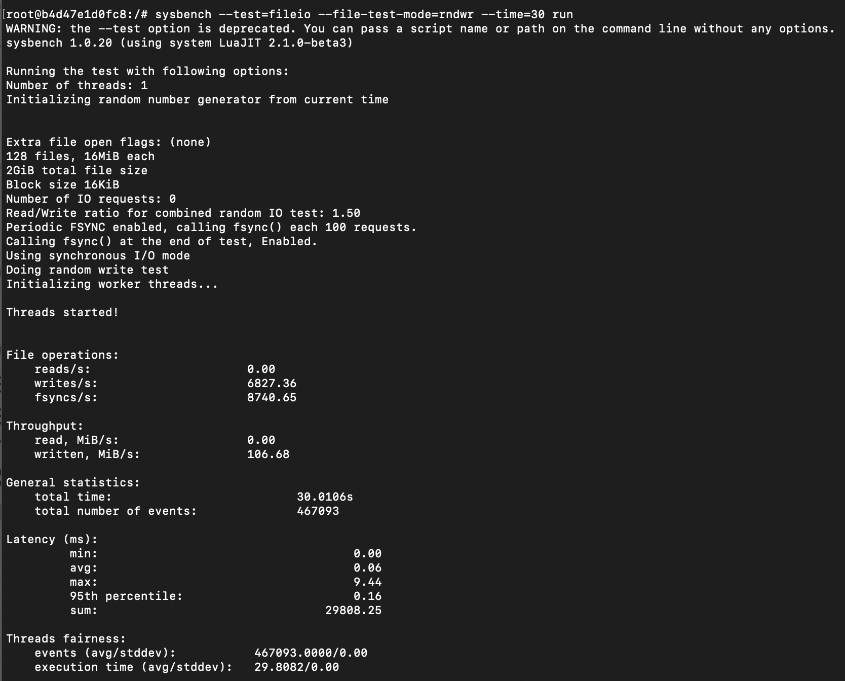

1. **MEMORY TEST WITH CPU – 3 CORES AND RAM – 2G**

**Test 1 – file-test-mode=seqwr**

1. QEMU qcow2 format –

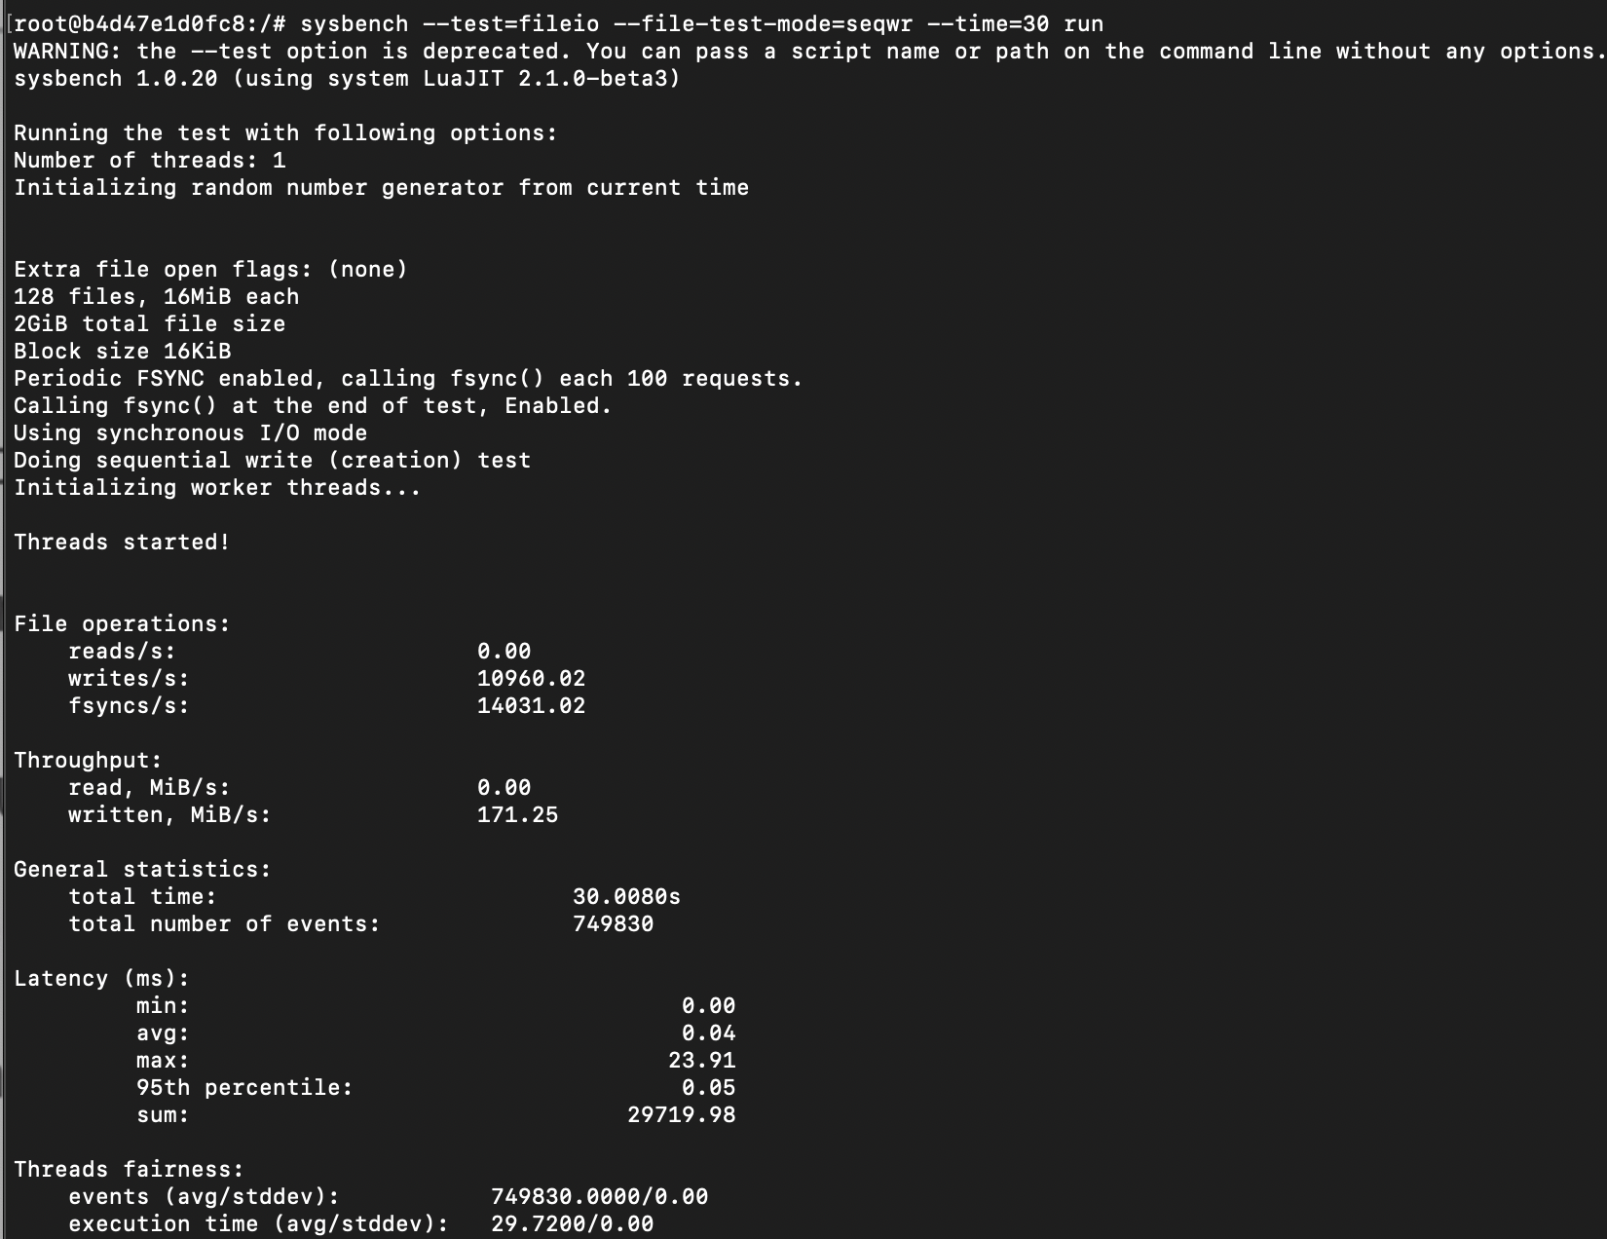

1. QEMU raw format –

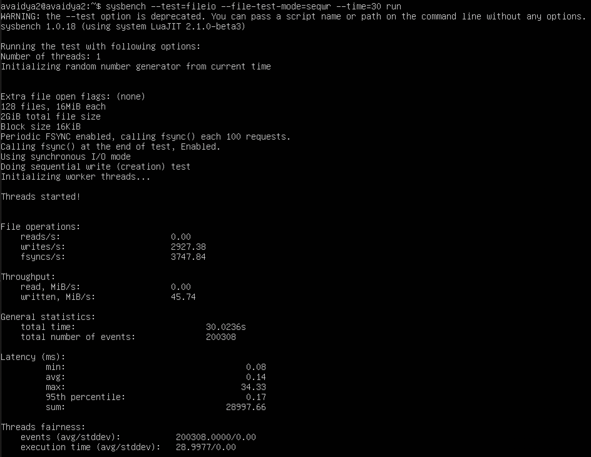

1. Docker –



**Test 2 – file-test-mode=rndwr**

1. QEMU qcow2 format –



1. QEMU raw format –



1. Docker –



1. **MEMORY TEST WITH CPU – 2 CORES AND RAM – 2G**

**Test 1 – file-test-mode=seqwr**

1. QEMU qcow2 format –

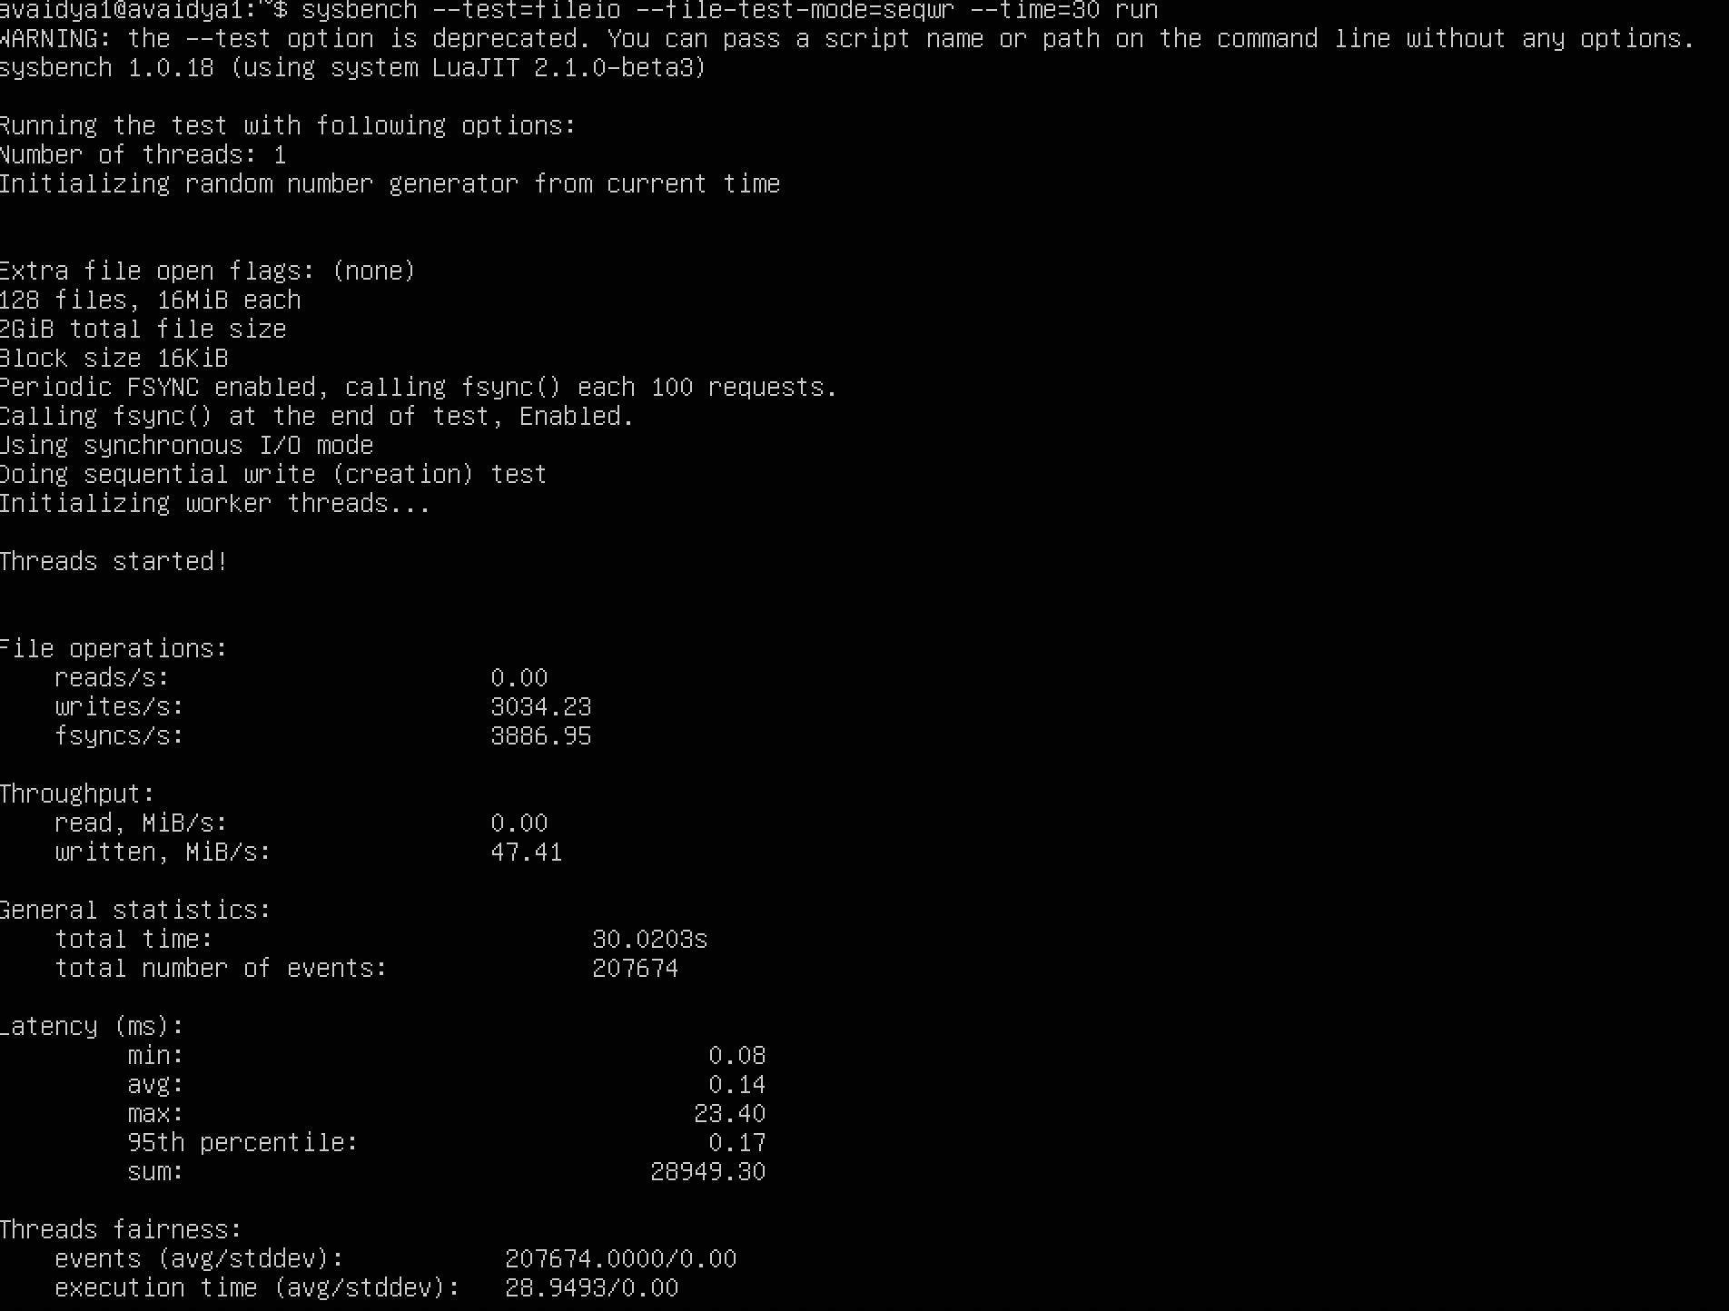

1. QEMU raw format –

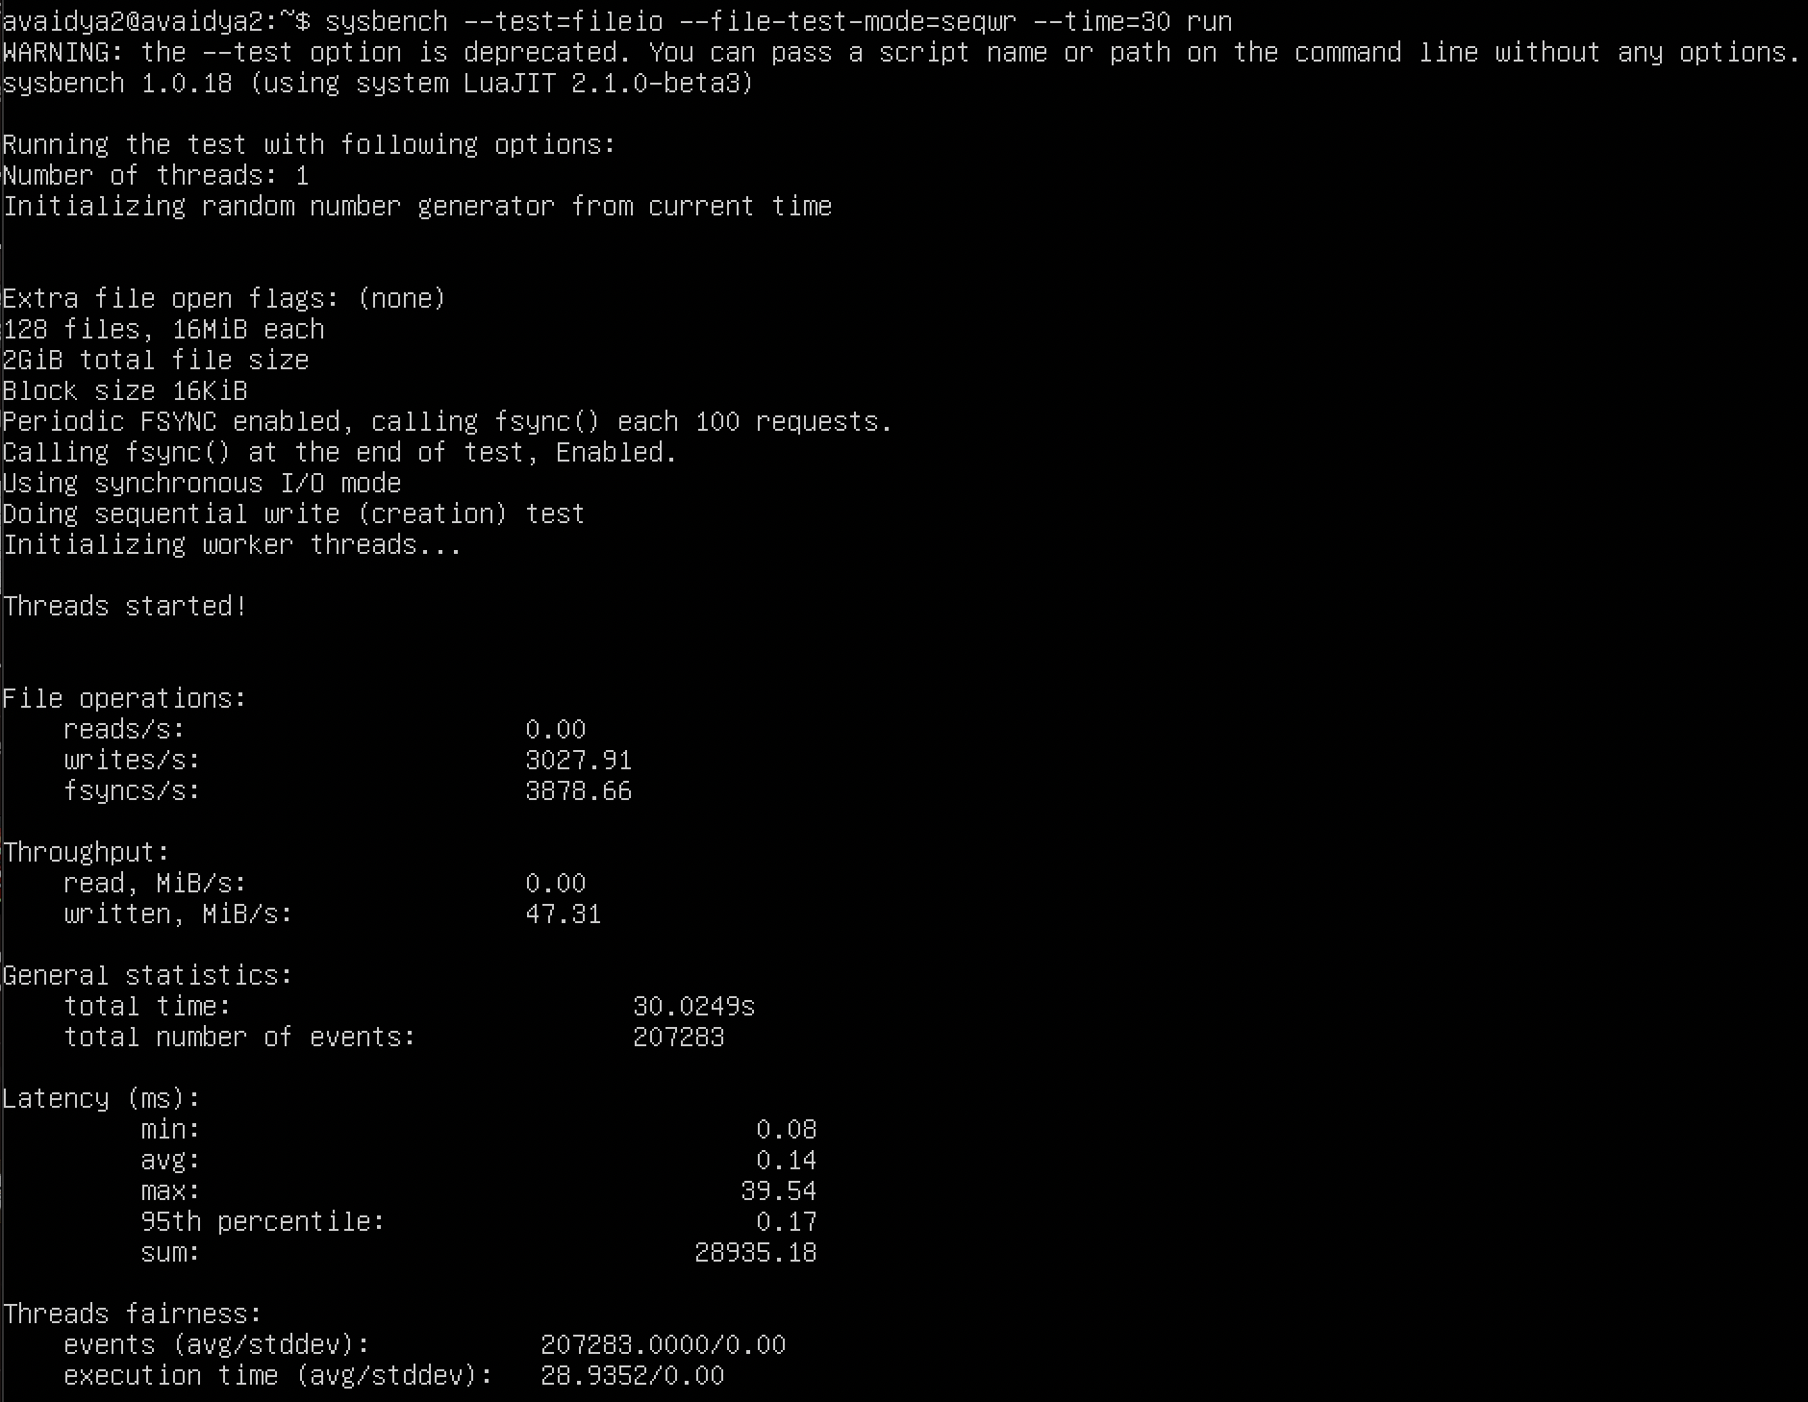

1. Docker –

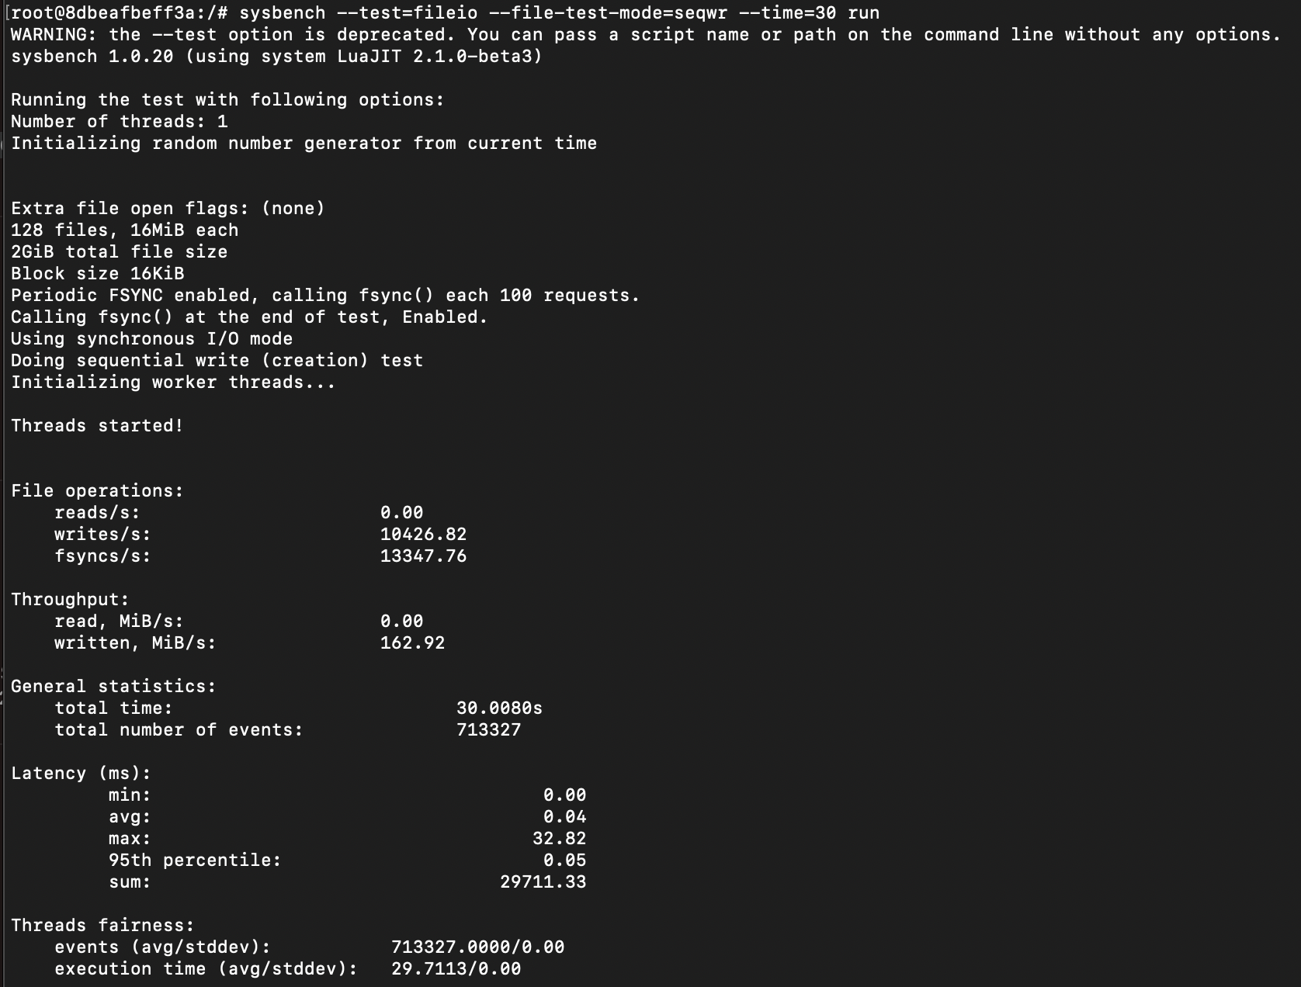

**Test 2 – file-test-mode=rndwr**

1. QEMU qcow2 format –

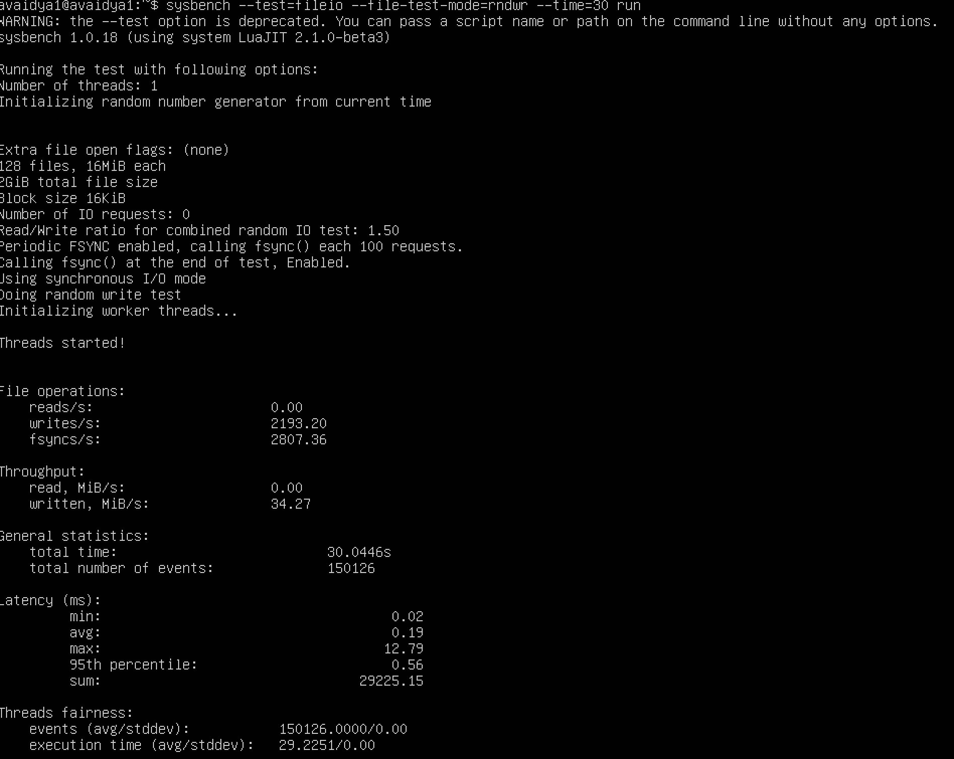

1. QEMU raw format –

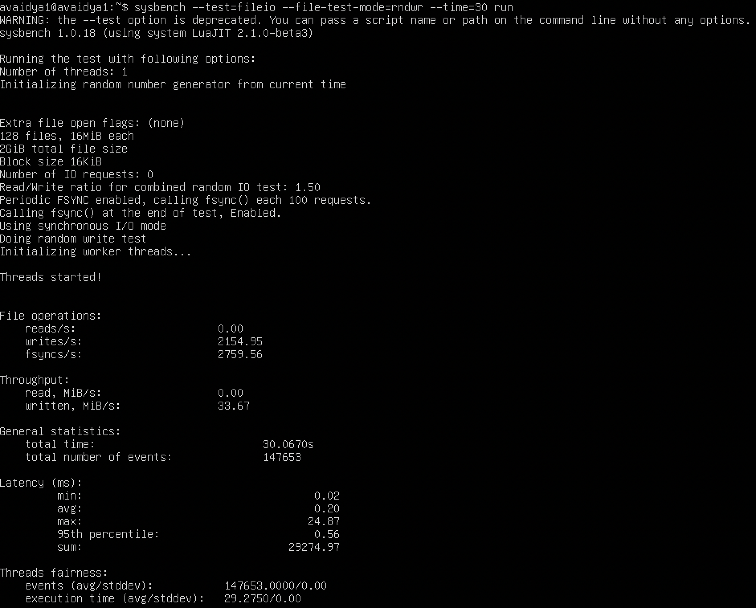

1. Docker –

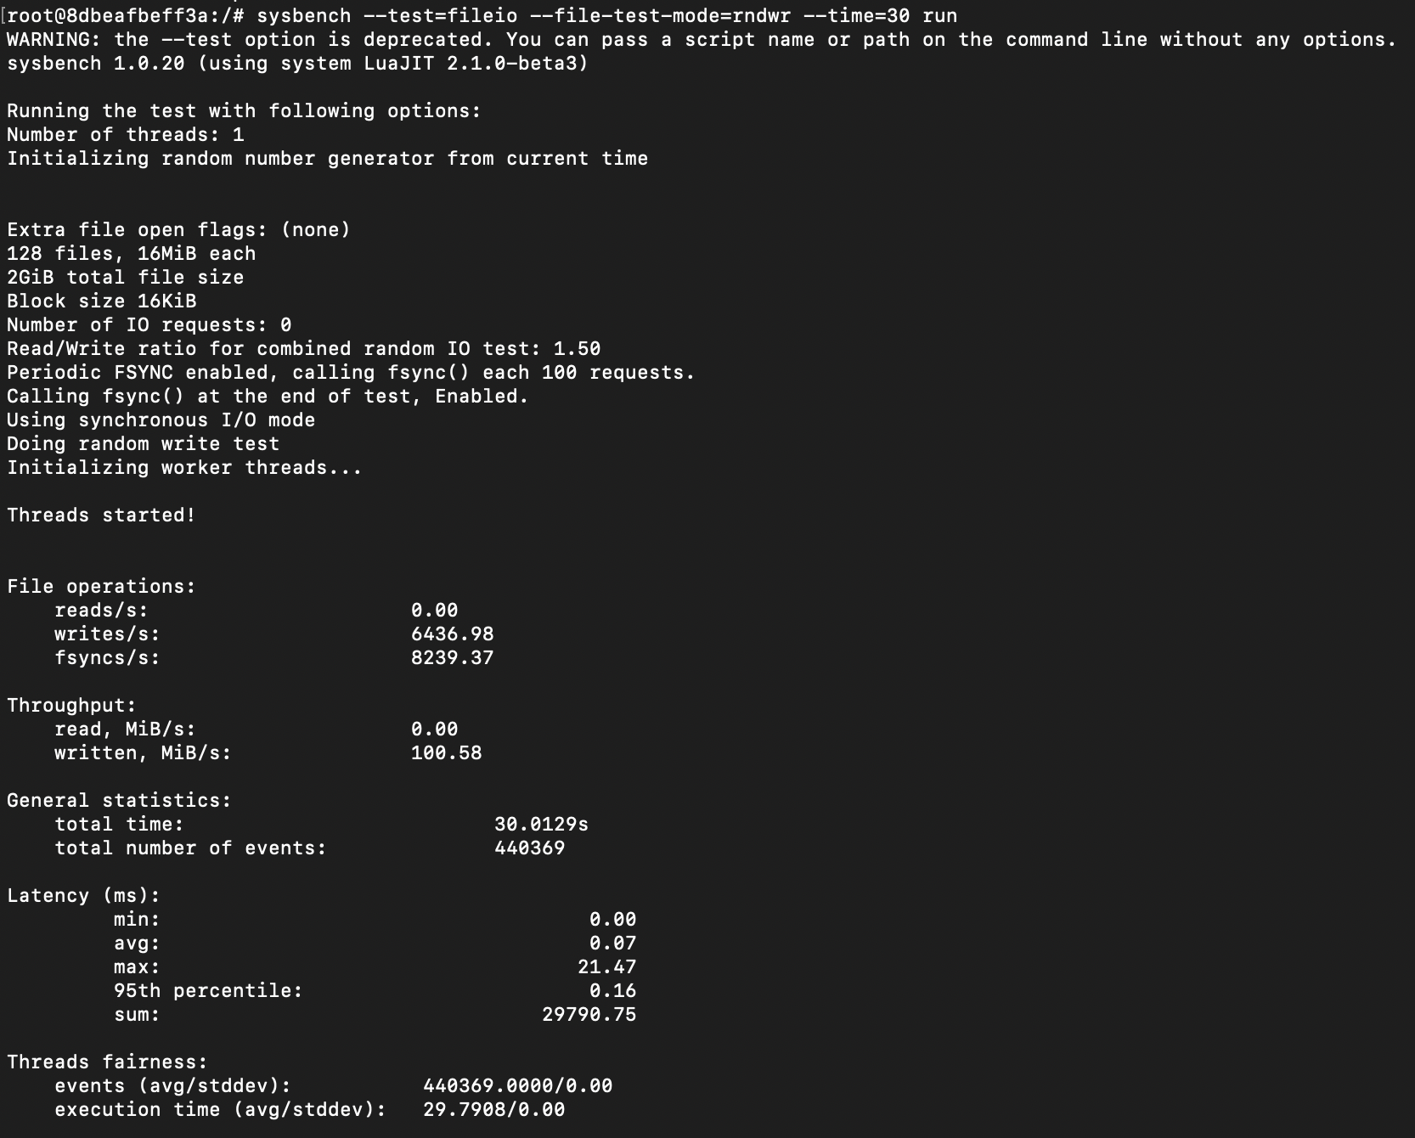

1. **MEMORY TEST WITH CPU – 3 CORES AND RAM – 4G**

**Test 1 – file-test-mode=seqwr**

1. QEMU qcow2 format –

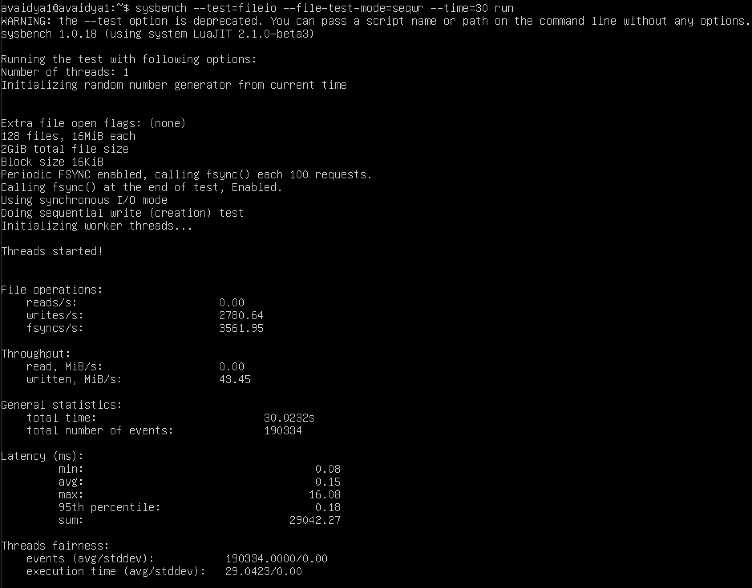

1. QEMU raw format –

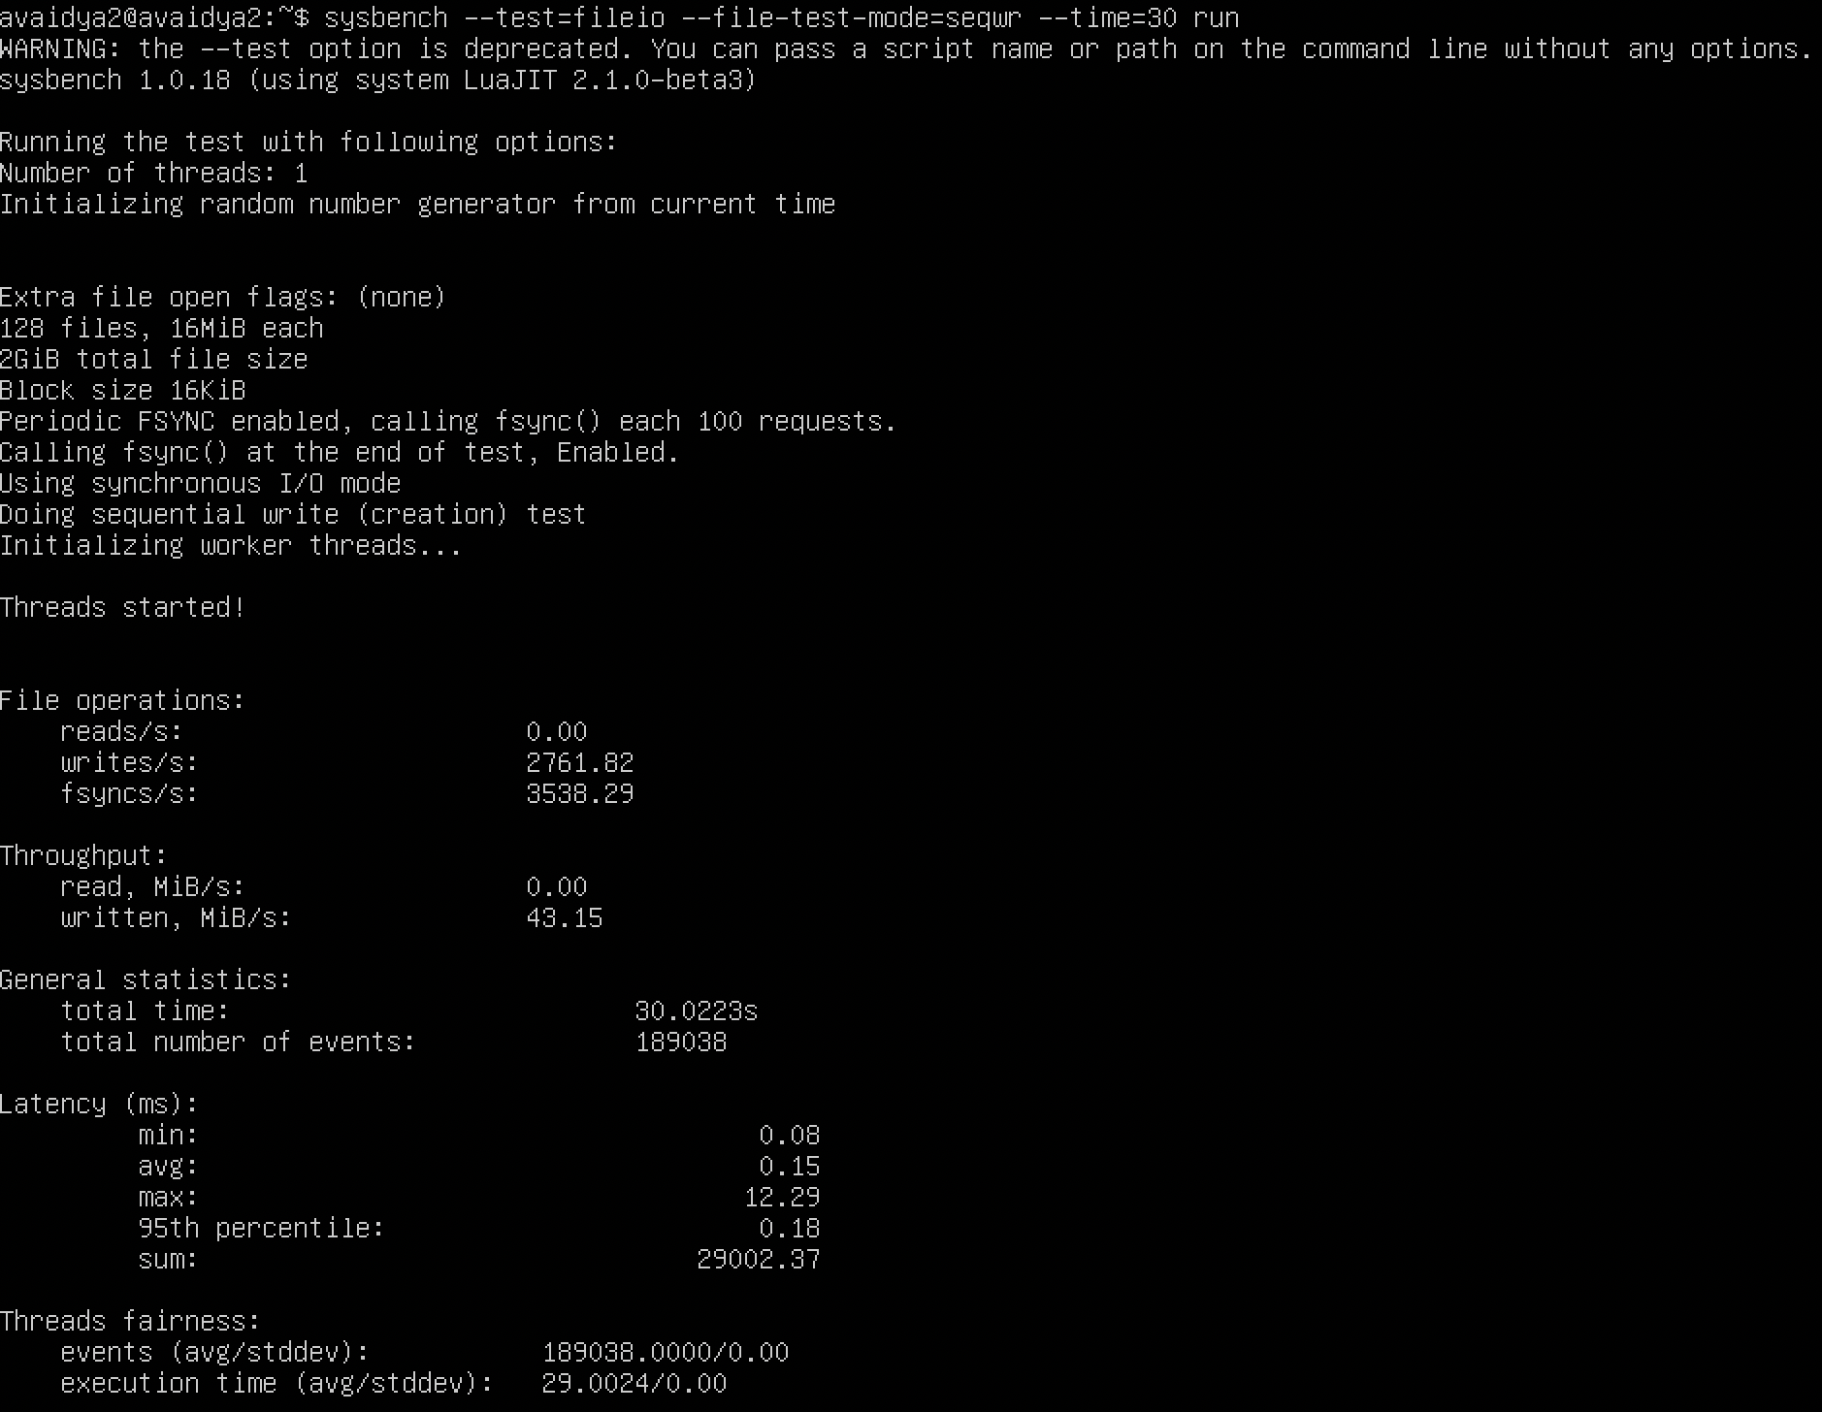

1. Docker –

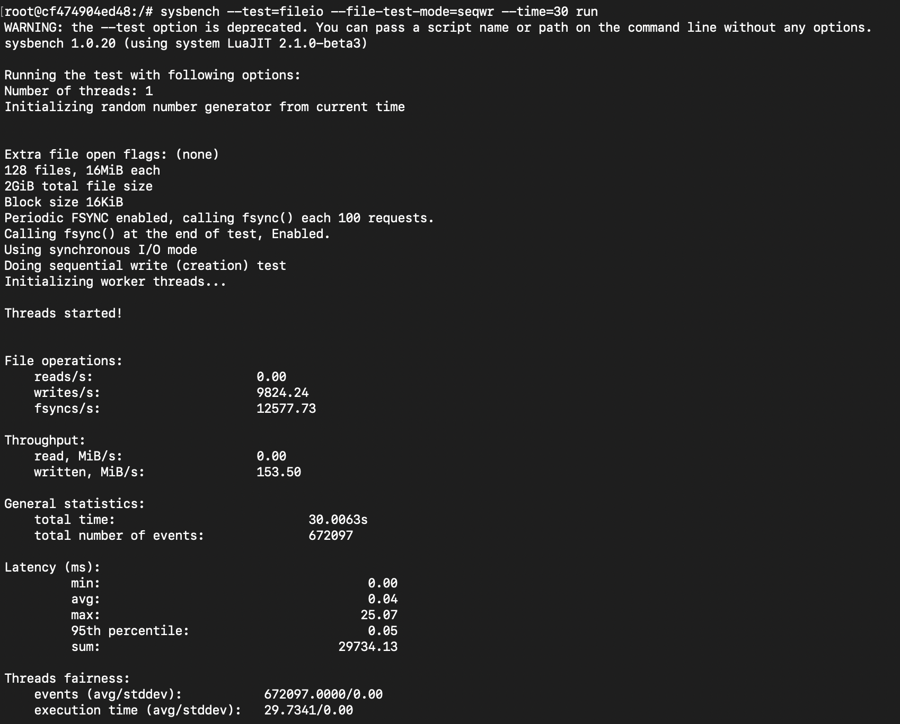

**Test 2 – file-test-mode=rndwr**

1. QEMU qcow2 format –

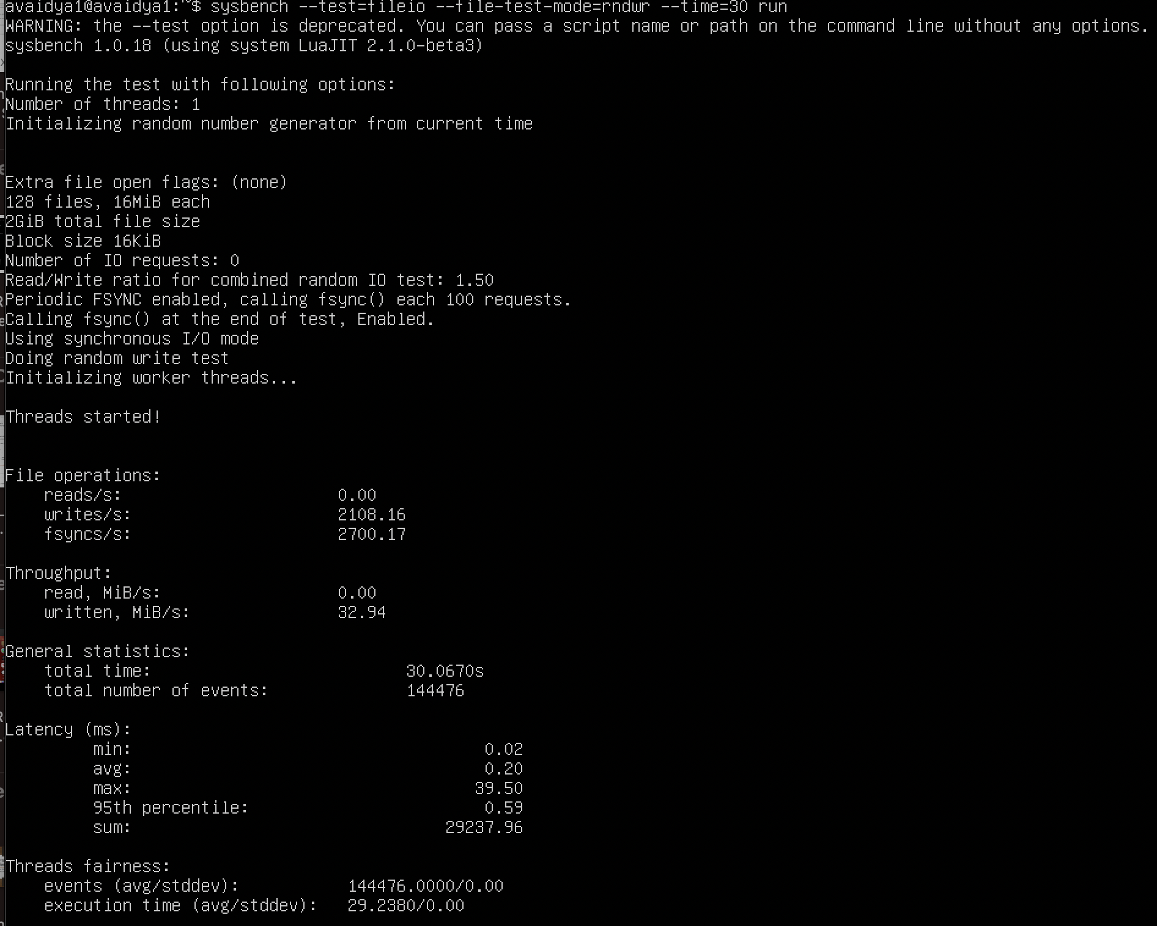

1. QEMU raw format –

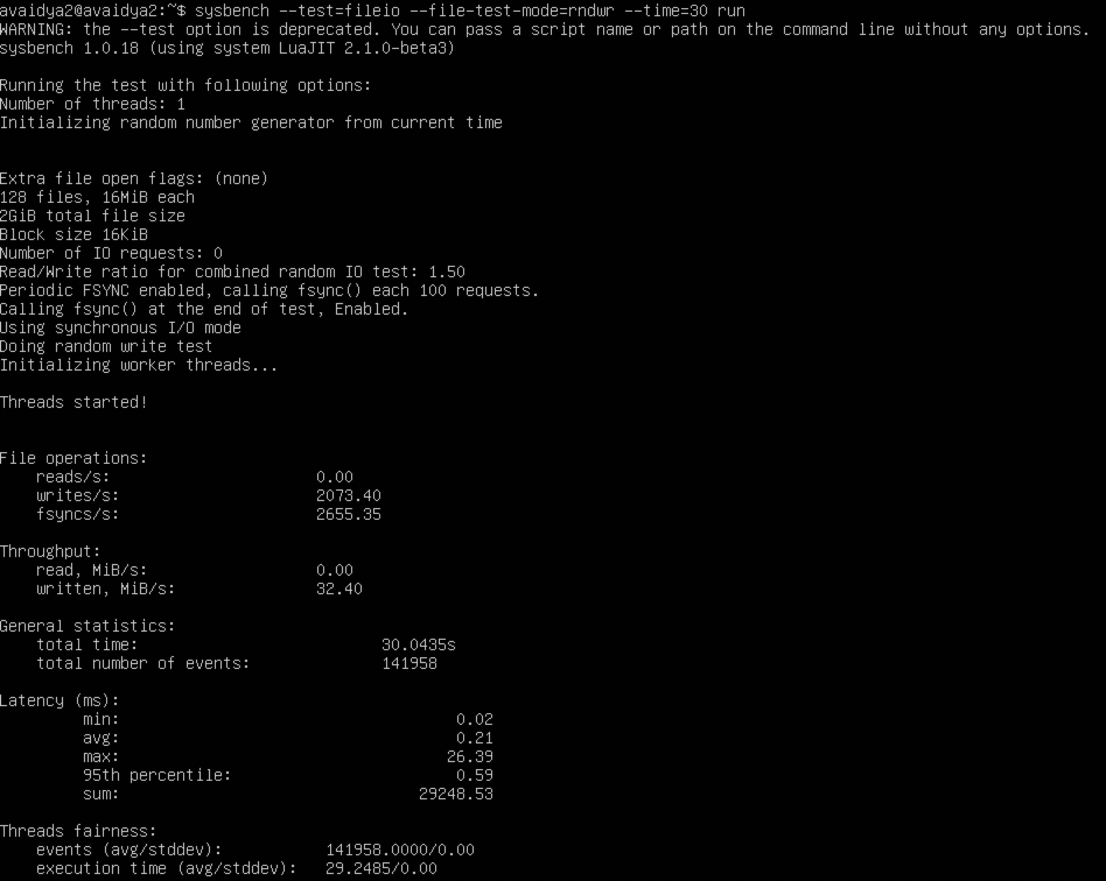

1. Docker –

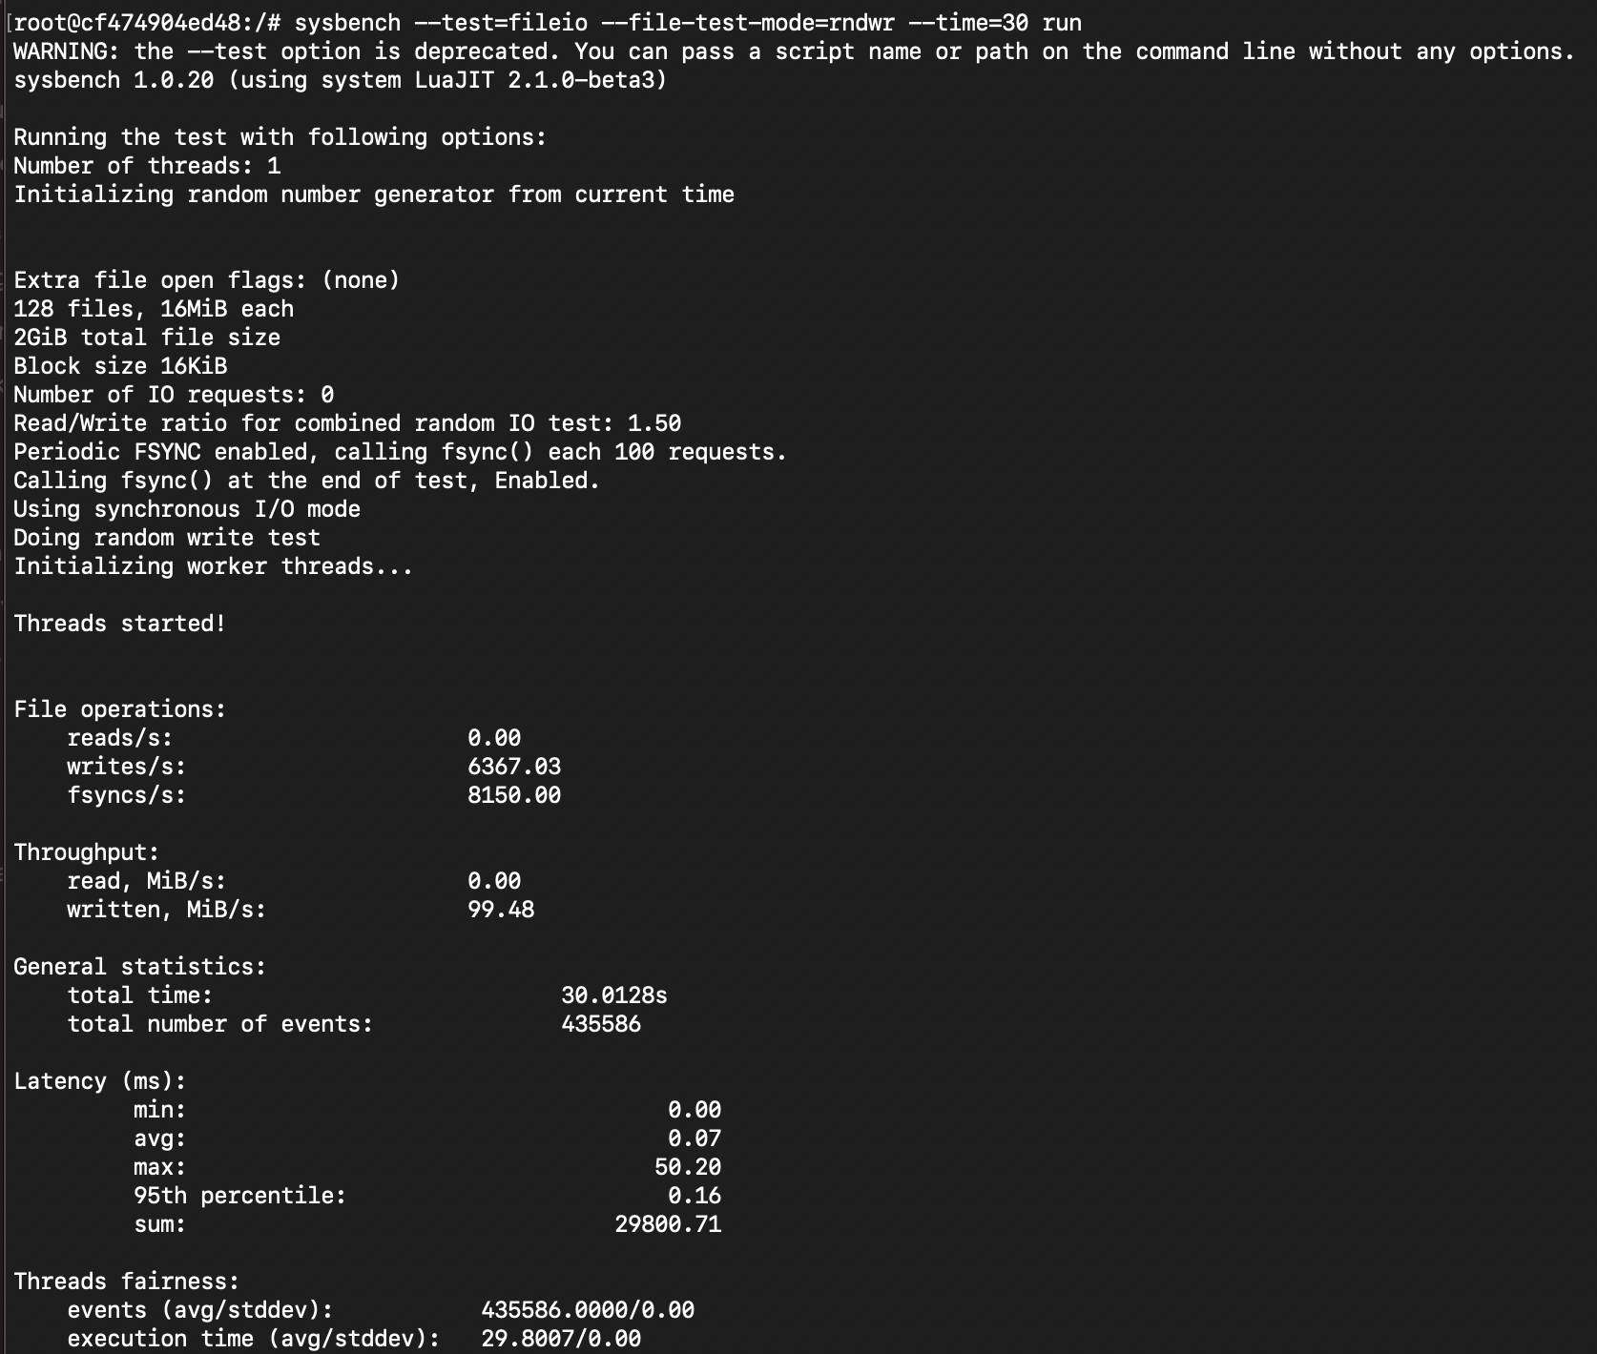

1. **EXPERIMENT RESULTS AND ANALYSIS**

**CPU Test - QEMU VM qcow2 vs Qemu VM raw vs. Docker Container**

To conduct the CPU Test, I've considered the following two primary parameters:

1. --cpu-max-prime Determines the maximum number up to which the tested numbers are checked for primality.

2. --time Sets the maximum allowable time for the process to complete.

Test 1 – cpu-max-prime=2000



|  |  |  |  |  |  |  |  |
| --- | --- | --- | --- | --- | --- | --- | --- |
| **Technology** | **CPU** | **RAM** | **min** | **max** | **avg** | **Std(events/sec)** | **No of events** |
| Qcow2 | **2** | **4** | **0.21** | **23.31** | **0.22** | **4472.55** | **134196** |
| Raw | **2** | **4** | **0.21** | **15.63** | **0.22** | **4495.27** | **134880** |
| docker | **2** | **4** | **0.2** | **21.57** | **0.2** | **42759.31** | **1282917** |
| Qcow2 | **3** | **2** | **0.21** | **18.32** | **0.22** | **4463.26** | **133517** |
| Raw | **3** | **2** | **0.21** | **31.19** | **0.22** | **4467.20** | **134044** |
| Docker | **3** | **2** | **0.02** | **5.268** | **0.02** | **42981.45** | **1289511** |
| Qcow2 | **2** | **2** | **0.21** | **32.91** | **0.22** | **4472.61** | **134201** |
| Raw | **2** | **2** | **0.21** | **35.47** | **0.22** | **4469.76** | **134113** |
| Docker | **2** | **2** | **0.2** | **17.59** | **0.2** | **42928.10** | **1288141** |
| Qcow2 | **3** | **4** | **0.21** | **14.89** | **0.22** | **4530.87** | **135459** |
| Raw | **3** | **4** | **0.21** | **18.73** | **0.22** | **4455.50** | **133709** |
| Docker | **3** | **4** | **0.02** | **18.96** | **0.02** | **42744.20** | **1276016** |

Test 2 – cpu-max-prime=3000



|  |  |  |  |  |  |  |  |
| --- | --- | --- | --- | --- | --- | --- | --- |
| **Technology** | **CPU** | **RAM** | **min** | **max** | **avg** | **Std(events/sec)** | **No of events** |
| Qcow2 | **2** | **4** | **0.35** | **28.45** | **0.36** | **2725.47** | **80273** |
| Raw | **2** | **4** | **0.35** | **9.02** | **0.36** | **2727.96** | **81853** |
| docker | **2** | **4** | **0.04** | **17.4** | **0.04** | **24671.45** | **740218** |
| Qcow2 | **3** | **2** | **0.35** | **17.92** | **0.37** | **2705.03** | **133517** |
| Raw | **3** | **2** | **0.35** | **18.2** | **0.36** | **2720.03** | **81623** |
| Docker | **3** | **2** | **0.04** | **7.12** | **0.04** | **25042.10** | **751305** |
| Qcow2 | **2** | **2** | **0.35** | **30.02** | **0.36** | **2723.40** | **81284** |
| Raw | **2** | **2** | **0.35** | **9.4** | **0.36** | **2721.80** | **81666** |
| Docker | **2** | **2** | **0.04** | **46.2** | **0.04** | **24819.51** | **744703** |
| Qcow2 | **3** | **4** | **0.35** | **25.95** | **0.36** | **2741.94** | **82273** |
| Raw | **3** | **4** | **0.35** | **18.4** | **0.36** | **2721.89** | **81462** |
| Docker | **3** | **4** | **0.04** | **18.16** | **0.04** | **25066.33** | **752019** |

MEMORY Test - QEMU VM qcow2 vs Qemu VM raw vs. Docker Container

To conduct the Memory Test, I've considered the following three primary parameters:

1. --memory-block-size the size of memory blocks utilized for the benchmarking process.

2. --time Sets the maximum allowable time for the process to complete.

Test 1 – memory-block-size=1G



|  |  |  |  |  |  |  |  |
| --- | --- | --- | --- | --- | --- | --- | --- |
| **Technology** | **CPU** | **RAM** | **min** | **max** | **avg** | **Std(events/sec)** | **No of events** |
| Qcow2 | **2** | **4** | **331.97** | **525.21** | **375.86** | **2.65** | **80** |
| Raw | **2** | **4** | **327** | **538.44** | **378.63** | **2.64** | **80** |
| docker | **2** | **4** | **45** | **277.8** | **62.8** | **16.4** | **100** |
| Qcow2 | **3** | **2** | **327.30** | **498.68** | **373.23** | **2.68** | **81** |
| Raw | **3** | **2** | **331** | **491.2** | **369.4** | **2.7** | **81.8** |
| Docker | **3** | **2** | **44.62** | **198.2** | **60.2** | **17.31** | **100** |
| Qcow2 | **2** | **2** | **337** | **613.2** | **378.2** | **2.6** | **80** |
| Raw | **2** | **2** | **346** | **469.8** | **376.6** | **2.65** | **80** |
| Docker | **2** | **2** | **44.67** | **126.4** | **56.2** | **17.6** | **100** |
| Qcow2 | **3** | **4** | **345** | **464.6** | **375.4** | **2.65** | **80** |
| Raw | **3** | **4** | **345.2** | **588.2** | **374.2** | **2.6** | **80.6** |
| Docker | **3** | **4** | **44.6** | **50.2** | **58.6** | **20** | **100** |

Test 2 – memory-block-size=2G



|  |  |  |  |  |  |  |  |
| --- | --- | --- | --- | --- | --- | --- | --- |
| **Technology** | **CPU** | **RAM** | **min** | **max** | **avg** | **Std(events/sec)** | **No of events** |
| Qcow2 | **2** | **4** | **748.39** | **1676.49** | **836.88** | **1.19** | **36** |
| Raw | **2** | **4** | **747.07** | **1541.53** | **816.58** | **1.22** | **36** |
| docker | **2** | **4** | **89.18** | **254.6** | **114.4** | **8.96** | **50** |
| Qcow2 | **3** | **2** | **46896.28** | **46896.28** | **46896.28** | **0.02** | **1** |
| Raw | **3** | **2** | **46468.28** | **46468.28** | **46468.28** | **0.02** | **1** |
| Docker | **3** | **2** | **2727.8** | **6274** | **4070.6** | **0.246** | **8** |
| Qcow2 | **2** | **2** | **48430.2** | **48430.2** | **48430.2** | **0.02** | **1** |
| Raw | **2** | **2** | **48381.2** | **48381.2** | **48381.2** | **0.02** | **1** |
| Docker | **2** | **2** | **2363** | **6398** | **3623.8** | **0.30** | **9** |
| Qcow2 | **3** | **4** | **744.6** | **1440.4** | **832.6** | **1.2** | **36** |
| Raw | **3** | **4** | **732.6** | **1290.8** | **809.4** | **1.23** | **38** |
| Docker | **3** | **4** | **89** | **257.8** | **100.4** | **9.4** | **50** |

FILEIO Test - QEMU VM qcow2 vs Qemu VM raw vs. Docker Container

For conducting the FILE-IO Test, I have considered the following three primary parameters:

1. --threads Specifies the number of threads to be utilized for the test.

2. --file-test-mode dictates the mode of the file test, with five available modes of file I/O:

a. rndrd b. rndrw c. rndwr d. seqrd e. seqrewr f. Seqwr

Test 1 – file-test-mode=seqwr



|  |  |  |  |  |  |  |  |
| --- | --- | --- | --- | --- | --- | --- | --- |
| **Technology** | **CPU** | **RAM** | **min** | **max** | **avg** | **Std(events/sec)** | **No of events** |
| Qcow2 | **2** | **4** | **0.08** | **17.96** | **0.14** | **2964.70** | **2895276** |
| Raw | **2** | **4** | **0.08** | **17.53** | **0.13** | **3170.41** | **216134** |
| docker | **2** | **4** | **0.00** | **26.6** | **0.04** | **11424** | **781604** |
| Qcow2 | **3** | **2** | **0.08** | **25.15** | **0.14** | **2951.44** | **202277** |
| Raw | **3** | **2** | **0.08** | **25.29** | **0.14** | **2940** | **201226.6** |
| Docker | **3** | **2** | **0.00** | **23.8** | **0.04** | **10679.6** | **730661.4** |
| Qcow2 | **2** | **2** | **0.08** | **26.8** | **0.14** | **3083.6** | **211052.2** |
| Raw | **2** | **2** | **0.08** | **18** | **0.14** | **3054.8** | **209102.8** |
| Docker | **2** | **2** | **0.00** | **42.38** | **0.04** | **10445.2** | **714645** |
| Qcow2 | **3** | **4** | **0.08** | **15.8** | **0.15** | **2794.2** | **191267.8** |
| Raw | **3** | **4** | **0.08** | **17.8** | **0.15** | **2773.8** | **189979** |
| Docker | **3** | **4** | **0.00** | **21.6** | **0.04** | **11000** | **752668.6** |

Test 2 – file-test-mode=rndwr



|  |  |  |  |  |  |  |  |
| --- | --- | --- | --- | --- | --- | --- | --- |
| **Technology** | **CPU** | **RAM** | **min** | **max** | **avg** | **Std(events/sec)** | **No of events** |
| Qcow2 | **2** | **4** | **0.01** | **9.01** | **0.14** | **2992.44** | **68334** |
| Raw | **2** | **4** | **0.02** | **19.2** | **0.19** | **2261.47** | **156864** |
| docker | **2** | **4** | **0.00** | **26.2** | **0.07** | **6481.8** | **443500.8** |
| Qcow2 | **3** | **2** | **0.02** | **16.59** | **0.19** | **2211.09** | **152225** |
| Raw | **3** | **2** | **0.02** | **15.37** | **0.19** | **2229.2** | **152610.4** |
| Docker | **3** | **2** | **0.00** | **20.2** | **0.07** | **6591.8** | **451846.6** |
| Qcow2 | **2** | **2** | **0.02** | **22.8** | **0.20** | **2175.2** | **148956.6** |
| Raw | **2** | **2** | **0.02** | **20.6** | **0.20** | **2172.4** | **148727.2** |
| Docker | **2** | **2** | **0.00** | **43** | **0.07** | **6445.4** | **440986.6** |
| Qcow2 | **3** | **4** | **0.02** | **21.4** | **0.20** | **2120.6** | **145215.6** |
| Raw | **3** | **4** | **0.02** | **18** | **0.20** | **2085** | **142760.8** |
| Docker | **3** | **4** | **0.00** | **31.2** | **0.07** | **6570.2** | **449535** |

1. **SYSBENCH FINDINGS AND CONCLUSION**.

The analysis presented above utilizes two separate test cases for each CPU, File-IO, and Memory test, encompassing diverse CPU and RAM configurations. Additionally, each test is repeated five times to evaluate the reliability and consistency of results across various scenarios. Based on the sysbench test results, several conclusions can be inferred.

CPU –

1. Across different configurations, Docker consistently demonstrates strong CPU performance.
2. Docker outperforms in terms of event processing efficiency, as evidenced by a higher number of events per second.
3. QEMU qcow2 and raw exhibit similar trends, with qcow2 tends to show slightly higher CPU usage.
4. Increased CPU count generally correlates with higher CPU usage, while the impact of memory configurations on performance varies.
5. In terms of CPU usage and event processing efficiency, Docker outshines QEMU with qcow2 or raw vm. Raw vm, in turn, displays greater stability compared to qcow2.

Memory –

1. Observations for memory test mode are like the above ones, where Docker consistently demonstrates strong CPU performance across different configurations.
2. QEMU and qcow2 exhibit similar trends in raw storage.
3. Thus, docker performs well than qcow2 and raw QEMU images with providing an efficient environment for given memory.

FileIO –

1. Docker consistently demonstrates lower CPU usage and tends to exhibit a lower standard deviation, making it a more stable option in terms of performance consistency.
2. Qemu qcow2 and raw show similar trends in all the test scenarios for fileio.

1. **SHELL SCRIPT**

The Following shell script performs the tests for CPU, Memory, and FileIO.

1. Shell script for CPU

#! /bin/bash

echo "CPU Test!"

PRIMES_UPTO=("2000" "3000")

MAX_TIME=30

TEST_RUNS=5

TEST_CASES=2

for ((i=0; i<$TEST_CASES;i++))

do

echo "$((i+1))st Test Case"

for (( j=1; j <=$TEST_RUNS; j++ ))

do

echo "Running ${j}st run of Test Case $((i+1))"

sysbench --test=cpu --cpu-max-prime=${PRIMES_UPTO[$i]} --time=${MAX_TIME} run

echo "Completed ${j}st run of Test Case $((i+1))"

done

echo "Completed $((i+1))st Test Case"

done

1. Shell script for Memory –

#! /bin/bash

echo "Memory Test!"

MEMORY_BLOCK_SIZE=("1G" "2G")

MAX_TIME=30

TEST_RUNS=5

TEST_CASES=2

for ((i=0; i<$TEST_CASES;i++))

do

echo "$((i+1))st Test Case"

for (( j=1; j <=$TEST_RUNS; j++ ))

do

echo "Running ${j}st run of Test Case $((i+1))"

sysbench --test=memory --memory-block-size=${MEMORY_BLOCK_SIZE[$i]} --time=${MAX_TIME} run

echo "Completed ${j}st run of Test Case $((i+1))"

done

echo "Completed $((i+1))st Test Case"

done

1. Shell script for Fileio –

#! /bin/bash

echo "Fileio Test"

TEST_MODE=("rndwr" "seqwr")

MAX_TIME=30

TEST_RUNS=5

TEST_CASES=2

for ((i=0; i<$TEST_CASES; i++))

do

echo "$((i+1))st Test Case"

for (( j=1; j <=$TEST_RUNS; j++ ))

do

echo "Running ${j}st run of Test Case $((i+1))"

sysbench --test=fileio --file-test-mode=${TEST_MODE[i]} --time=${MAX_TIME} cleanup

sysbench --test=fileio --file-test-mode=${TEST_MODE[i]} --time=${MAX_TIME} prepare

sysbench --test=fileio --file-test-mode=${TEST_MODE[i]} --time=${MAX_TIME} run

echo "Completed ${j}st run of Test Case $((i+1))"

done

echo "Completed $((i+1))st Test Case"

done

GITHUB LINK –

<https://github.com/AvaniVaidya/cloud-computing.git>